|  |
| --- |
|  |
| Orenda Marine Engines |
| Trailer Traffic Control System |
|  |
| **JGRC Consulting** |
|  |

Contents

Executive Summary – Graeme McBriarty 5

Dispatcher Dashboard – Corey Depres 6

Trailer Management 6

Driver Management 6

Request Management 6

Trailer Management – Corey Depres 9

Arrivals – Use Case Diagram 9

Log an Arrival 10

Trailer List 11

Trailer Screen 14

Edit Trailer Screen 16

Broken Seal Incidents 18

Repair Incidents 20

Expected Arrivals 21

Yard Map 23

Driver Management – Corey Depres 24

Driver List 24

Driver Screen 25

Request Management – Corey Depres 28

Request Management Screen 28

Request Screen 29

Departures and Overdue Trailers – Corey Depres 32

Trailer by Company Dialog 32

Trailer by Company Screen 33

Departure Queue 35

Dock Foreman Dashboard – Jack Watt/Corey Depres 37

Dock Foreman Dashboard 37

Request for Components 39

Request for Empty Trailer 41

Request for Empty Trailer Removal 43

Driver Interface – Ryan Vaughan 46

Use Case Overview 46

Task List 46

Current Task 48

Perform Task 50

Record Break 50

Report Issue 51

My Productivity 53

Reporting – Graeme McBriarty 55

Executive Dashboard 55

Report Dashboard Manager 57

Report Scheduler 58

Report View 61

Driver Productivity 62

Driver Productivity – Individual 62

Driver Daily, Weekly, and Monthly Detail 64

Trailer Movements 65

Trailer Movements by Dock 66

Trailer Movements Daily, Weekly, and Monthly Details 66

Dock Statistics 68

Arrivals and Departures 68

Implementation Plan 70

Development and Quality Assurance 72

Implementation – Infrastructure, Hardware and Software 72

Training 72

Deployment 73

Plan Summary 73

Hardware 74

Dell Professional P1913 19" Monitor with LED 74

**Connectivity** 75

PowerEdge T320 75

NetGear Ultra 4 Network Attached Storage 76

HP EliteBook 2570p Notebook PC 76

HP 2570p Docking Station 78

TrippLite SMARTPRO® Series - SMART3000NET 78

Xerox WorkCentre 6015 79

Printing 80

Terminals – Samsung Galaxy Tab 2 7.0 80

Costs/Benefits – Ryan Vaughan 82

Costs 82

Benefits 83

NPV/ROI 85

Conclusion – Graeme McBriarty 86

Appendix A: Use Cases 87

JGRC-1001 – Operation Hours Arrivals 87

JGRC-1002 – Non-Operational Hours Arrivals 90

JGRC-1003 – Mark for Departure 93

JGRC-1004 – Release Trailer 95

JGRC-2001 – Request for Components 97

JGRC-2002 – Requests for Components 99

JGRC-2003 – Request for Driver 101

JGRC-2004 – Request for Empty Trailer 103

JGRC-2005 – Handle Reported Issue 106

JGRC-3001 – View Trailer Screen 108

JGRC-3002 – View Trailer List 110

JGRC-3003 – Trailer List Advanced Search 112

JGRC-3004 – Broken Seal Incidents 114

JGRC-3005 – Repair Incidents 116

JGRC-3006 – Edit Trailer 118

JGRC-3007 – View Driver Manager 120

JGRC-3008 – View Driver Screen 122

JGRC-4001 – Task List 124

JGRC-4002 – View Task 126

JGRC-4003 – Current Task 128

JGRC-4004 – Perform Task 130

JGRC-4005 – Record Break 132

JGRC-4006 – Report Issue 134

JGRC-5001 – Run Report 136

JGRC-5002 – Schedule Report 138

Appendix B: Other Frameworks 140

Simple Trailer List 140

Print Report Dialog 142

Request Cancelation Dialog 143

Request Change Log 144

Assigned Tasks 145

Driver Terminal Log in Screen 146

Appendix C: Slide Show 147

Executive Summary – Graeme McBriarty

JGRC Consulting has been tasked with analyzing and optimizing the current Trailer Traffic Control System as used by Orenda Marine Engines. Our goal is to fully replace the current TTCS with a system designed from the ground up. Our new vision for the system is outlined below.

The current system consists of three major components: arrivals, departures, and internal movements. The main issues identified have been a breakdown in communication, a lack of reporting and accountability, and slow or inefficient manual processes.

We have designed a system that facilitates communication via asynchronous requests, provides accountability through reporting, and improves the efficiency by eliminating slow manual processes.

Graeme

Dispatcher Dashboard – Corey Depres

The Dispatcher dashboard is designed to be an easy way for the dispatcher to view the status of drivers and any unanswered requests as well as working as a hub to access every part of the system in one place. The dashboard is broken down into three main sections: Trailer Management, Driver management and Request management.

### Trailer Management

Trailer management is essentially a hub use to access the screens required for a dispatcher to review the status and history of each trailer in the yard. Through this section the Dispatcher is able to view the Trailer list, the overdue trailer list, broken seal incidents and trailer repair incidents. Each of these screens will be discussed in detail later.

### Driver Management

The Driver Manager section has a list of all drivers currently working and what their status is (Available, On Task, On Break, On Lunch). This can be used as a quick reference for the dispatcher to know how many drivers he has available at any time. The Dispatcher may also open the Driver screen for any specific driver by selecting them from the list. Alternatively he may open the Driver manager screen which has more detailed information about all the drivers and will be discussed in detail later.

### Request Management

The Request Management section has a list of all tasks that currently need the dispatchers’ attention whether it is a new request needing assignment or a current request needing correction. Each request will have a unique request number as well as a time of the last change to the request. Any request that has an issue reported will be put into the list and highlighted in red so it is easy to identify. The Dispatcher may also open the request screen by clicking on a request. As well by clicking the Request Management button the dispatcher can open a more comprehensive list of open a more comprehensive list of all requests, this will be discussed in detail later.

Corey

#### Figure 1-1

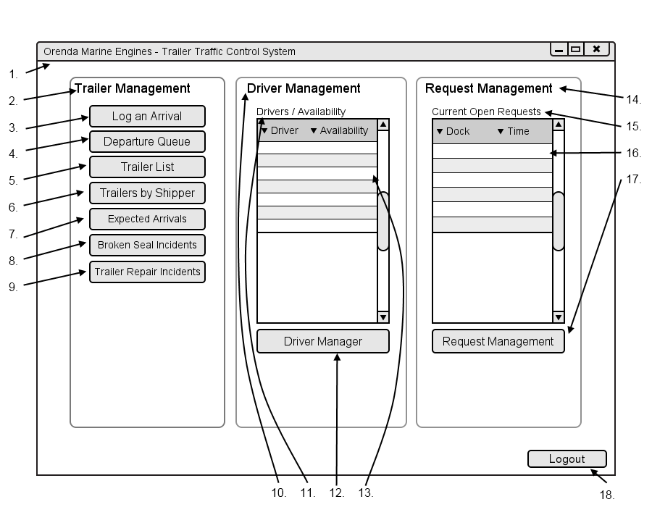

|  |  |  |  |
| --- | --- | --- | --- |
| # | Type | Text | Functions/Notes |
| 1 | Windows | Orenda Marine Engines – Trailer Traffic Control System | 800x600 |
| 2 | Label | Trailer Management |  |
| 3 | Button | Log An Arrival | Displays the Bill of Lading Dialog |
| 4 | Button | Departure Queue | Displays the Departure Queue Dialog |
| 5 | Button | Trailer List | Displays the Trailer List Screen |
| 6 | Button | Trailer By Shipper | Displays the Trailer By Shipper Filter Dialog |
| 7 | Button | Expected Arrivals | Displays the Expected Arrivals Screen |
| 8 | Button | Broken Seal Incidents | Displays the Broken Seal Incidents Screen |
| 9 | Button | Trailer Repair Incidents | Displays the Trailer Repair Incidents Screen |
| 10 | Label | Driver Management | Corey |
| 11 | Label | Drivers/Availability |  |
| 12 | DataGrid |  | Fields : Driver Name, Current Availability  This displays a list of all current drivers and their current status : Off Duty, Available, On Task |
| 13 | Button | Driver Manager | Displays the Driver Manager Screen |
| 14 | Label | Request Management |  |
| 15 | Label | Current Open Requests |  |
| 16 | DataGrid |  | Fields : Dock, Time  This displays a list of all requests that need the dispatchers’ attention.  They are sorted by Time from soonest to latest. Plant are highlighted light green, warehouse are highlighted light blue.  Requests with an issue are placed at the top highlighted red. |
| 17 | Button | Request Management | Displays the Request Management Screen |
| 18 | Button | Logout | Logs the Dispatcher out of the system |

Corey

Trailer Management – Corey Depres

### Arrivals – Use Case Diagram

#### Figure 1-2

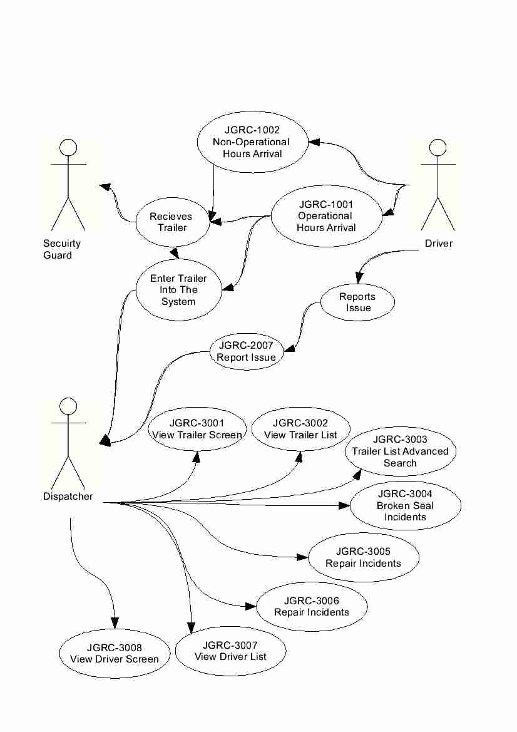

Corey

### Log an Arrival

When the dispatcher selects the Log an Arrival (JGRC-1001, P.95) option a window will pop-up (Figure 1-3) with a field for the Bill of Lading number. Once the B.O.L number is submitted the trailer screen for the appropriate trailer screen will be brought up with the Trailer No., Shipper No., Seal No., B.O.L. No., P.O No., Shipper Name, Shipper Address, Current Status, Current Location, Overdue Status, Overdue Cost Incurred and the Contents. There are two buttons on the screen. The first is to Admit the trailer that when pressed will ask the dispatcher to enter a lot number for the trailer. The second is to report an issue with a trailer in the system (I.E Repair needed or Broken seal) this will mark the trailer as unavailable as well as require a reason to be entered there is also a spot for a Lot No. and a new Seal Number if needed.

Corey

#### Figure 1-3

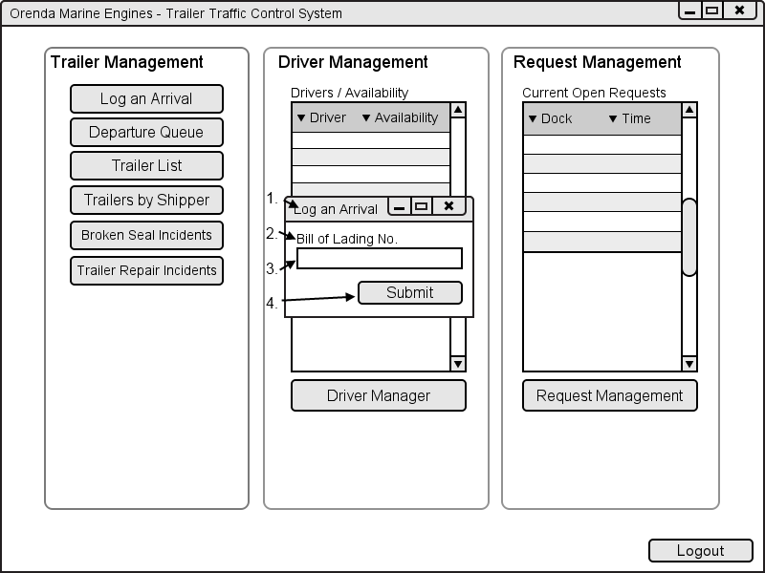

|  |  |  |  |
| --- | --- | --- | --- |
| # | Type | Text | Functions/Notes |
| 1 | Windows | Log an Arrival |  |
| 2 | Label | Bill of Lading No. |  |
| 3 | Text box |  | B.O.L text box |
| 4 | Button | Submit | Brings the dispatcher to the trailer screen of the trailer associated with the Bill of Lading entered |

### Trailer List

The trailer list (JGRC-3002, P.108) is used by the dispatcher to view a full list of all trailers in the system as well as the ability to search for trailers via two different methods, Simple Search (Appendix B-1 , P.139) and Advanced search(JRGC-3003, P.110). The simple search will allow the Dispatcher to enter a Trailer No., Shipper No., Shipper Name, the Contents and the Arrival Date, When one of these fields is filled out the list will automatically update according to the new parameters. If the option is selected to use the advanced search function, the dispatcher can search the list of trailers by Trailer No., Trailer Status, Bill of Lading No., Shipper No., Shipper Name, Purchase Order, Trailer Contents, Arrival date, Arrived After date and the Lot No. The dispatcher may also use the advanced search to exclude trailers based on if the trailer is full, empty, Overdue, Departed or pending arrival. By default departed trailers and pending arrival trailers are filtered out of the list on both simple and advanced search.

The trailer list itself contains the Trailer No., Shipper No., Shipper Name, Contents, Lot No., Arrival Date and the number of days that the trailer is overdue. To gain a more detailed list of information about a specific trailer the dispatcher can select a trailer from the list by double clicking it which will bring up the Trailer screen. The list will also page itself based on the number of records that have been returned within the search parameters. By default the list will only retrieve trailers that have arrived in the last 60 days.

#### Figure 1-4

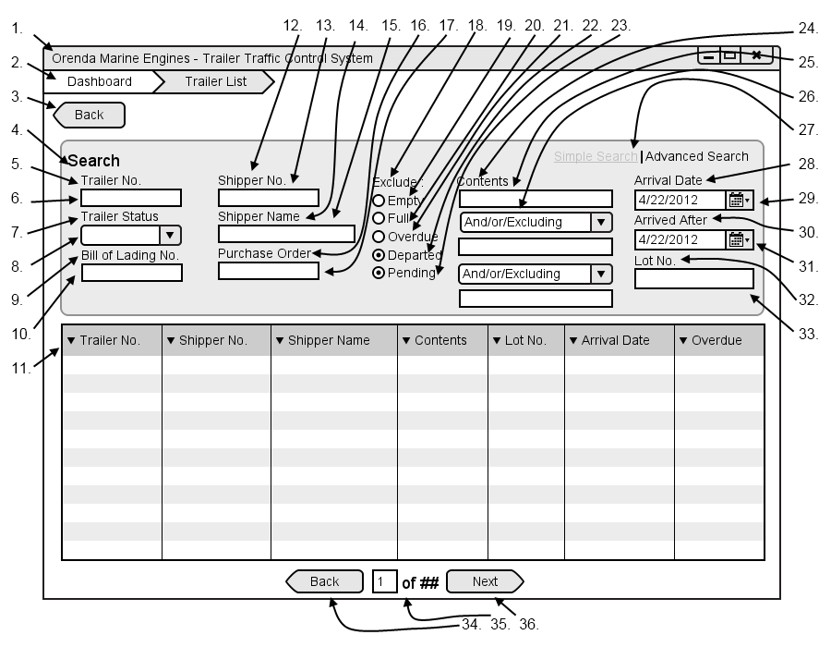

Corey

|  |  |  |  |
| --- | --- | --- | --- |
| # | Type | Text | Functions/Notes |
| 1 | Windows | Orenda Marine Engines – Trailer Traffic Control System | 800x600 |
| 2 | Breadcrumb |  | A list of all pages and subpages of the currently accessed page |
| 3 | Button | Back | Return to the Dispatcher Dashboard |
| 4 | Label | Search |  |
| 5 | Label | Trailer No. |  |
| 6 | Text Box |  | Trailer Number textbox, when it is filled in and taken from focus it filters the Datagrid |
| 7 | Label | Trailer Status |  |
| 8 | Selection Box |  | A list of all trailer status, once this is changed it automatically filters the Datagrid |
| 9 | Label | Trailer No. |  |
| 10 | Text Box |  | Bill of Lading textbox, when it is filled in and taken from focus it filters the Datagrid |
| 11 | Datagrid |  | Fields: Trailer No., Shipper No., Shipper Name, Contents, Lot No., Arrival Date, Overdue  A list of all trailers that are current on the Orenda Properties |
| 12 | Label | Shipper No. |  |
| 13 | Text Box |  | Shipper No textbox, when it is filled in and removed from focus it filters the Datagrid |
| 14 | Label | Shipper Name |  |
| 15 | Text Box |  | Shipper Name textbox, when it is filled in and removed from focus it filters the Datagrid |
| 16 | Label | Purchase Order |  |
| 17 | Text Box |  | Purchase Order textbox, when it is filled in and removed from focus it filters the Datagrid |
| 18 | Label | Exclude: |  |
| 19 | Radio Button | Empty | Filters out any empty trailers when selected |
| 20 | Radio Button | Full | Filters out any full trailers when selected |
| 21 | Radio Button | Overdue | Filters out any overdue trailers when selected |
| 22 | Radio Button | Departed | Filters out any departed trailers when selected |
| 23 | Radio Button | Pending | Filters out any pending trailers when selected |
| 24 | Label | Contents |  |
| 25 | Text Box |  | Contents textbox, when it is filled in and taken from focus it filters the Datagrid |
| 26 | Selection Box |  | And/or/Excluding |
| 27 | Link | Simple Search | Advanced Search | Clicking this opens the Simple Search options |
| 28 | Label | Arrival Date | Corey |
| 29 | Date Picker |  | Arrival Date Picker, when it is filled in and removed from focus it filters the Datagrid |
| 30 | Label | Arrived After |  |
| 31 | Date Picker |  | Arrived After Picker, when it is filled in and removed from focus it filters the Datagrid |
| 32 | Label | Lot No. |  |
| 33 | Text Box |  | Lot No. textbox, when it is filled in and taken from focus it filters the Datagrid |
| 34 | Button | Back | Move back one list of trailers, only visible if there are enough results to require multiple pages. |
| 35 | Label | ## of ## | Display the number based on the current page and the total pages |
| 36 | Button | Next | Move forward one list of trailers, only visible if there are enough results to require multiple pages. |

Corey

### Trailer Screen

The trailer screen(Figure 1-5, JGRC-3001, P.106) is a combined page of all information for a specific trailer used for verifying the Bill of lading and viewing specific trailer data. On the trailer screen the trailers Trailer No., Shipper No., Seal No., B.O.L. No., P.O No., Shipper Name, Shipper Address, Current Status, Current Location, Overdue Status, Overdue Cost Incurred and the Contents. There is also a change log that contains a list of all of the changes that have been made to the trailer (movements, repairs, seal changes). There is a button for Edit Trailer which when pressed opens the Edit Trailer Screen (Figure 1-6).

#### Figure 1-5

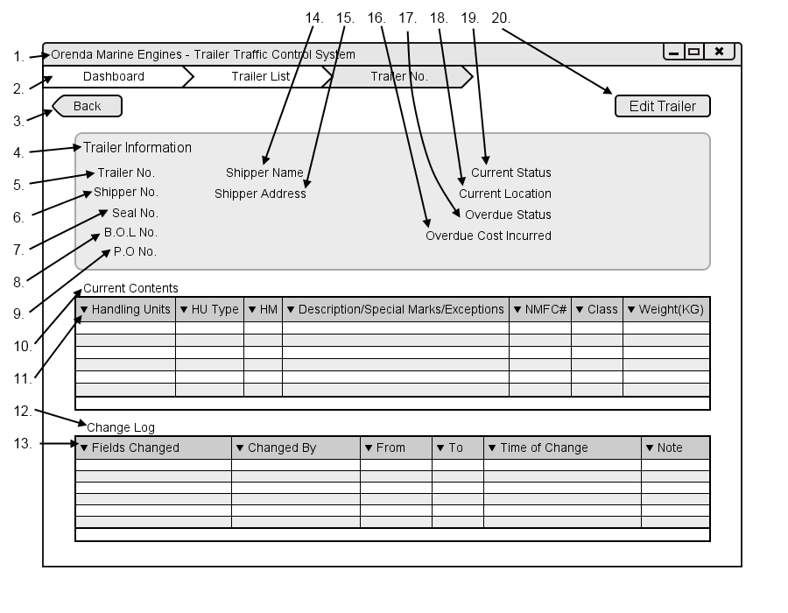

|  |  |  |  |
| --- | --- | --- | --- |
| # | Type | Text | Functions/Notes |
| 1 | Windows | Orenda Marine Engines – Trailer Traffic Control System | 800x600 |
| 2 | Breadcrumb |  | A list of all pages and subpages of the currently accessed page |
| 3 | Button | Back | Return to the Dispatcher Dashboard |
| 4 | Label | Trailer Information | Corey |
| 5 | Label | Trailer No. | Followed By the trailer number |
| 6 | Label | Shipper No. | Followed By the shipper number |
| 7 | Label | Seal No. | Followed By the seal number |
| 8 | Label | B.O.L No. | Followed By the B.O.L number |
| 9 | Label | P.O No. | Followed By the P.O Number |
| 10 | Label | Current Contents |  |
| 11 | Datagrid |  | Fields: Handling, HU Type, HM, Description/Special Marks/Exceptions,NMFC#,Class,Weights(KG)  A list of all contents within the selected trailer |
| 12 | Label | Change Log |  |
| 13 | Datagrid |  | Fields: Fields Changes, Changed By, From, To, Time of Change, Note  A list of all changes made to the trailer record from being entered into the system to departure |
| 14 | Label | Shipper Name | Followed By the Shipper Name |
| 15 | Label | Shipper Address | Followed By the Shipper Address |
| 16 | Label | Current Status | Followed By the Current Status |
| 17 | Label | Current Location | Followed By the Current Location |
| 18 | Label | Overdue Status | Followed By the Overdue Status |
| 19 | Label | Overdue Inccurred Costs | Followed By the Overdue Inccurred Costs |
| 20 | Button | Edit Trailer | Opens the edit trailer screen |

Corey

### Edit Trailer Screen

The edit trailer screen(JGRC-3006, P.116) is used to update trailer information in the event that information for a trailer needs to be updated. On this screen the dispatcher has the ability to edit the Seal No, Current Status, Current Location and trailer contents. There is a field where the dispatcher can enter notes about any changes being made.

#### Figure 1-6

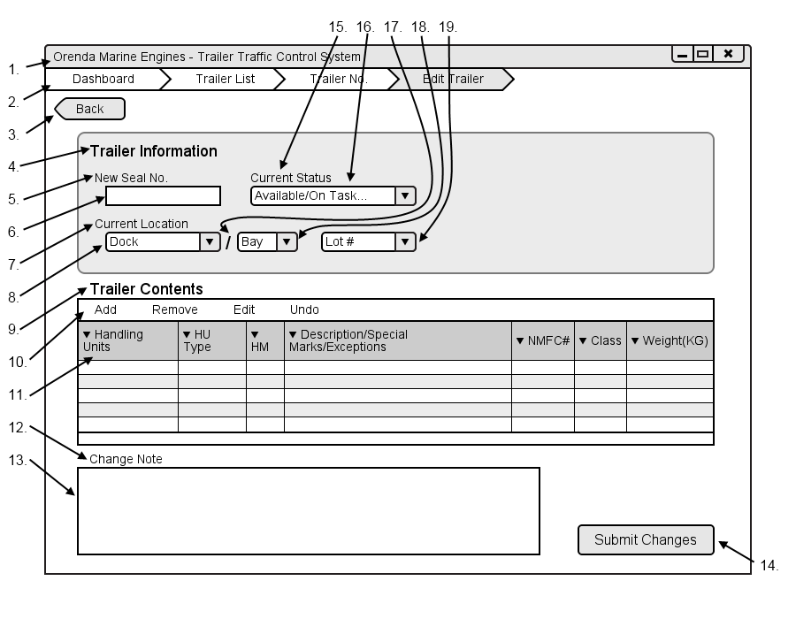

|  |  |  |  |
| --- | --- | --- | --- |
| # | Type | Text | Functions/Notes |
| 1 | Windows | Orenda Marine Engines – Trailer Traffic Control System | 800x600 |
| 2 | Breadcrumb |  | A list of all pages and subpages of the currently accessed page |
| 3 | Button | Back | Return to the Trailer List |
| 4 | Label | Trailer Information |  |
| 5 | Label | New Seal No. | Corey |
| 6 | Textbox |  | New Seal No. Textbox |
| 7 | Label | Current Location |  |
| 8 | Selection Box |  | A list of all locations in the yard that the trailer can be |
| 9 | Label | Trailer Contents |  |
| 10 | GridMenu |  | Options : Add, Remove, Edit, undo  A menu used to edit the inventory DataGrid |
| 11 | Datagrid |  | Fields: Handling, HU Type, HM, Description/Special Marks/Exceptions, NMFC#, Class, Weights(KG)  A list of all contents within the selected trailer |
| 12 | Label | Change Note |  |
| 13 | Textbox |  | The change note text box |
| 14 | Button | Submit Changes | Submits the changes that were made, updating the record and adding an item to the change log of the trailer |
| 15 | Label | Current Status |  |
| 16 | Selection Box |  | A list of all available statuses to be selected from |
| 17 | Label | / |  |
| 18 | SelectionBox |  | A list of all bays available at the selected dock if applicable |
| 19 | Textbox |  | Lot number text box |

Corey

### Broken Seal Incidents

The broken seal incident screen (JGRC-3004, P.112) contains a list of all broken seal incidents. The list is displayed with the Trailer No., Shipper No., Shipper Name, Broken seal date and a note if any was added when the new seal number was added. Double clicking any record in the list will bring up the trailer record of that entry. The list can be filters by Trailer No., Shipper No., Shipper Name, or Broken Deal Date.

#### Figure 1-7

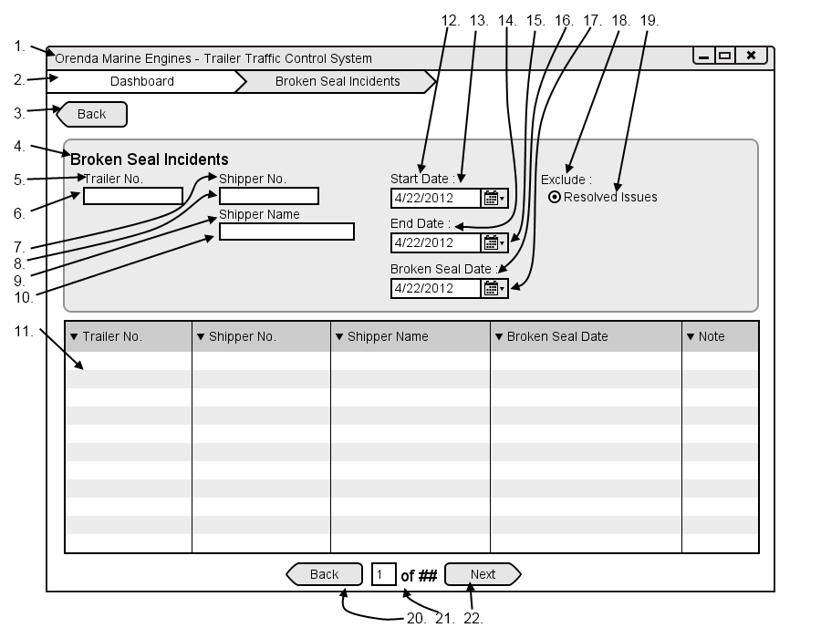

|  |  |  |  |
| --- | --- | --- | --- |
| # | Type | Text | Functions/Notes |
| 1 | Windows | Orenda Marine Engines – Trailer Traffic Control System | 800x600 |
| 2 | Breadcrumb |  | A list of all pages and subpages of the currently accessed page |
| 3 | Button | Back | Return to the Dispatchers Dashboard |
| 4 | Label | Broken Seal Incidents |  |
| 5 | Label | Trailer No. |  |
| 6 | Text Box |  | Trailer Number textbox, when it is filled in and taken from focus it filters the Datagrid  Corey |
| 7 | Label | Shipper No. |  |
| 8 | Text Box |  | Shipper No textbox, when it is filled in and removed from focus it filters the Datagrid |
| 9 | Label | Shipper Name |  |
| 10 | Text Box |  | Shipper Name textbox, when it is filled in and removed from focus it filters the Datagrid |
| 11 | Datagrid |  | Fields: Trailer No., Shipper No., Shipper Name, Repair Date, Note  A list of all trailers that have been found to have a broken seal within the specified filter dates |
| 12 | Label | Start Date: |  |
| 13 | Date Picker |  | Start Date picker |
| 14 | Label | End Date: |  |
| 15 | Date Picker |  | End Date picker |
| 16 | Label | Repair Date: |  |
| 17 | Date Picker |  | Repair date picker |
| 18 | Label | Exclude: |  |
| 19 | Radio | Resolved Issues | When checked broken seal incidents that have been resolved are nor displayed |
| 20 | Button | Back | Move back one list of trailers, only visible if there are enough results to require multiple pages. |
| 21 | Label | ## of ## | Display the number based on the current page and the total pages |
| 22 | Button | Next | Move forward one list of trailers, only visible if there are enough results to require multiple pages. |

Corey

### Repair Incidents

The repair incidents screen(JGRC-3005, P.114) contains a list of all trailers that are currently or have been repaired. The list displays the Trailer No., Shipper No., Shipper Name, Repair Date and any notes that have been entered when the changes were made. Double clicking a record will bring up the trailer record. This list can be filtered by Trailer No., Shipper No., Shipper Name or the date of the repair.

#### Figure 1-8

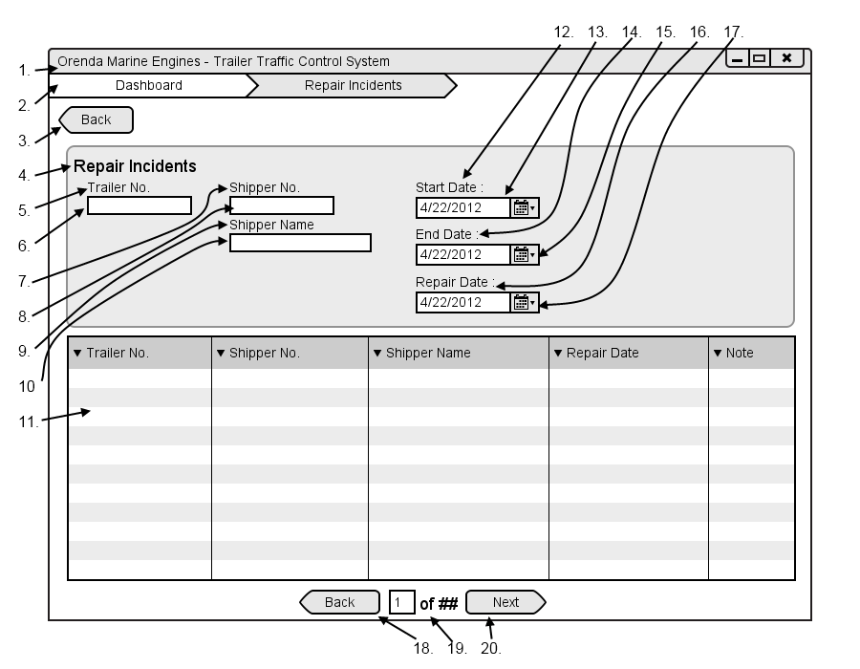

|  |  |  |  |
| --- | --- | --- | --- |
| # | Type | Text | Functions/Notes |
| 1 | Windows | Orenda Marine Engines – Trailer Traffic Control System | 800x600 |
| 2 | Breadcrumb |  | A list of all pages and subpages of the currently accessed page |
| 3 | Button | Back | Return to the Dispatchers Dashboard |
| 4 | Label | Repair Incidents |  |
| 5 | Label | Trailer No. |  |
| 6 | Text Box |  | Trailer Number textbox, when it is filled in and taken from focus it filters the Datagrid  Corey |
| 7 | Label | Shipper No. |  |
| 8 | Text Box |  | Shipper No textbox, when it is filled in and removed from focus it filters the Datagrid |
| 9 | Label | Shipper Name |  |
| 10 | Text Box |  | Shipper Name textbox, when it is filled in and removed from focus it filters the Datagrid |
| 11 | Datagrid |  | Fields: Trailer No., Shipper No., Shipper Name, Repair Date, Note  A list of all trailers that have needed repair within the specified filter dates |
| 12 | Label | Start Date: |  |
| 13 | Date Picker |  | Start Date picker |
| 14 | Label | End Date: |  |
| 15 | Date Picker |  | End Date picker |
| 16 | Label | Repair Date: |  |
| 17 | Date Picker |  | Repair date picker |
| 18 | Button | Back | Move back one list of trailers, only visible if there are enough results to require multiple pages. |
| 19 | Label | ## of ## | Display the number based on the current page and the total pages |
| 20 | Button | Next | Move forward one list of trailers, only visible if there are enough results to require multiple pages. |

### Expected Arrivals

This is a list of all trailers that have not yet arrived at the OME facilities. This list will contain the trailer No., Shipper No. Shipper Name and the expected arrival date. By default all trailers are listed and sorted by soonest to arrive. The dispatcher can filter trailer by the trailer no, Shipper No., Shipper Name and the date they will be arriving.

Corey

#### Figure 1-9

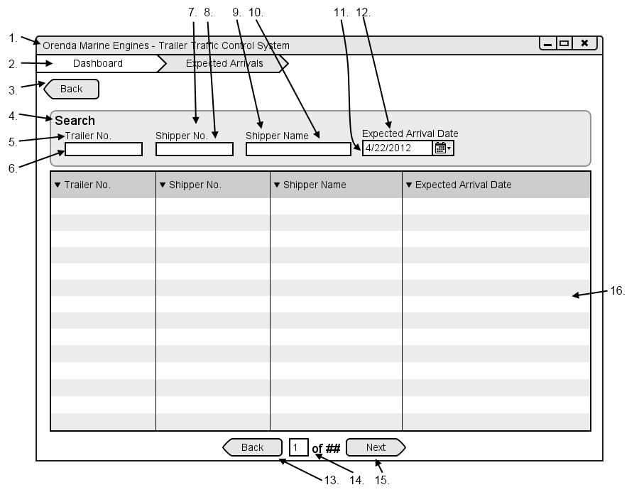

|  |  |  |  |
| --- | --- | --- | --- |
| # | Type | Text | Functions/Notes |
| 1 | Windows | Orenda Marine Engines – Trailer Traffic Control System | 800x600 |
| 2 | Breadcrumb |  | A list of all pages and subpages of the currently accessed page |
| 3 | Button | Back | Return to the Dispatchers Dashboard |
| 4 | Label | Search |  |
| 5 | Label | Trailer No. |  |
| 6 | Text Box |  | Trailer Number textbox, when it is filled in and taken from focus it filters the Datagrid |
| 7 | Label | Shipper No. |  |
| 8 | Text Box |  | Shipper No textbox, when it is filled in and removed from focus it filters the Datagrid |
| 9 | Label | Shipper Name |  |
| 10 | Text Box |  | Shipper Name textbox, when it is filled in and removed from focus it filters the Datagrid |
| 11 | Label | Expected Arrival Date | Corey |
| 12 | Date Picker |  | Start Date picker |
| 13 | Button | Back | Move back one list of trailers, only visible if there are enough results to require multiple pages. |
| 14 | Label | ## of ## | Display the number based on the current page and the total pages |
| 15 | Button | Next | Move forward one list of trailers, only visible if there are enough results to require multiple pages. |
| 16 | Datagrid |  | Fields: Trailer No., Shipper No., Shipper Name, Expected Arrival Date  A list of all trailers expected to arrive or in pending status |

### Yard Map

The yard map is used by the dispatcher to have a representation of the current yard and the activity within. The map is a set of 10 rows with 30 slots; each slot represents a trailer or a space within the yard. If a slot is empty it is represented by the lot number, if it is full it is a white rectangle, each rectangle can be highlighted a different color based on the trailers status. If a trailer has a move request attached it will be blue, if it has a repair order or a broken seal incident it is highlighted red. At any point the dispatcher can click a trailer and it will display the trailer No, Shipper Name and the contents in the bottom right corner. In the top right corner there is list of all current moves in the yard.

#### Figure 1-10

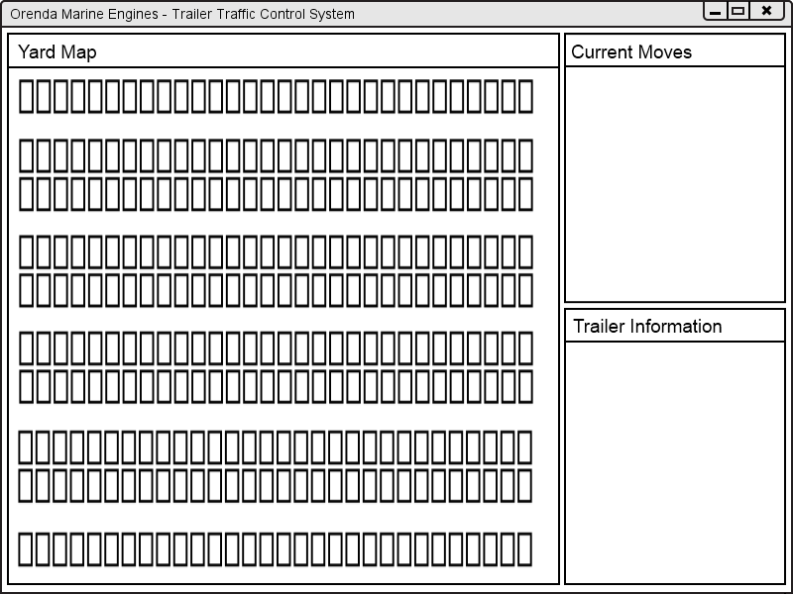

Corey

Driver Management – Corey Depres

### Driver List

The driver list (JGRC-3007, P.118) is used by the dispatcher to view a full list of all drivers who are currently on site as well as the ability to search for a specific driver based on one or many criteria. The driver list contains Driver No., Driver Name, Current status and Current task. The dispatcher may also use the search functions to filter the list. They may search by Driver number, Driver Name, or the drivers Current Status.

#### Figure 1-11

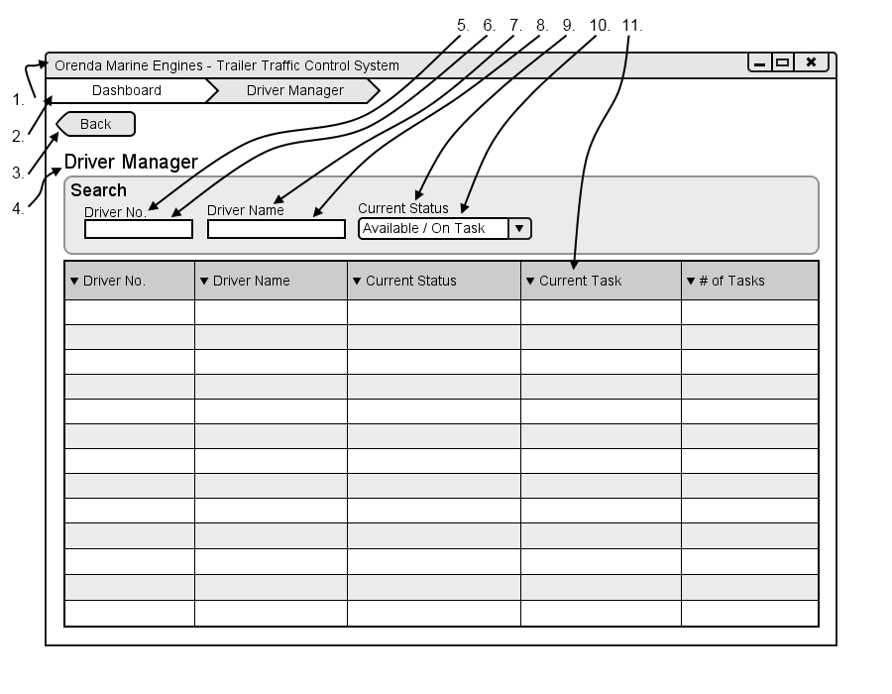

|  |  |  |  |
| --- | --- | --- | --- |
| # | Type | Text | Functions/Notes |
| 1 | Windows | Orenda Marine Engines – Trailer Traffic Control System | 800x600 |
| 2 | Breadcrumb |  | A list of all pages and subpages of the currently accessed page  Corey |
| 3 | Button | Back | Return to the Dispatcher Dashboard |
| 4 | Label | Driver Manager |  |
| 5 | Label | Driver No |  |
| 6 | Textbox |  | Driver Number Textbox |
| 7 | Label | Driver Name |  |
| 8 | Textbox |  | Driver name Textbox |
| 9 | Label | Current Status |  |
| 10 | Selection box |  | List of driver statuses |
| 11 | Datagrid |  | Fields: Driver No, Driver name, Current Status, Current Task, # of Tasks.  A list of all current drivers on Orenda’s property. By clicking on the number of tasks it displays a list of all of the drivers tasks in a dialog box |

### Driver Screen

The Driver screen(JGRC-3008, p.120) is a used to see what a driver has been doing and what task are assigned to them. The driver screen has a Driver Information box where the Drivers Name, number, terminal no., status and their current task are listed. As well, on the screen there is a task list that contains the Status Time of Request Time of Delivery and the Task name that can be searched and filtered using the available controls.

Corey

#### Figure 1-12

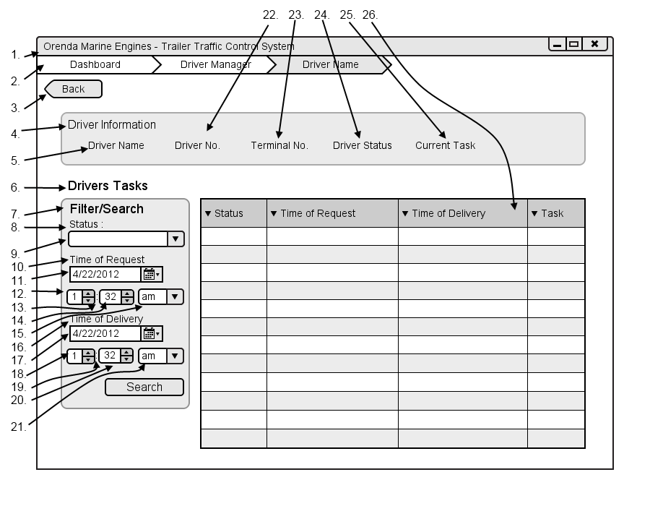

|  |  |  |  |
| --- | --- | --- | --- |
| # | Type | Text | Functions/Notes |
| 1 | Windows | Orenda Marine Engines – Trailer Traffic Control System | 800x600 |
| 2 | Breadcrumb |  | A list of all pages and subpages of the currently accessed page |
| 3 | Button | Back | Return to the Dispatcher Dashboard |
| 4 | Label | Driver Information |  |
| 5 | Label | Driver Name | Followed by the drivers name |
| 6 | Label | Drivers Tasks |  |
| 7 | Label | Filter/Search |  |
| 8 | Label | Status |  |
| 9 | Selection box |  | List of all task statuses |
| 10 | Label | Time of request |  |
| 11 | Date Picker |  | Time of request date picker |
| 12 | Selection Box |  | Numbers one through 12 |
| 13 | Label | : | Corey |
| 14 | Selection Box |  | Numbers 1 through 59 |
| 15 | Selection box |  | Am / pm |
| 16 | Label | Time of delivery |  |
| 17 | Date Picker |  | Time of delivery date picker |
| 18 | Selection Box |  | Numbers one through 12 |
| 19 | Label | : |  |
| 20 | Selection Box |  | Numbers 1 through 59 |
| 21 | Selection box |  | Am / pm |
| 22 | Label | Driver No. | Followed by the drivers Number |
| 23 | Label | Terminal No | Followed by the terminal number |
| 24 | Label | Driver Status | Followed by the status |
| 25 | Label | Current Task | Followed By Current Task |
| 26 | DataGrid |  | Fields: Status, Time of Request, Time of Delivery, Task |

Corey

Request Management – Corey Depres

### Request Management Screen

The dispatcher request management screen contains a list of all current requests from all dock foremen. The list of requests contains the Request No, Dock, Bay, Part, Status, Time of Delivery and the request date. There are filters available for the foreman to search through the list of requests; the dispatcher can filter using the Status, Dock, Bay, Product, Time of Delivery and start date. The dock foreman can choose to exclude or include closed requests which are by default not included.

#### Figure 1-13

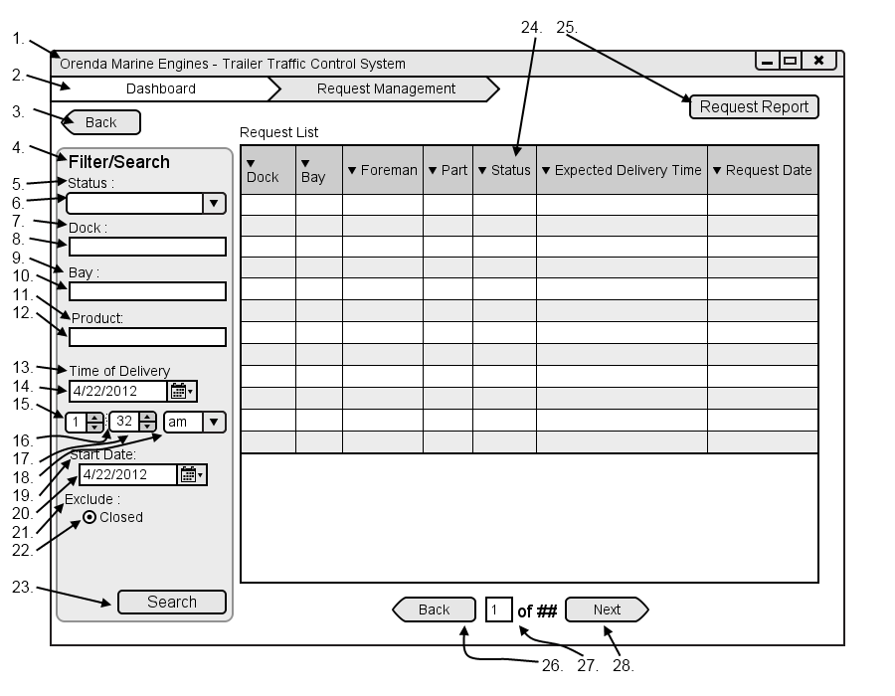

|  |  |  |  |
| --- | --- | --- | --- |
| # | Type | Text | Functions/Notes |
| 1 | Windows | Orenda Marine Engines – Trailer Traffic Control System | 800x600  Corey |
| 2 | Breadcrumb |  | A list of all pages and subpages of the currently accessed page |
| 3 | Button | Back | Return to the Dispatcher Dashboard |
| 4 | Label | Filter/Search |  |
| 5 | Label | Status |  |
| 6 | Selection box |  | List of all task statuses |
| 7 | Label | Dock: |  |
| 8 | Textbox |  | Dock textbox |
| 9 | Label | Bay: |  |
| 10 | Textbox |  | Bay textbox |
| 11 | Label | Product: |  |
| 12 | Label | Time of delivery |  |
| 13 | Date Picker |  | Time of delivery date picker |
| 14 | Selection Box |  | Numbers one through 12 |
| 15 | Label | : |  |
| 16 | Selection Box |  | Numbers 1 through 59 |
| 17 | Selection box |  | Am / pm |
| 18 | Label | Start Date: |  |
| 19 | Date Picker |  | Start Dare Picker |
| 20 | Label | Exclude |  |
| 21 | Radio Button | Closed | Removes all closed requests if checked |
| 22 | DataGrid |  | Fields: Dock, Bay, Foreman, Part, Status, Expected Deliver Time, Request Date  A list of all requests that match the currently selected search criteria |
| 23 | Button | Request Report | Displays the print report dialog |
| 24 | Button | Back | Move back one list of trailers, only visible if there are enough results to require multiple pages. |
| 25 | Label | ## of ## | Display the number based on the current page and the total pages |
| 26 | Button | Next | Move forward one list of trailers, only visible if there are enough results to require multiple pages. |

### Request Screen

The dispatcher request screen contains all of the information that the dock foreman entered for a specific request. The request information is broken down into Dock, Bay, Foreman, Status, P.O No, Delivery Time, Part and the shipper name. The dispatcher has the ability to assign a trailer and driver by selecting a button with will open the Trailer and Driver list respectively. When the trailer list is open it is pre-filtered by all relevant information entered into the system. The dispatcher has the ability to enter notes on the request before submitting it to the driver.

Corey

#### Figure 1-14

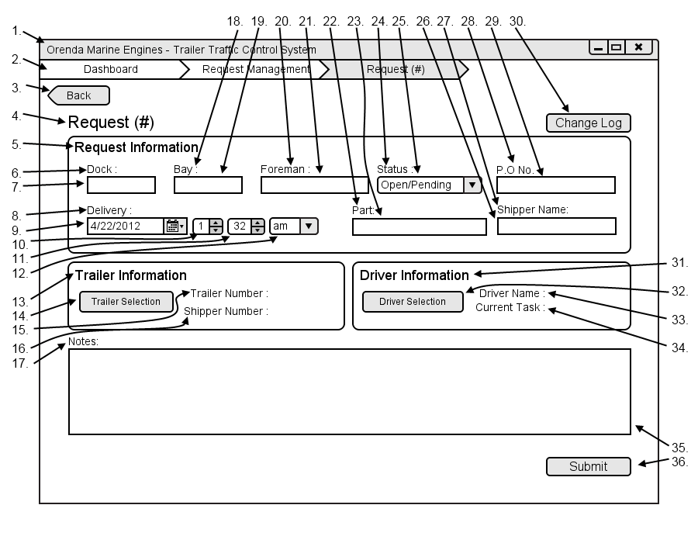

|  |  |  |  |
| --- | --- | --- | --- |
| # | Type | Text | Functions/Notes |
| 1 | Windows | Orenda Marine Engines – Trailer Traffic Control System | 800x600 |
| 2 | Breadcrumb |  | A list of all pages and subpages of the currently accessed page |
| 3 | Button | Back | Return to the Request Management |
| 4 | Label | Request # | # is the Unique request ID |
| 5 | Label | Request Information |  |
| 6 | Label | Dock: |  |
| 7 | Textbox |  | Dock textbox |
| 8 | Label | Time of delivery |  |
| 9 | Date Picker |  | Time of delivery date picker |
| 10 | Selection Box |  | Numbers one through 12 |
| 11 | Selection Box |  | Numbers 1 through 59 |
| 12 | Selection box |  | Am / pm |
| 13 | Label | Trailer Information |  |
| 14 | Button | Trailer Selection | Opens the Trailer list in advanced view with all information fron the request already entered  Corey |
| 15 | Label | Trailer No. | Followed By the Trailer No. |
| 16 | Label | Shipper Name | Followed By the Shipper Name |
| 17 | Label | Notes: |  |
| 18 | Label | Bay: |  |
| 19 | Textbox |  | Bay textbox |
| 20 | Label | Foreman: |  |
| 21 | Textbox |  | Foreman textbox |
| 22 | Label | Part: |  |
| 23 | Textbox |  | Part textbox |
| 24 | Label | Status |  |
| 25 | Selection box |  | List of all task statuses |
| 26 | Label | Shipping Name: |  |
| 27 | Textbox |  | Shipping Name textbox |
| 28 | Label | P.O No. |  |
| 29 | Textbox |  | P.O No. textbox |
| 30 | Button | Change Log | Opens the Change log for the request |
| 31 | Label | Driver Information |  |
| 32 | Button | Driver Selection | Opens the Driver list in advanced view with all information from the request already entered |
| 33 | Label | Driver Name : | Followed By the Driver Name : |
| 34 | Label | Current Task | Followed By the Current Task |
| 35 | Textbox |  | Note for the change to the request |
| 36 | Button | Submit | Submits the changes to the request and sends in to the appropriate sources |

Corey

Departures and Overdue Trailers – Corey Depres

### Trailer by Company Dialog

The trailer by company dialog (JGRC-1003, P.91) is used by the dispatcher to filter what is displayed on the Trailer by company screen. The dialog contains the ability to add companies to the list as well as remove them. He may also filter trailers by Trailer No, Due By, Status, Due Status and Total Cost. Once the dispatcher has added all of the companies to the list he submits the list and the Trailer By Company screen is displayed with the selected filters used.

#### Figure1-15

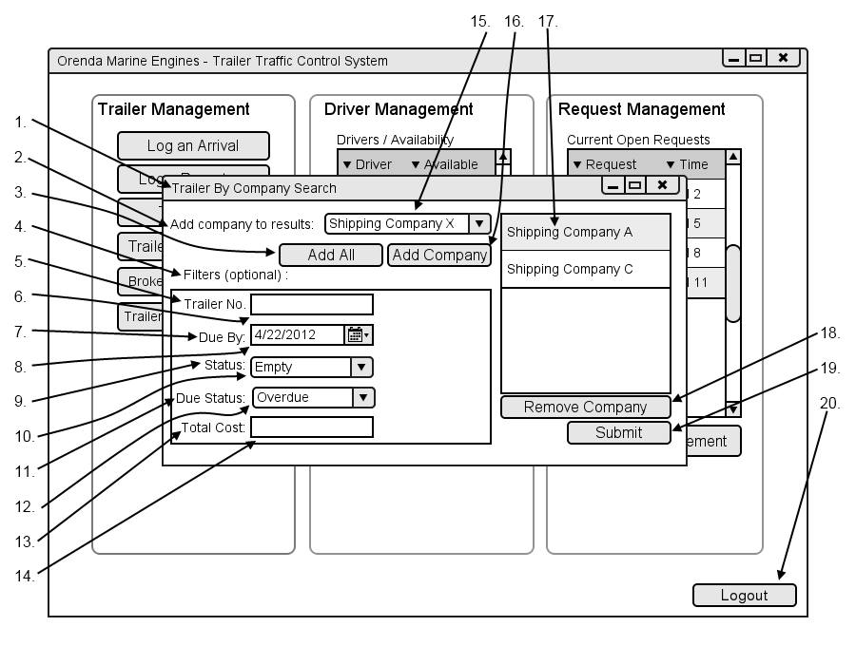

|  |  |  |  |
| --- | --- | --- | --- |
| # | Type | Text | Functions/Notes |
| 1 | Container | Trailer Company Search |  |
| 2 | Label | Add company to results: |  |
| 3 | Button | Add All | Adds all companies to the datagrid  Corey |
| 4 | Label | Filters (optional) : |  |
| 5 | Label | Trailer No. |  |
| 6 | Text Box |  | Trailer number text box |
| 7 | Label | Due By |  |
| 8 | Date picker |  | Due By date picker |
| 9 | Label | Status |  |
| 10 | Selection Box |  | Status selection box is populated with all trailer statuses |
| 11 | Label | Due Status |  |
| 12 | Selection Box |  | A list of all overdue statuses |
| 13 | Label | Total Cost |  |
| 14 | Textbox |  | Total Cost Textbox |
| 15 | Selection box |  | List of all available shipping companies |
| 16 | Button | Add Company | Adds the selected company to the list |
| 17 | DataList |  | A list of all companies added |
| 18 | Button | Remove Company | Removes the selected company from the list |
| 19 | Submit |  | Submits the filters and displays the Trailer by company screen based on the selected filters |

### Trailer by Company Screen

The Trailer by company screen(JGRC-1003, P.91) can be used by the dispatcher to mark trailers for departure as well as view a more refined list of trailers and their overdue status. The screen contains a list of all trailers from the companies selected on the Trailer by Company Dialog as well and refined by any filters that were entered into dialog. The list contains the Trailer Number, Location, Arrival Date, Status, Due Status, Overdue By, overdue cost incurred, Lot No as well as a checkbox to mark a trailer for departure. By marking a trailer by departure the dispatcher can see the trailer on the departure Queue which will be discussed later.

Corey

#### Figure 1-16

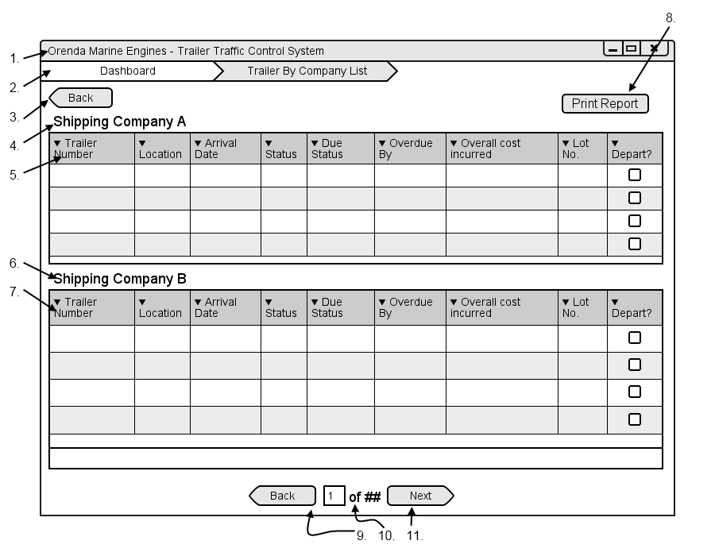

|  |  |  |  |
| --- | --- | --- | --- |
| # | Type | Text | Functions/Notes |
| 1 | Windows | Orenda Marine Engines – Trailer Traffic Control System | 800x600 |
| 2 | Breadcrumb |  | A list of all pages and subpages of the currently accessed page |
| 3 | Button | Back | Return to the Dispatcher Dashboard |
| 4 | Label | Shipping Company Name |  |
| 5 | DataGrid |  | Fields : Trailer Number, Location, Arrival Date, Status, Due status, Overdue By, Overall cost incurred, lot no., depart checkbox  A list of all trailers on the property sorted by trucking company. |
| 6 | Label | Shipping Company Name |  |
| 7 | DataGrid |  | Fields : Trailer Number, Location, Arrival Date, Status, Due status, Overdue By, Overall cost incurred, lot no., depart checkbox  Corey  A list of all trailers on the property sorted by trucking company. |
| 8 | Button | Print Report | Bring up the print report dialog |
| 9 | Button | Back | Move back one list of trailers, only visible if there are enough results to require multiple pages. |
| 10 | Label | ## of ## | Display the number based on the current page and the total pages |
| 11 | Button | Next | Move forward one list of trailers, only visible if there are enough results to require multiple pages. |

### Departure Queue

The departure queue(JGRC-1004, P.94) is used by the dispatcher to quickly view a list of trailers marked for departure. The dialog contains a list of all the trailers with the Trailer No. and the trucking company. The dispatcher can depart a trailer by selecting one from the queue and clicking the depart button, this will then mark the trailer as departed in the system.

#### Figure 1-17

Corey

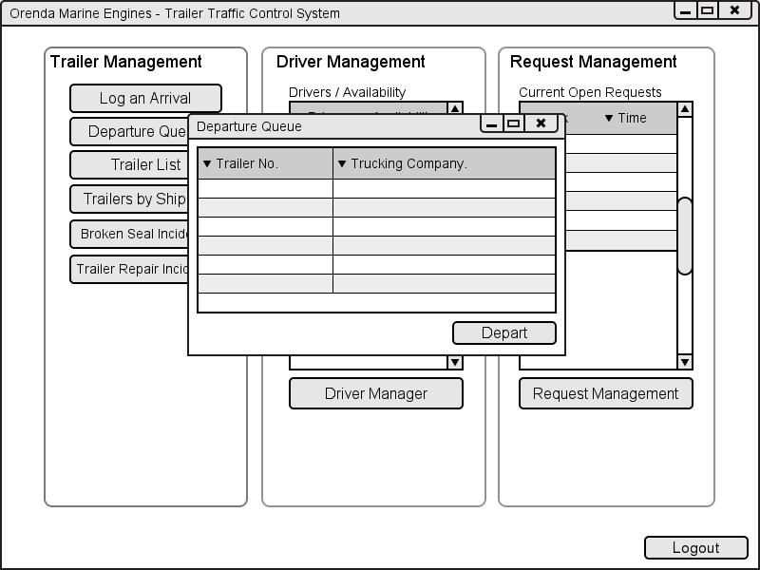

1

2

3

|  |  |  |  |
| --- | --- | --- | --- |
| # | Type | Text | Functions/Notes |
| 1 | Dialog | Departure Queue | Pop-up dialog, 400X300 |
| 2 | Data Grid |  | Fields: Trailer No., Trucking Company  This table shows a list of the trailers in the yard. From here the user can mark a trailer for departure |
| 3 | Button | Depart | Marks selected trailer for departure. Inactive if no trailer selected |

Corey

Dock Foreman Dashboard – Jack Watt/Corey Depres

### Dock Foreman Dashboard

The Dock foreman dashboard is a list of all request that the logged in Dock Foreman. The list of requests contains the Request No, Dock, Bay, Part, Status, Time of Delivery as well as a Received Trailer checkbox to allow the dispatcher to quickly identify which trailers have arrived at the dock. There are filters available for the foreman to search through the list of requests. the dock foreman can filter by Status, Dock, Bay, Product, Time of Delivery and Start Date. He can also choose to choose to include or exclude closed requests which are not displayed by default.

The dock foreman can create a new request for a trailer by selecting the "New Request" button which will display the request dialog with the Parts Request tab displayed by default.

#### Figure 2-1

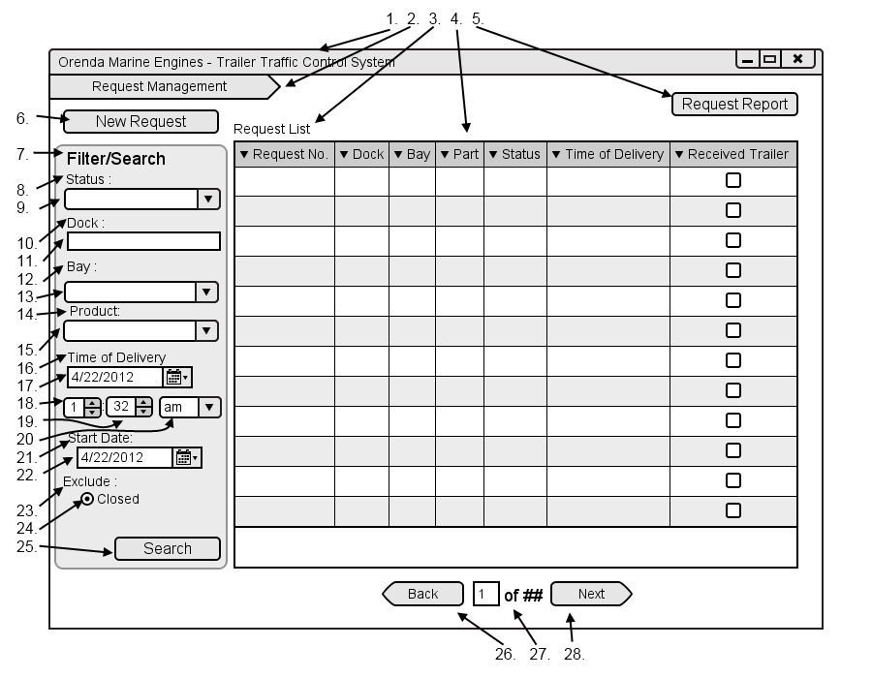

Corey

|  |  |  |  |
| --- | --- | --- | --- |
| # | Type | Text | Functions/Notes |
| 1 | Windows | Orenda Marine Engines – Trailer Traffic Control System | 800x600 |
| 2 | Breadcrumb |  | A list of all pages and subpages of the currently accessed page |
| 3 | Label | Request List |  |
| 4 | DataGrid |  | Fields: Dock, Bay, Foreman, Part, Status, Expected Deliver Time, Request Date  A list of all requests that match the currently selected search criteria |
| 5 | Button | Request Report | Displays the print report dialog |
| 6 | Button | New Request | Displays the dialog to create a new request |
| 7 | Label | Filter/Search |  |
| 8 | Label | Status |  |
| 9 | Selection box |  | List of all task statuses |
| 10 | Label | Dock: |  |
| 11 | Textbox |  | Dock textbox |
| 12 | Label | Bay: |  |
| 13 | Textbox |  | Bay textbox |
| 14 | Label | Product: |  |
| 15 | Textbox |  | Product Textbox |
| 16 | Label | Time of delivery |  |
| 17 | Date Picker |  | Time of delivery date picker |
| 18 | Selection Box |  | Numbers one through 12 |
| 19 | Selection Box |  | Numbers 1 through 59 |
| 20 | Selection box |  | Am / pm |
| 21 | Label | Start Date: |  |
| 22 | Date Picker |  | Start Dare Picker |
| 23 | Label | Exclude |  |
| 24 | Radio Button | Closed | Removes all closed requests if checked |
| 25 | Button | Submit | Filters the request list by the entered information |
| 26 | Button | Back | Move back one list of trailers, only visible if there are enough results to require multiple pages. |
| 27 | Label | ## of ## | Display the number based on the current page and the total pages |
| 28 | Button | Next | Move forward one list of trailers, only visible if there are enough results to require multiple pages. |

Corey

### Request for Components

Request for components is the heart of the system. Being a form of trailer movement this is going to be one of three major requests that the dock foreman can perform through the TTCS. One of the pertinent issues was the way the TTCS was being utilized in the system. Not everything can be automated, but things can be automated to help with manual processes. We are looking to interface your TTCS with your business and employees to help keep everything running smoothly.

Resolving the break in communication comes down to creating a means which everyone has a system that speaks between the sections of business. Giving the dock foreman a form to submit for requesting components frees up the phone, doesn’t depend on someone being on the other end to receive, more than one can be received at once, processing each request becomes less resource vintensive. Using a computer system to hold and keep track of all this data saves the dispatcher time as they only need to look at the data when they want to resolve the request. Opposed to using a telephone system the dispatcher needs to assign himself to taking down the request from the dock foreman.

The change in process ends up affecting everyone involved. It is projected that this will save time for everyone by eliminating the need to record information for requests. The dock foreman saves the dispatcher from entering information like part, and destination. The dispatcher saves the driver from needing to write down or memorize tasks as the driver will have a list of tasks with them in their trucks.

Corey & Jack

#### Figure 2-2

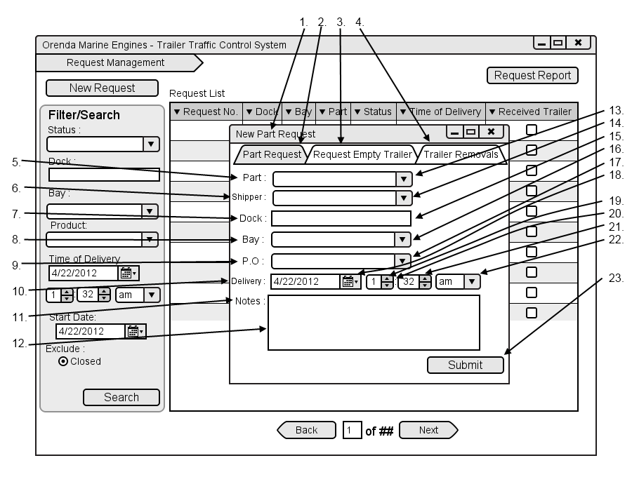

|  |  |  |  |
| --- | --- | --- | --- |
| # | Type | Text | Functions/Notes |
| 1 | Window | New Part Request | Corey |
| 2 | Tab Menu Item | Part Request |  |
| 3 | Tab Menu Item | Request Empty Trailer | Displays the Request Empty Trailer Options |
| 4 | Tab Menu Item | Trailer Removals | Displays the Trailer Removals Options |
| 5 | Label | Part: |  |
| 6 | Label | Shipper: |  |
| 7 | Label | Dock: |  |
| 8 | Label | Bay: |  |
| 9 | Label | P.O |  |
| 10 | Label | Delivery: |  |
| 11 | Label | Notes: |  |
| 12 | Textbox |  | Notes Textbox |
| 13 | Textbox |  | Part textbox |
| 14 | Textbox |  | Shipper textbox |
| 15 | Textbox |  | Dock textbox |
| 16 | Textbox |  | Bay textbox |
| 17 | Textbox |  | P.O textbox |
| 18 | Date Picker |  | Time of delivery date picker |
| 19 | Selection Box |  | Numbers one through 12 |
| 20 | Label | : |  |
| 21 | Selection Box |  | Numbers 1 through 59 |
| 22 | Selection box |  | Am / pm |
| 23 | Button | Submit | Submit the request and return them to the request list |

### Request for Empty Trailer

Request for empty trailer can be considered the heart of the system, adding a means to increase the flow of the process is crucial. The ability to put everything on a cloud and have someone else pull down that information from another location helps everyone involved spend less time back and forth on phones and radios.

The ability for the dispatcher to view information on drivers and trailers is crucial on a constant basis. Having a screen to view information on trailers, drivers, and requests is going to play a big role in the system. It will require no direct input. When the dispatcher assigns a trailer it will show on this monitor that the trailer is either in the yard, at the docks, or at the warehouse. This external screen has to be used for reporting to the dispatcher. The less interaction needed the better.

Jack

#### Figure 2-3

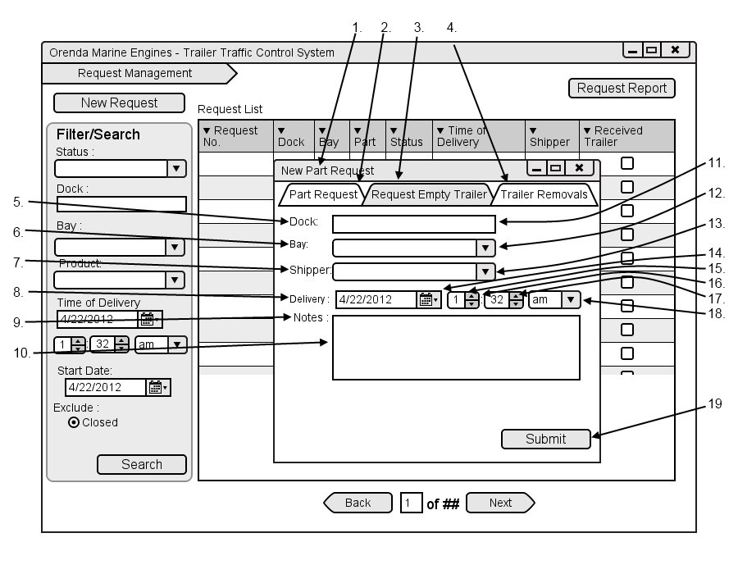

|  |  |  |  |
| --- | --- | --- | --- |
| # | Type | Text | Functions/Notes |
| 1 | Window | New Part Request |  |
| 2 | Tab Menu Item | Part Request | Displays the Part Request Options |
| 3 | Tab Menu Item | Request Empty Trailer |  |
| 4 | Tab Menu Item | Trailer Removals | Displays the Trailer Removals Options |
| 5 | Label | Shipper: |  |
| 6 | Label | Dock: |  |
| 7 | Label | Bay: |  |
| 8 | Label | Delivery: |  |
| 9 | Label | Notes: |  |
| 10 | Textbox |  | Notes Textbox |
| 11 | Textbox |  | Dock textbox |
| 12 | Textbox |  | Bay textbox |
| 13 | Textbox |  | Shipper textbox |
| 14 | Date Picker |  | Time of delivery date picker |
| 15 | Selection Box |  | Numbers one through 12 |
| 16 | Label | : |  |
| 17 | Selection Box |  | Numbers 1 through 59  Corey |
| 18 | Selection box |  | Am / pm |
| 19 | Button | Submit | Submit the request and return them to the request list |

### Request for Empty Trailer Removal

This process begins when a trailer has been emptied at a dock of the Warehouse or Plant, and the driver does not wait for the trailer to be unloaded. Once the Dock Foreman identifies that there is an empty trailer at the dock, he or she will call the dispatcher requesting a driver to come pick it up.

The Dock Foreman provides the dispatcher with the appropriate information. This includes the dock name and bay number at which the trailer is located, as well as the trailer number of the trailer. Once this call has been placed, the dispatcher must now find a driver to perform this task (See Use Case JGRC-2002).

The dispatcher must determine where the empty trailer will be placed in the yard after it is picked up. The dispatcher will provide the driver with the information given to him from the Dock Foreman as well as the end destination, determined beforehand. This process concludes when the trailer has been removed from the dock and placed in the specified parking spot in the yard.

One issue that can be encountered in this process is that the dispatcher may not always get the required information for pick-up. He may only get the bay number or the trailer number and this can cause problems for the driver. Without the appropriate information, the driver will have to search for the correct dock or for the specific trailer at the docks. This is very time consuming and slows down an otherwise simple process.

Another issue is when a driver cannot be reached or is late. In either of these situations, the trailer will have to sit and wait at the bay. The main concerns here are that the trailers are unattended in an unsecure area, and that the empty trailer is now taking up a bay. The process of trailer removals is essential to the flow of the business. When trailers are being removed on time, it leaves availability for other tasks to be completed, and the bay to be used for something else.

Jack

#### Figure 2-4

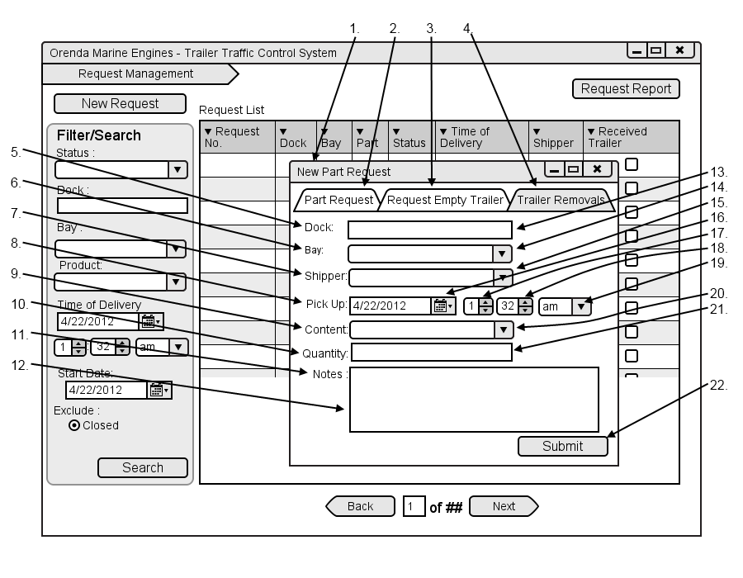

|  |  |  |  |
| --- | --- | --- | --- |
| # | Type | Text | Functions/Notes |
| 1 | Window | New Part Request |  |
| 2 | Tab Menu Item | Part Request | Displays the Part Request Options |
| 3 | Tab Menu Item | Request Empty Trailer | Displays the Request Empty Trailer Options |
| 4 | Tab Menu Item | Trailer Removals |  |
| 5 | Label | Dock: |  |
| 6 | Label | Bay: |  |
| 7 | Label | Shipper: |  |
| 8 | Label | Pick Up: |  |
| 9 | Label | Content: |  |
| 10 | Label | Quantity: |  |
| 11 | Label | Notes: |  |
| 12 | Textbox |  | Notes Textbox |
| 13 | Textbox |  | Dock textbox |
| 14 | Textbox |  | Bay textbox |
| 15 | Textbox |  | Shipper textbox |
| 16 | Date Picker |  | Time of delivery date picker |
| 17 | Selection Box |  | Numbers one through 12  Corey |
| 18 | Selection Box |  | Numbers 1 through 59 |
| 19 | Selection box |  | Am / pm |
| 20 | Textbox |  | Content Textbox |
| 21 | Textbox |  | Quantity textbox |
| 22 | Button | Submit | Submit the request and return them to the request list |

Corey

Driver Interface – Ryan Vaughan

### Use Case Overview

#### Figure 3-1



### Task List

When the user logs on to the Driver Task Tracking device, he/she will see the Task List screen. This is considered the Main Page of the system. On this page the user can see all the tasks that have been assigned to him, including the ones he has already completed. From here, he can begin a task (Use Case 4004 – Performs Task), view a task’s details (Use Case 4002 – View Task), report an issue (Use Case 4006 – Report Issue), go off duty (Use Case 4005 – Records Break) or log off.

Ryan

#### Figure 3-2

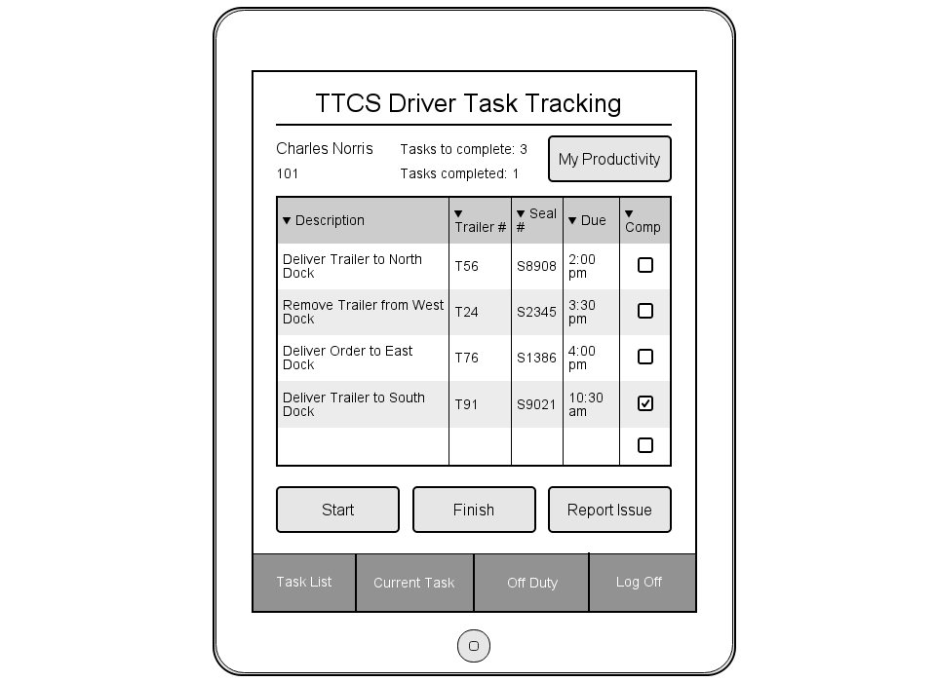

1

2

3

4

5

6

7

8

9

10

11

12

13

14

15

16

|  |  |  |  |
| --- | --- | --- | --- |
| # | Type | Text | Functions/Notes |
| 1 | Label | TTCS Driver Task Tracking |  |
| 2 | Label | Tasks to complete |  |
| 3 | Label | Tasks completed |  |
| 4 | Label | Driver name (ex. Charles Norris) |  |
| 5 | Label | Driver number (ex. 101) |  |
| 6 | Data Grid |  | Fields: Description, Trailer #, Seal #, Due, Completed  This displays tasks that have been assigned by the Dispatcher. It will show the driver a description of the task (type of task and location), the trailer and seal number to check, and what time the task is due for. It also has a completed field which indicates if the task is finished or not. |
| 7 | Button | Finish | Ends the current task and time stamps. If there is no task currently being done, this button is inactive  Ryan |
| 8 | Button | Start | Inactive in this view |
| 9 | Menu Option | Task List | This option is inactive in this view |
| 10 | Menu Option | Current Task | This option takes the use to the current task (if any). If no current task, option disabled |
| 11 | Label | Number of tasks the driver has received that day |  |
| 12 | Label | Number of tasks driver has completed that day |  |
| 13 | Button | My Productivity | This button will take you to the My Productivity screen |
| 14 | Button | Report Issue | Inactive from this view as a task needs to selected or started t or report an issue on it |
| 15 | Menu Option | Log Off | This option will pop up a dialog for the driver to confirm his log off time. After confirmation, Log on screen is displayed |
| 16 | Menu Option | Off Duty | This option will pop up a dialog for the driver to confirm his log off time. After confirmation, Off duty screen is displayed |

### Current Task

This screen shows the details of the task which is currently being performed. The user will be taken to this screen when he/she selects the Start button from either the Task List view or the View Task view. This screen is identical to the View Task screen but has a different, obvious title. The purpose of this screen is to help the user quickly identify whether the details he is viewing are for the task at hand or any other task in the list.

Ryan

#### Figure 3-3

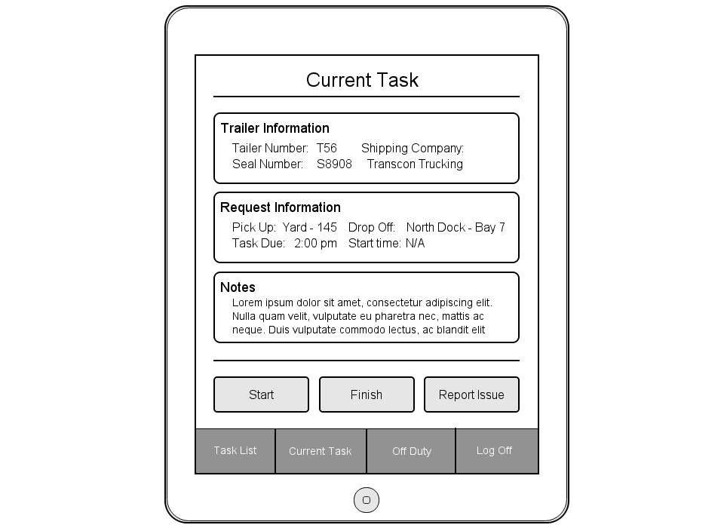

1

2

3

4

5

6

7

8

9

10

11

12

13

14

15

16

17

18

19

20

21

22

23

24

25

26

|  |  |  |  |
| --- | --- | --- | --- |
| # | Type | Text | Functions/Notes |
| 1 | Label | Current Task | Static |
| 2 | Label | Trailer Information | Static |
| 3 | Label |  | Trailer Number |
| 4 | Label | Trailer Number: | Static |
| 5 | Label | Seal Number: | Static |
| 6 | Label |  | Seal Number |
| 7 | Label | Request Information | Static |
| 8 | Label | Pick Up: | Static |
| 9 | Label | Task Due: | Static |
| 10 | Label |  | Pick up location: Dock/Yard – bay/spot # |
| 11 | Label |  | Time task is due |
| 12 | Label | Notes | Static |
| 13 | Text Area |  | Text area for additional notes |
| 14 | Button | Start | Time stamps the start time of a task |
| 15 | Button | Finish | Time stamps the end time of a task. When a task is finished, send start and finish time stamps back to TTCS |
| 16 | Menu Option | Task List | Switch to Task List view  Ryan |
| 17 | Menu Option | Current Task | Disabled |
| 18 | Label | Shipping Company: | Static |
| 19 | Label |  | Name of the shipping (trucking) company |
| 20 | Label | Drop Off: | Static |
| 21 | Label |  | Location: dock/yard – bay/spot # |
| 22 | Label |  | Time stamp of when the task was started |
| 23 | Label | Start Time: | Static |
| 24 | Button | Report Issue | Go to report issue screen |
| 25 | Menu Option | Off Duty | Prompt for confirmation, if OKAY time stamp off duty time and take user to off duty screen. If Cancel, return to screen. |
| 26 | Menu Option | Log Off | Prompt for confirmation, if OKAY time stamp off duty time and take user Log On screen. If Cancel, return to screen. |

### Perform Task

There are two ways to begin a task. If the user is currently in the Task List view, he may select the “Current Task” radio button of the task he would like to perform, and then hit Start. He may also perform Use Case 4002 – View Task. Once I the View Task view, he can hit start to begin the selected task. When a task is started, a time stamp is saved as the start time of that task. When the user is finished with that task, he will hit Finish and the end time of the task will be time stamped. Once completed, the task will be dropped to the bottom of the queue with its completed field checked. The start and end time stamps will then be sent to the TTCS.

### Record Break

When the driver is going off duty for lunch, break, meetings, etc, he will use the Off Duty feature of the device. This will simply time stamp when he went off duty, and time stamp when he comes back. That information is passed back to the TTCS. When a driver is off duty, his status is set to such in the TTCS for dispatch to see.

Ryan

#### Figure 3-4

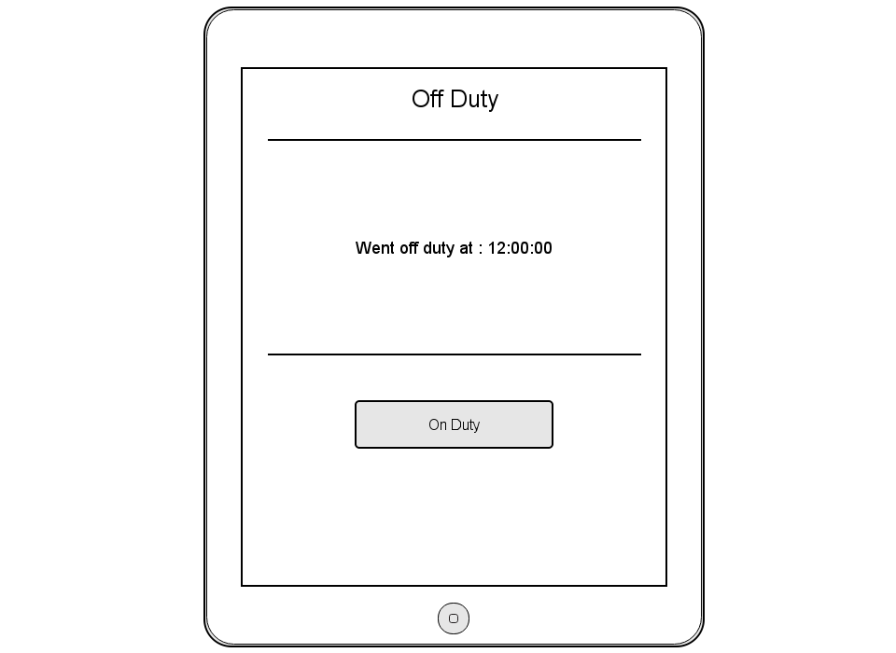

1

2

4

3

|  |  |  |  |
| --- | --- | --- | --- |
| # | Type | Text | Functions/Notes |
| 1 | Label | Off Duty | Static |
| 2 | Label | Went off duty at: | Static |
| 3 | Label | time stamp | Time that the driver went off duty |
| 4 | Button | On Duty | Take user to Task List view. Time stamp the on duty time as the end of the break |

### Report Issue

If there is an issue preventing the driver from starting or completing his task, he can report an issue with the selected task. He will provide the reason for reporting the issue as well as any additional notes he may want to add. The issue will be sent to the TTCS for the dispatcher to handle. If the issue was reported while performing a task, that task will be stopped and sent to the bottom of the queue. The task will be time stamped when the issue was sent and again when it is restarted.

Ryan

#### Figure 3-5

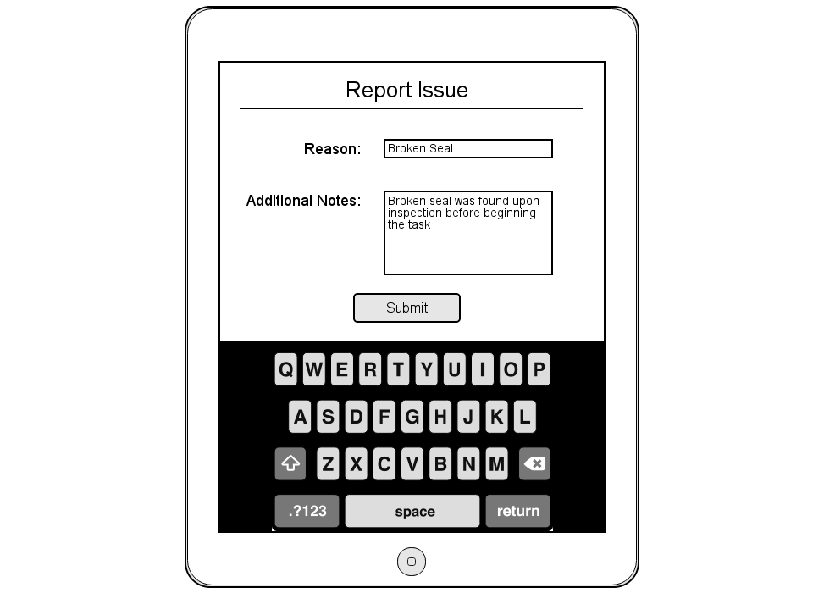

1

2

3

4

5

6

7

|  |  |  |  |
| --- | --- | --- | --- |
| # | Type | Text | Functions/Notes |
| 1 | Label | Report Issue | Static |
| 2 | Label | Reason: | Static |
| 3 | Label | Additional Notes: | Static |
| 4 | Button | Submit | Send Issue information to TTCS – Reason, Notes, time stamp of when issue was reported + task information. Return to Task List view |
| 5 | Keyboard |  | Full QWERTY keyboard with option for numerical characters |
| 6 | Text Box |  | Reason for the reported issue |
| 7 | Text Area |  | Notes about the issue |

Ryan

### My Productivity

From the View Task screen, the user can select the My Productivity button. Clicking it will take the user to the My Productivity screen. This screen displays the driver’s stats for the current day including Tasks received/completed, Average move time, and Average late time. There are also do charts, the first being a pie chart depicting that driver’s Time Spent. This chart has three categories, On Duty, Off Duty, and Duty. The second chart is a bar chart comparing the driver’s stats for the day versus the average stats of all the drivers for that day.

#### Figure 3-6

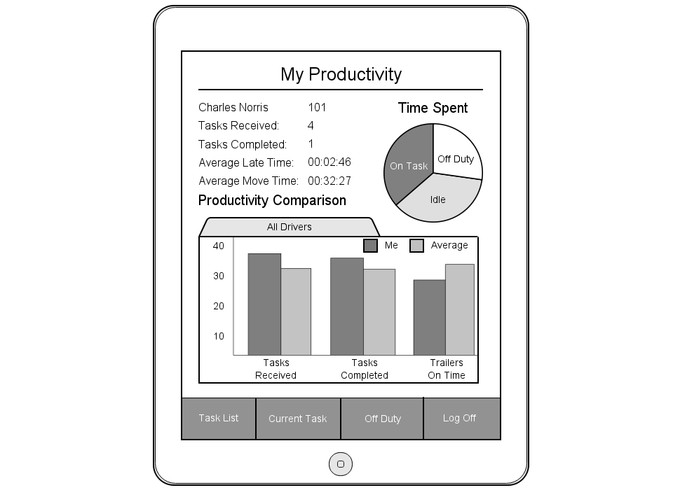

1

2

3

4

5

6

7

8

9

10

11

12

13

14

15

16

17

18

19

20

|  |  |  |  |
| --- | --- | --- | --- |
| # | Type | Text | Functions/Notes |
| 1 | Label | My Productivity | Static |
| 2 | Label | Driver Name |  |
| 3 | Label | Tasks Received: | Static |
| 4 | Label | Tasks Completed: | Static |
| 5 | Label | Average Late Time: | Static |
| 6 | Label | Average Move Time: | Static |
| 7 | Label | Productivity Comparison | Static |
| 8 | Label | All Drivers | Static |
| 9 | Bar Chart |  | Fields: Tasks Received, Tasks Completed, Trailers On Time  Ryan  Graphical representation of the driver’s current stats for the day vs the average stats of all the drivers |
| 10 | Menu Option | Current Task | Takes user to current task view. If no current task, option is disabled |
| 11 | Menu Option | Task List | Takes user to Task List screen |
| 12 | Label | Driver’s number |  |
| 13 | Label | Number of tasks received today |  |
| 14 | Label | Number of tasks completed today |  |
| 15 | Label | Time Spent | Static |
| 16 | Label | Average late time for trailer deliveries for that day | HH:MM:SS |
| 17 | Label | Average time spent on a task for that day | HH:MM:SS |
| 18 | Pie Chart |  | Fields: On Duty, Off Duty, Idle  Pie Chart showing how the driver has spent his time that day |
| 19 | Menu Option | Off Duty | Prompt for confirmation, if OKAY time stamp off duty time and take user to off duty screen. If Cancel, return to screen. |
| 20 | Menu Option | Log Off | Prompt for confirmation, if OKAY time stamp off duty time and take user Log On screen. If Cancel, return to screen. |

Ryan

Reporting – Graeme McBriarty

Graeme

### Executive Dashboard

The executive reporting dashboard allows for a quick overview and access to all reporting options. The dashboard is heavily customizable, the visibility of any report quick view being editable, as well as the size/arrangement of the dashboard panels. The panels themselves show all the reports available for that category, as well as a list of overall daily statistics to quickly identify any issues or breakdowns.

It will also allow access to the report scheduler (Figure 4-3, P.59), which enables customized, filtered reports to be sent out on a consistent schedule.

#### Figure 4-1

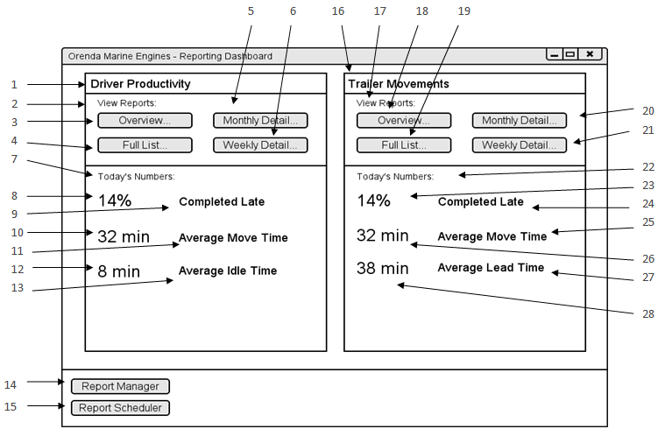

|  |  |  |  |
| --- | --- | --- | --- |
| # | Type | Text | Functions/Notes |
| 1 | Label | Driver Productivity | Report Title |
| 2 | Label | View Reports: |  |
| 3 | Button | Overview… | Brings up dialog to select reporting period, and to run or schedule report.  This report shows the overall statistics for all drivers selected in the time period selected. |
| 4 | Button | Full List… | Brings up dialog to select reporting period, and to run or schedule report.  This report shows all moves for the selected driver for the reporting period, subtotalled by week and month. |
| 5 | Button | Monthly Detail… | Brings up dialog to select reporting period, and to run or schedule report.  This report shows the average statistics for a selected driver by month, subtotalled by year. |
| 6 | Button | Weekly Detail… | Brings up dialog to select reporting period, and to run or schedule report.  This report shows the average statistics for a selected driver by week, subtotaled by month and year. |
| 7 | Label | Today’s Numbers: |  |
| 8 | Live Statistic Label | <Varies> | This label updates periodically based on live data. |
| 9 | Label | Completed Late |  |
| 10 | Live Statistic Label | <Varies> | This label updates periodically based on live data. |
| 11 | Label | Average Move Time |  |
| 12 | Live Statistic Label | <Varies> | This label updates periodically based on live data. |
| 13 | Label | Average Idle Time |  |
| 14 | Button | Report Manager | This button brings up the Report Manager screen, allowing the user to customize what is displayed on the dashboard, and other options associated with the reports. |
| 15 | Button | Report Scheduler | This button brings up the Report Scheduler screen, allowing the user to manage scheduled reports, add/update/remove/etc. |
| 16 | Label | Trailer Movements |  |
| 17 | Label | View Reports: |  |
| 18 | Button | Overview… | Brings up dialog to select reporting period, and to run or schedule report.  This report shows the overall statistics for all four docks in the time period selected. |
| 19 | Button | Full List… | Brings up dialog to select reporting period, and to run or schedule report.  This report shows all moves to and from a specific dock for the reporting period, subtotaled by week and month. |
| 20 | Button | Monthly Detail… | Brings up dialog to select reporting period, and to run or schedule report.  Graeme  This report shows the average statistics for a specific dock by month, subtotalled by year. |
| 21 | Button | Weekly Detail… | Brings up dialog to select reporting period, and to run or schedule report.  This report shows the average statistics for a specific dock by week, subtotalled by month and year. |
| 22 | Label | Today’s Numbers: |  |
| 23 | Live Statistic Label | <Varies> | This label updates periodically based on live data. |
| 24 | Label | Completed Late |  |
| 25 | Label | Average Move Time |  |
| 26 | Live Statistic Label | <Varies> | This label updates periodically based on live data. |
| 27 | Label | Average Lead Time |  |
| 28 | Live Statistic Label | <Varies> | This label updates periodically based on live data. |

### Report Dashboard Manager

The report manager will show a list of all reports, with options to add the quick view panel to the dashboard. The visibility of each individual report from a category is also customizable. From this screen, each report can be run (JGRC-5001, P.135) or scheduled (JGRC-5002, P.137).

#### Figure 4-2

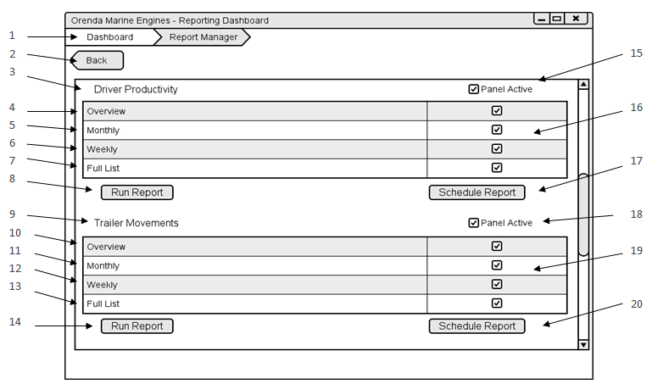

Graeme

|  |  |  |  |
| --- | --- | --- | --- |
| # | Type | Text | Functions/Notes |
| 1 | Breadcrumb Menu | Dashboard > Report Manager | The user can click on the relevant breadcrumb and be brought back to that view. |
| 2 | Button | Back | Brings the user back one page. |
| 3 | Label | Driver Productivity |  |
| 4 | Label | Overview |  |
| 5 | Label | Monthly |  |
| 6 | Label | Weekly |  |
| 7 | Label | Full List |  |
| 8 | Button | Run Report | Runs the selected report for that subsection. |
| 9 | Label | Trailer Movements |  |
| 10 | Label | Overview |  |
| 11 | Label | Monthly |  |
| 12 | Label | Weekly |  |
| 13 | Label | Full List |  |
| 14 | Button | Run Report | Runs the selected report for that subsection. |
| 15 | Check box | Panel Active | Determines if the panel containing that report is visible from the dashboard |
| 16 | Check boxes |  | Determines if each corresponding report is available to be run. |
| 17 | Button | Schedule Report | Brings up the report scheduling dialog, and allows the user to schedule a report. |
| 18 | Check box | Panel Active | Determines if the panel containing that report is visible from the dashboard |
| 19 | Check Boxes |  | Determines if each corresponding report is available to be run. |
| 20 | Button | Schedule Report | Brings up the report scheduling dialog, and allows the user to schedule a report. |

### Report Scheduler

The report scheduler allows the user to manage, edit, and view all the currently scheduled reports as well as schedule new reports. The view shows the name of the report, the frequency, the dates or days of the week, and the users to whom the reports will be sent.

If a report is added to the schedule from the report scheduler, then the report must be selected from the list. However, if the report is scheduled from a report view, or a view other than the report scheduler, then it is automatically populated into the report selection list. Editing a report uses an identical interface, for ease of operation (Figure 4-4, P.60).

Scheduled reports allow an increase in efficiency for the reporting process. Reports are simple to create in the first place, and a regularly scheduled report directly to the executive inbox is easy, convenient, and doesn’t require any additional effort.

Graeme

#### Figure 4-3

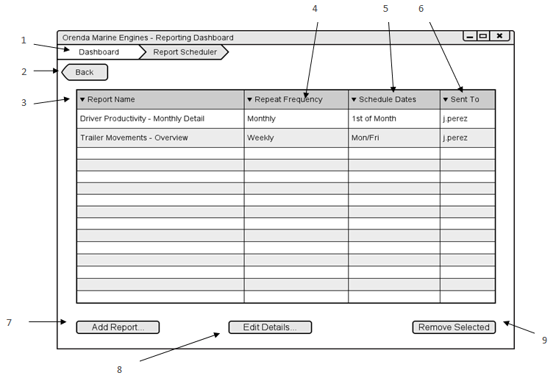

|  |  |  |  |
| --- | --- | --- | --- |
| # | Type | Text | Functions/Notes |
| 1 | Breadcrumb Menu | Dashboard > Report Scheduler | The user can click on the relevant breadcrumb and be brought back to that view. |
| 2 | Button | Back | Brings the user back one page. |
| 3 | Grid Column | Report Name | Displays the title of the report. If clicked, sorts alphabetically. |
| 4 | Grid Column | Repeat Frequency | Shows how often the report is repeated. |
| 5 | Grid Column | Schedule Dates | Shows the relative dates or days of the week that the report is scheduled for. |
| 6 | Grid Column | Sent To | Shows the user IDs of who the report gets sent to. |
| 7 | Button | Add Report… | Opens up the add report dialog, allowing the user to schedule a report. |
| 8 | Button | Edit Details… | Opens the edit report dialog. Essentially the add report dialog, but with the selected report details prepopulated. |
| 9 | Button | Remove Selected | Removes the selected report from the schedule. |

Graeme

#### Figure 4-4

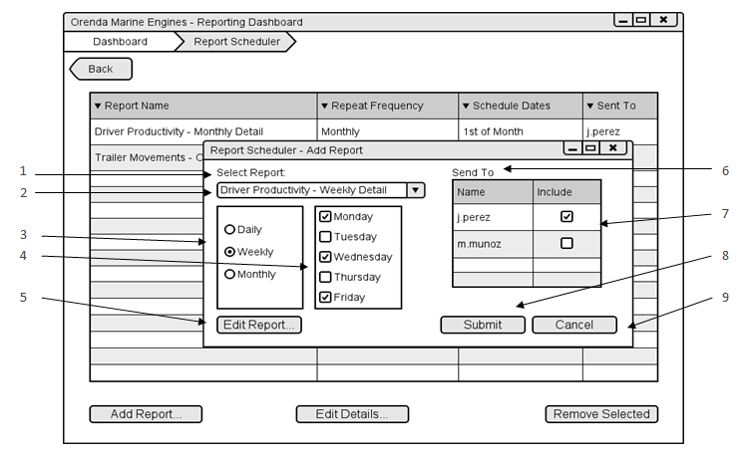

|  |  |  |  |
| --- | --- | --- | --- |
| # | Type | Text | Functions/Notes |
| 1 | Label | Select Report |  |
| 2 | Combobox | <Varies – Report names> | Combobox of all available reports, arranged in a tree structure |
| 3 | Radio Buttons | Daily/Weekly/Monthly | Repeating period for the report, changes the controls in #4. |
| 4 | Check Boxes or Date picker | <Varies – Dates, weekdays, or times> | Varies depending on #3, lets the user pick the days, times, or dates that the report will send in the repeating period.  Graeme |
| 5 | Button | Edit Report… | Brings the user to a modified Report view, where they can select filters for the scheduled report. |
| 6 | Label | Send To |  |
| 7 | Check Boxes | <Varies – User Names> | Lists the usernames of anyone with permission to receive the report. |
| 8 | Button | Submit | Closes the dialog, and saves the scheduled report to the system. |
| 9 | Button | Cancel | Closes the dialog, and does not save the report. |

### Report View

The report view screen shows the paged report, with a panel of relevant filters. There is a filter for each parameter of the report. From this view a report can be exported, either printed or as a file.

#### Figure 4-5

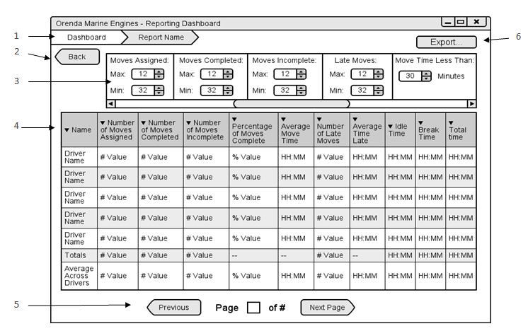

|  |  |  |  |
| --- | --- | --- | --- |
| # | Type | Text | Functions/Notes |
| 1 | Breadcrumb Menu | Dashboard > <Report Name> | The user can click on the relevant breadcrumb and be brought back to that view. |
| 2 | Button | Back | Brings the user back one page. |
| 3 | Filter Panel | <Varies> | Depending on the report, there will be a list of relevant filters and selection criteria. Each column on the report and each parameter will have a default value, but they will be all searchable, selectable, and modifiable. |
| 4 | Report View | <Varies> | Column-based view of the chosen report, columns vary depending on report chosen. |
| 5 | Page Selection | Previous, Page <Current> of <Total>, Next | Page selection, shows the current page, the total number of pages, and buttons for the next and previous page (disabled if at start or end). The current page is also a text entry field, to allow the user to jump to any given page at will. |
| 6 | Button | Export… | Brings up a dialog for export options, including printing, and exporting as a file (XLS, PDF, etc).  Graeme |

### Driver Productivity

The driver productivity report shows an overall view for each driver, averaged over the reporting period. This report also includes the totals and averages across all drivers.

This report can be sorted for each metric, and used as a tool to identify an overall comparison for each driver against the average.

#### Figure 4-6

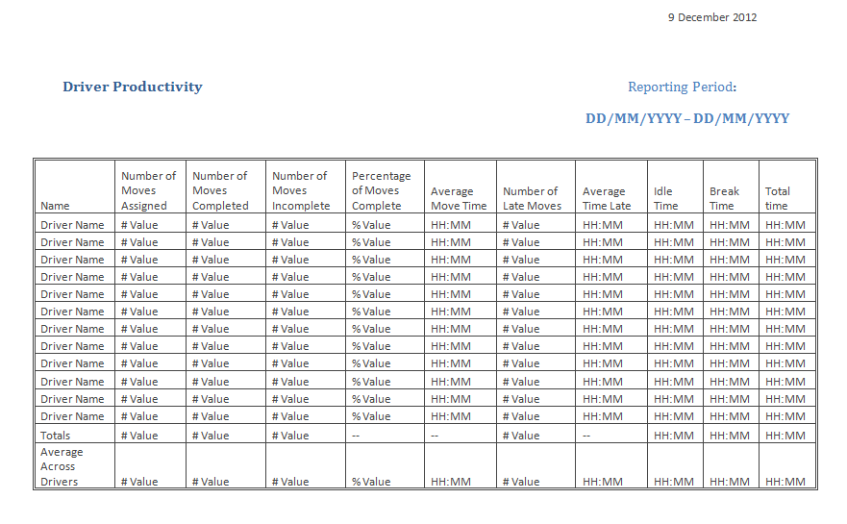

### Driver Productivity – Individual

This report allows a detailed view of a driver’s movements and statistics. Each move is listed, along with weekly summaries and averages, as well as monthly of the same.

Graeme

#### Figure 4-7

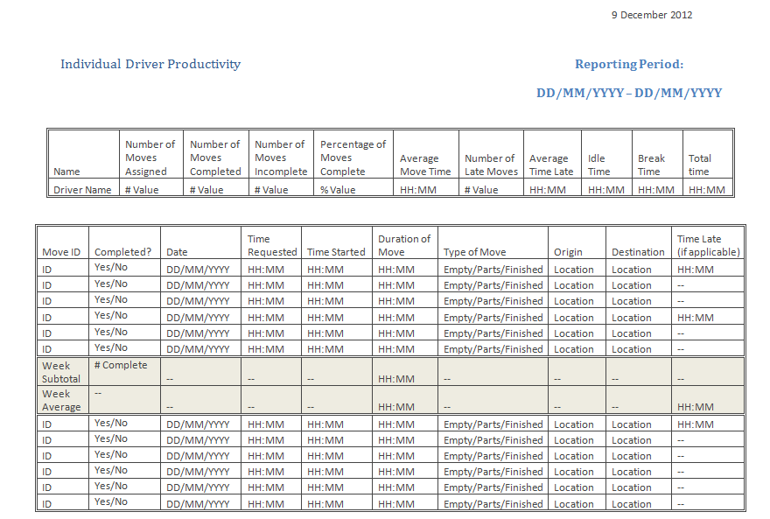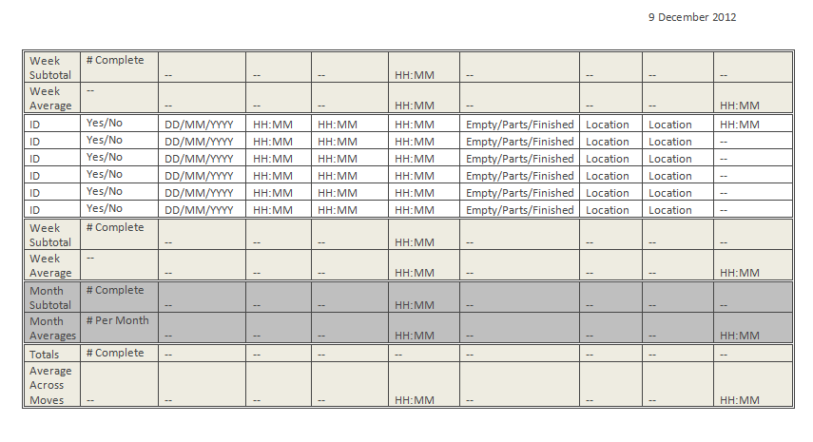

Graeme

### Driver Daily, Weekly, and Monthly Detail

In addition to the individual report, there are daily, weekly and monthly breakdowns, which will serve to show the driver’s behavior over a longer period of time. Reporting over a longer and longer time periods begins to get unwieldy with the individual reports, as there are many hundreds of moves involved. These reports let broad trends over time be tracked.

#### Figure 4-8

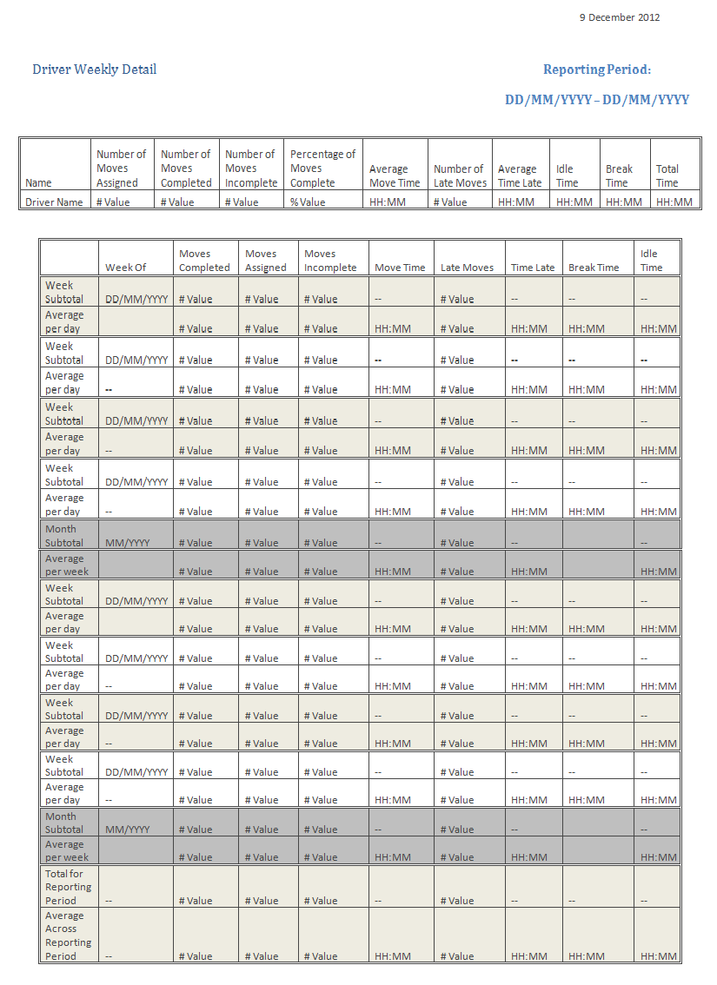

Graeme

### Trailer Movements

This report is similar to the driver productivity report, but its metrics are tied to the docks overall, rather than to individual drivers. This report would be useful for isolating problems stemming from requests, rather than from driver responses.

#### Figure 4-9

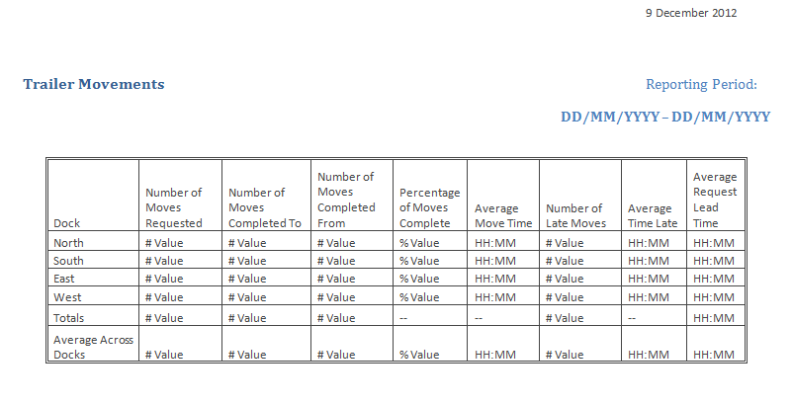

Graeme

### Trailer Movements by Dock

As the Individual Driver Productivity report shows all moves for the driver, this report shows all movements to and from any selected dock.

#### Figure 4-10

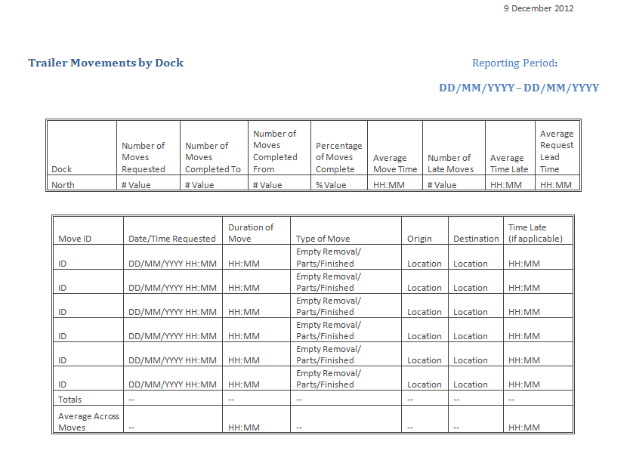

### Trailer Movements Daily, Weekly, and Monthly Details

A similar detailed view, these reports will track the trends of movements to and from the selected dock over the reporting period.

Graeme

#### Figure 4-11

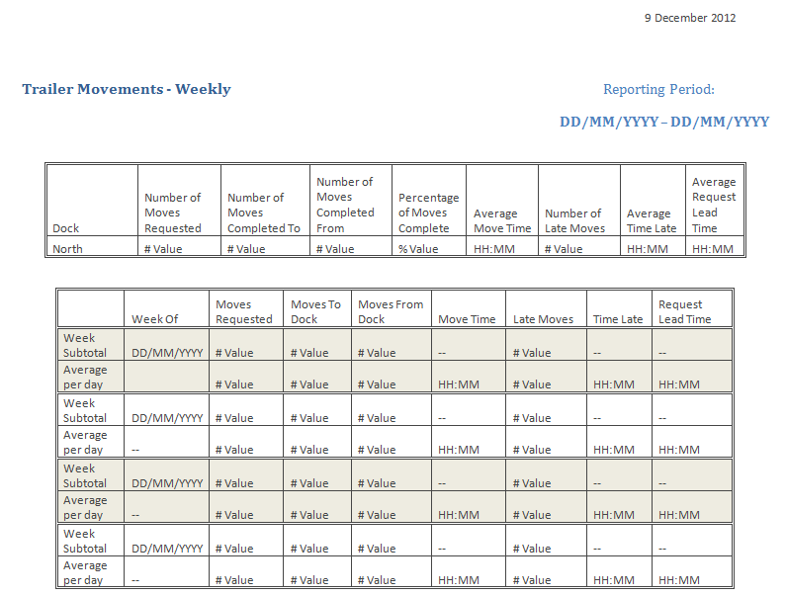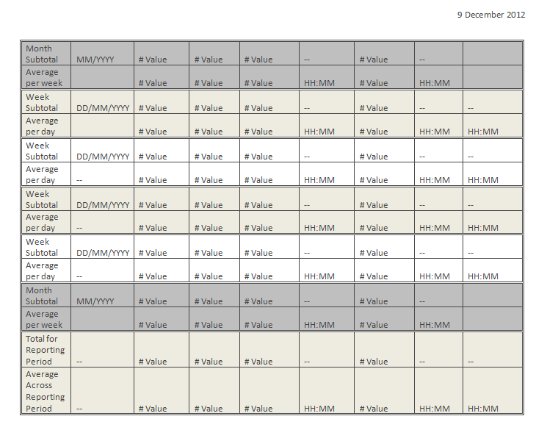

Graeme

### Dock Statistics

This report is an alternate way of viewing movements to and from the docks. It focuses on the requests originating from the docks themselves, rather than the trailer movements to and from.

#### Figure 4-12

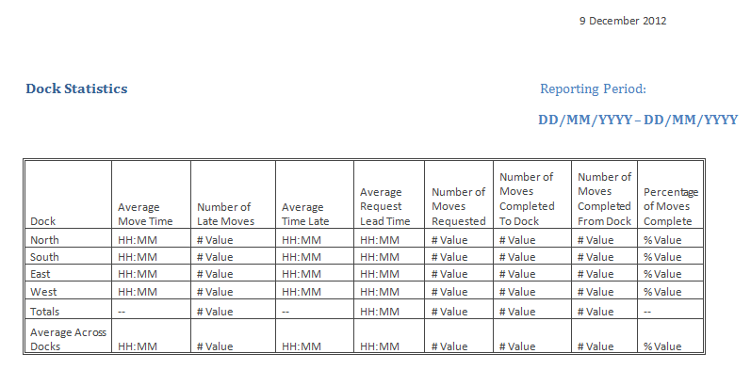

### Arrivals and Departures

The arrivals and departures report is tied into the order and inventory management. It tracks the arrivals of orders based on the Purchase Order number, and if there is an associated departure, then this is indicated along with the Bill of Lading number and departure time.

Graeme

#### Figure 4-13

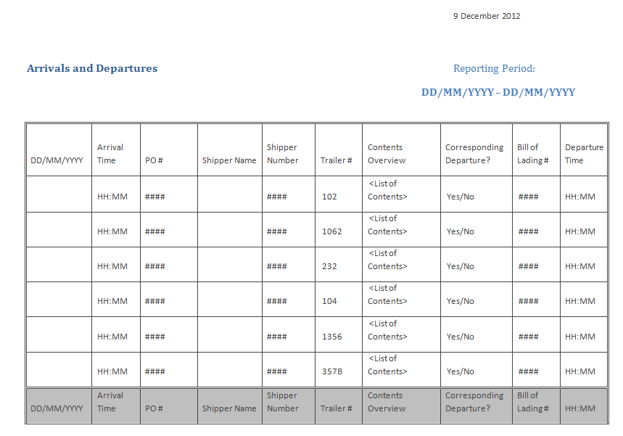

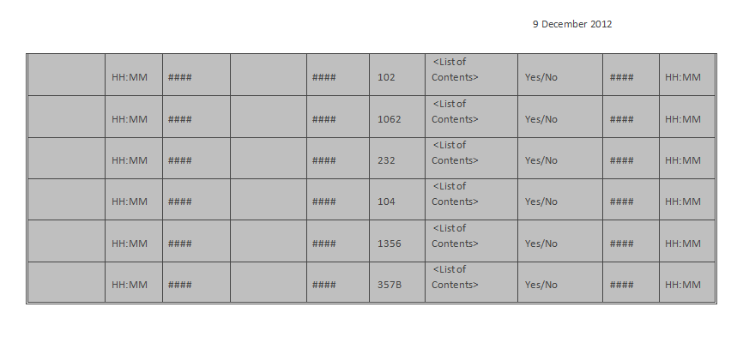

Graeme

Implementation Plan

The implementation of the project will be geared towards rapid development, continual feedback, and a combination of guided and self-directed training. It will begin with simultaneous development and quality assurance phases. During these there will be a focus on deliverable, working sections of the project (instead of documents and graphs) and constant feedback between the client, the QA team, and the developers.

The implementation and deployment on site will also be focused on convenience. All the hardware and infrastructure that the client requires will be put in place as development is coming to a close, overlapping with the final stages, so there is no wait to deploy the software when it is finished.

Training will be provided in guided sessions, and a test/training database will be put in place for actual, hands-on training with the live software. There will also be documents provided if any users wish to take the initiative and learn on their own time, the system with the test data will stay in place until final activation.

Graeme

The final stage of the deployment will take place after a team of data entry specialists ensure that the live system accurately reflects the state of Orenda, and all relevant data is entered into the system.

#### Figure 5-1

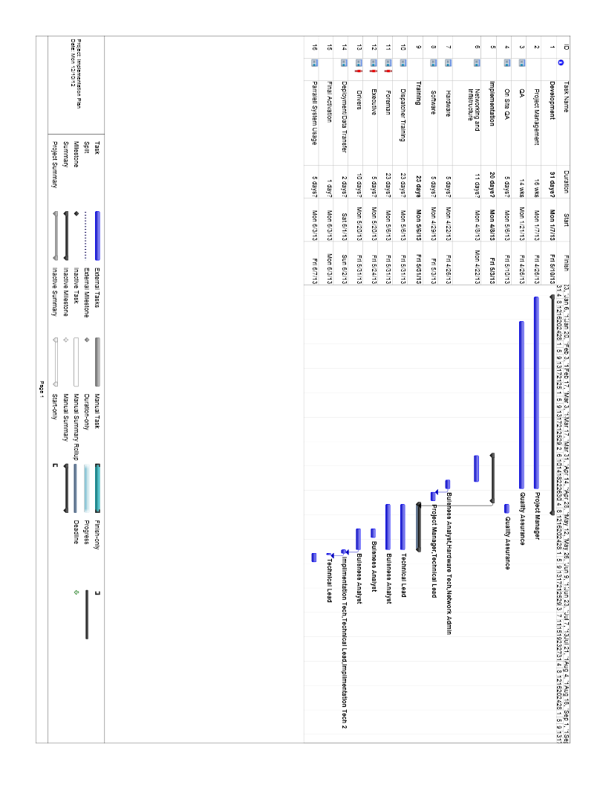

Graeme

### Development and Quality Assurance

The development phase is the first section of the project to begin after this analysis is completed. This phase will be enacted by the team of three developers and the technical lead. The project manager will also be heavily involved in this phase, overseeing the developer’s actions. The team will be using the Agile development methodology, which benefits the client in that working sections will be demoed, rather than flat documents, and there will be weekly updates to the client on the progress, if they so desire.

Quality assurance begins after two weeks of development, when the developers have their software set up and have begun to produce a sufficiently large body of testable code. The QA team will work closely with the developers, providing feedback to ensure a quality product, and to enable any potential issues to be identified before they can become a problem.

### Implementation – Infrastructure, Hardware and Software

During the last three weeks of QA, the implementation phase will begin. The first two weeks of the phase will be the network installation. It will be installed in parallel with the current network, so that no conflict or outages will occur. The network installation will be outsourced to a fibre installation company, who will lay the fibre backbone between buildings and to the blanket wireless access points, as well as wiring the network drops in the buildings and installing the switches.

Graeme

The following week will be the hardware installation and configuration. The server and the new workstations, as well as the executive laptops will all be brought on site, and installed where applicable. The fourth week of the implementation phase will be dedicated to software installation and configuration, as the new TTCS will be finished development, and the QA phase will have completed alongside the hardware installations. Mock data is entered at this time into a test database, for the training sessions. Again, as this is on entirely new hardware, there will be no outages to the current system.

### Training

The week after the system software is in place with mock data, training will begin. This will be a one month period that will cover all employees, while the new system remains running with mock data. Each dispatcher will receive two weeks of training, consecutively. This will consist of one hour sessions either before or after the dispatcher’s shift (up to their discretion). The dock foremen will be trained for a week each, in a similar schedule to the dispatchers. The system will also be running live while training is occurring, so that the dispatchers and dock foremen can use the system with the training documentation on their own time.

The QA team will be available during the first week to gather feedback from the training team. They will be conducting user acceptance testing during this time.

During the last two weeks of the training period, the executives and drivers will receive their training. The executives will receive one week of training each, as the reporting system is very minimal and easy to use. The drivers will each receive two hours of training over the course of two weeks. One hour per day for each driver, and training three drivers each day. Four days out of each week will be required to train all twelve drivers.

### Deployment

The final deployment will be over the course of a week. The weekend following training will cover the data transfer. All data on the suppliers, anything relevant from the previous system, and the information for creating user accounts will have been gathered. A data entry team will be provided this information to populate the TTCS. They will also enter the current state of the lot and any other information that would have been fluid until the end of operations into the TTCS, to be activated on Monday morning.

The revised TTCS and the old system will run in parallel for one week’s time, and for that week there will be technical leads and developers on site and on call to address any issues with the changeover. After this week, it will be up to Orenda’s discretion to phase out, deactivate, and remove the previous system.

### Plan Summary

This plan is one that involves the client every step of the way, providing feedback and updates. It focuses on real deliverables and quality service. Redundancies and inefficiency with time is eliminated by staggering and overlapping the phases. With quick but in-depth, as well as self-led training, the system will be able to be used at peak efficiency in little time. And with no interruptions to the regular operations of the facility, the transition can be a smooth and effective one.

Graeme

Hardware

### OptiPlex 3010 Mini Tower

|  |  |
| --- | --- |
| **Part** | **Name** |
| **PROCESSOR** | Intel® Pentium® Processor G645 (3M Cache, 2.90 GHz, w/HD Graphics) |
| **OPERATING SYSTEM** | Windows 7 Home Premium, No Media, 32-bit, English |
| **OFFICE SOFTWARE** | Microsoft® Office Trial |
| **MEMORY** | 2GB, NON-ECC, 1600MHZ DDR3,1DIMM |
| **OPTICAL DRIVE** | 16X DVD-ROM SATA, Data Only |
| **HARD DRIVE** | 250GB 3.5" SATA 3.0Gb/s and 8MB DataBurst Cache™ |
| **GRAPHICS** | Intel® Integrated Graphics w/Single HDMI/VGA |
| **SUPPORT PLAN** | 3 Year Basic Hardware Service with 3 Year NBD Limited Onsite Service After Remote Diagnosis |
| **KEYBOARD** | Dell KB212-B USB 104 Quiet Key Keyboard,English |
| **SECURITY SOFTWARE** | Trend Micro Worry-Free Business Security Services, 30-days |
| **BASE/ POWER SUPPLY** | OptiPlex 3010 Minitower for Standard Power Supply |
| **SPEAKERS** | Internal Dell Business Audio Speaker |
| **MOUSE** | Dell MS111 USB Optical Mouse |
| **POWER SUPPLY** | OptiPlex 3010 Minitower w/ Standard PSU |
| **THERMALS** | Heat Sink, Mainstream, Minitower |
| **SYSTEM DOCUMENTATION** | Documentation English and French |

### Dell Professional P1913 19" Monitor with LED

|  |  |
| --- | --- |
| **Part** | **Name** |
| **Diagonally Viewable Size** | 48.26 cm  19 Inches (19-inch wide viewable image size) |
| **Aspect Ratio** | Widescreen (16:10) |
| **Panel Type** | TN (Twisted Nematic), anti glare with hard coat 3H |
| **Optimal resolution** | 1440 x 900 at 60 Hz |
| **Contrast Ratio** | 1000: 1 (typical)  2 Million:1 (Max) (Dynamic Contrast Ratio) |
| **Brightness** | 250 cd/m2 (typical) |
| **Response Time** | 5 ms (back to white) |
| **Max Viewing Angle** | (160° vertical / 170° horizontal) |
| **Color Support** | 16.7 million colors |
| **Pixel Pitch** | 0.248 mm  Corey |
| **Panel Backlight** | LED |
| **Display Type** | Widescreen Flat Panel Display |
| **Connectivity** | 1 Digital Visual Interface connectors (DVI-D) with HDCP  1 Video Graphics Array (VGA)  1 DisplayPort (version 1.2)  1 USB 2.0 upstream port  2 USB 2.0 downstream ports)  DC power connector for Dell Soundbar (AX510 only) |

### PowerEdge T320

|  |  |
| --- | --- |
| **Part** | **Name** |
| **Chassis Configuration** | Chassis with up to 8, 3.5" Hot-Plug Hard Drives and Embedded SATA |
| **Processor** | Intel® Xeon® E5-2420 1.90GHz, 15M Cache, 7.2GT/s QPI, Turbo, 6C, 95W, Max Mem 1333MHz |
| **Memory Configuration Type** | Performance Optimized |
| **Memory DIMM Type and Speed** | 1333 MHz UDIMMs |
| **Memory Capacity** | 4GB UDIMM, 1333 MT/s, Low Volt, Dual Rank, x8 Data Width |
| **Operating System** | Windows Server 2008 R2 SP1, Standard Edition,x64, Includes 5 CALS |
| **OS Media Kits** | Windows Server®2008SP2,Standard ED, x86/x64,Downgrade Media |
| **RAID Configuration** | SW RAID 5 for S110 (3-4 SATA/SATA SSD HDDs) |
| **RAID Controller** | Software RAID (for Microsoft OS Only) |
| **Hard Drives** | 500GB 7.2K RPM SATA 3Gbps 3.5in Hot-plug Hard Drive x3 |
| **Embedded Systems Management** | Basic Management |
| **Add-in Network Adapter** | On-Board Dual Gigabit Network Adapter |
| **Power Supply** | Single, Cabled Power Supply , 350W |
| **Power Cords** | NEMA 5-15P to C13 Wall Plug, 125 Volt, 15 AMP, 10 Feet (3m), Power Cord |
| **Power Management BIOS Settings** | Power Saving Dell Active Power Controller |
| **Rack Rails and Casters** | Tower Chassis, No Casters |
| **System Documentation** | Electronic System Documentation and OpenManage DVD Kit |
| **Server Accessories** | Keyboard and Optical Mouse, USB, Black, English, with 17 LCD Monitor |
| **Hardware Support Services** | 3Yr Basic Hardware Warranty Repair: 5x10 HW-Only, 5x10 NBD Onsite |

Corey

### NetGear Ultra 4 Network Attached Storage

|  |  |
| --- | --- |
| **Part** | **Name** |
| **Processor Brand** | Intel |
| **Processor Class** | Atom |
| **Processor Speed** | 1.66 GHz |
| **Dimensions** | 5.28 x 8.07 x 8.78 in |
| **Memory Type** | DDR2 |
| **Total Memory** | 1 GB |
| **USB Ports (Total)** | 3 |
| **RJ-45 Ports** | 2 |
| **Interface Type** | Gigabit Ethernet |
| **Data Transfer Rate** | 80 Mbps |
| **Compatible RAID Levels** | RAID 0, 1, 5 |
| **Number Of Hard Drives Bays** | 4 |

### HP EliteBook 2570p Notebook PC

|  |  |
| --- | --- |
| **Part** | **Name** |
| **Operating system** | Windows 7 Professional 64bit |
| **Processor** | Intel® Core™ i3-3120M (2.50 GHz, 3 MB L3 cache, 2 cores) |
| **Chipset** | Mobile Intel® QM77 Express |
| **Environmental** | BFR/PVC-free |
| **Weight** | Starting at 3.6 lb (Starting at 1.63 kg) |
| **Dimensions (W x D x H)** | 12.02 x 8.23 x 1.08 in (30.5 x 20.9 x 2.7 cm) |
| **Memory, maximum** | 16 GB 1600 MHz DDR3 SDRAM |
| **Memory slots** | 2 SODIMM |
| **Internal drive** | SATA II (7200 rpm) 500 GB |
| **Optical drive** | DVD+/-RW SuperMulti DL; DVD-ROM |
| **Display** | 12.5" diagonal LED-backlit HD anti-glare (1366 x 768) |
| **Graphics** | Integrated Intel® HD Graphics 4000 |
| **Ports** | 1 USB 3.0 1 USB 2.0 charging 1 eSATA/USB 2.0 combo 1 combo stereo headphone/mic jack 1 AC power 1 RJ-11 1 RJ-45 1 docking connector 1 1394a 1 DisplayPort 1.1a 1 VGA  Graeme |
| **Slots** | 1 Express Card/34 1 Secure Digital |
| **Audio** | SRS Premium Sound PRO; Integrated stereo speakers; Integrated dual-microphone array; Combo headphone/microphone jack |
| **Keyboard** | Spill-resistant keyboard and drain |
| **Input devices** | Touchpad with on/off button, two-way scroll, gestures, two pick buttons; Pointstick with two additional pointstick buttons |
| **Network interface** | Integrated Intel 82579LM Gigabit Network Connection (10/100/1000) |
| **Wireless** | Broadcom 802.11a/b/g/n HP Integrated Module with Bluetooth 4.0+ EDR |
| **Energy efficiency** | ENERGY STAR® qualified configurations available; EPEAT® where HP registers commercial desktop products. See www.epeat.net for registration status in your country. |
| **Power supply** | 65W Smart AC adapter; HP Fast Charge (not supported on 9-cell battery) |
| **Battery  type** | 6-cell (62 WHr) Li-Ion |
| **Battery life** | 6-cell (62 WHr) Li-Ion: Up to 9 hours and 15 minutes |
| **Security management** | Standard: HP Client Security (Windows 8 only) HP ProtectTools TPM Embedded Security Chip 1.2 Drive Encryption Smart Card Reader Credential Manager Password Manager One Step Logon Face Recognition SpareKey Device Access Manager w/ JITA Security lock slot Optional: Microsoft Defender (Windows 8 only, includes Microsoft Security Essentials) Microsoft Security Essentials HP Fingerprint Sensor HP Privacy Filter HP Combo Lock  Graeme |

### HP 2570p Docking Station

|  |  |
| --- | --- |
| **Part** | **Name** |
| **Ports** | 1 eSATA; 4 USB (3 USB 3.0, 1 USB 2.0 powered); 1 DisplayPort 1.2; 1 VGA; 2 Audio (Audio in, audio out (does not support mic out)); 1 LAN/Ethernet jack |
| **Power requirements** | Energy-efficient 65W Smart AC adapter |
| **Product dimensions (W x D x H)** | 14.1 x 4.8 x 2 in |
| **Security management** | HP Lock (Lock not included) |
| **Manufacturer Warranty** | HP Ultra-light Docking Stations are supported by a one-year limited warranty. Additional support is available 24 hours a day, seven days a week by phone as well as online support forums. NOTE: Certain restrictions and exclusions apply. Consult the HP Customer Support Center for details. |
| **Weight** | 2.04 lb / 0.93 kg |

### TrippLite SMARTPRO® Series - SMART3000NET

|  |  |
| --- | --- |
| **Part** | **Name** |
| **Output Volt Amp Capacity (VA)** | 3000 |
| **Output kVA capacity (kVA)** | 3 |
| **Output Watt Capacity (watts)** | 2400 |
| **Output kW capacity** | 2.4 |
| **Output power factor** | 0.8 |
| **Nominal Output Voltage(s) Supported** | 120V |
| **Frequency compatibility** | 60 Hz |
| **Output voltage regulation (line mode)** | -13% / +5% |
| **Output voltage regulation (Battery mode)** | +/- 5% |
| **Built-in UPS output receptacles** | 4 5-15R outlet(s); 4 5-15/20R outlet(s) |
| **Built-in controllable switched load banks** | Three switchable single-outlet 5-15R load banks |
| **Output circuit breaker** | 15A branch rated (x2) - each breaker protects 4 outlets |
| **Output AC waveform (AC mode)** | Sine wave |
| **Output AC waveform (battery mode)** | PWM sine wave |
| **Rated input current (at maximum load)** | 22A |
| **Nominal Input Voltage(s) Supported** | 120V AC  Graeme |
| **UPS input connection type** | L5-30P |
| **UPS Input cord length (ft.)** | 8 |
| **UPS Input cord length (m)** | 2.4 |
| **Recommended Electrical Service** | 30A 120V |
| **Input cord length (ft.)** | 8 |
| **Full load runtime (minutes)** | 7 min. (2400w) |
| **Half load runtime (minutes)** | 23 min. (1200w) |
| **Expandable battery runtime** | Extended runtime supported via optional external battery packs |
| **External battery pack compatibility** | BP24V28-2U (limit 1); BP24V70-3U (multi-pack compatible) |
| **DC system voltage (VDC)** | 24 |
| **Battery recharge rate (included batteries)** | Less than 9 hours from 10% to 90% |
| **Transfer time** | 2-4 milliseconds |
| **Low voltage transfer to battery power (setpoint)** | 87 |
| **High voltage transfer to battery power (setpoint)** | 140 |
| **Product Warranty Period (Worldwide)** | 2-year warranty, 3 year with [registration](http://www.tripplite.com/en/support/Product-Warranty-Step-1.cfm). Note: [registration](http://www.tripplite.com/en/support/Product-Warranty-Step-1.cfm) is required for 3-year warranty. |
| **Connected Equipment Insurance (U.S., Canada & Puerto Rico)** | $250,000 [Ultimate Lifetime Insurance](http://www.tripplite.com/en/support/insurance-coverage-and-claims.cfm) |

### Xerox WorkCentre 6015

|  |  |
| --- | --- |
| **Part** | **Name** |
| **Standard functions** | Copy, Email, Fax, Print, Scan |
| **Print speed** | Color: up to 12 ppm Black: up to 15 ppm |
| **Connectivity** | 10/100BaseTX Ethernet, USB 2.0, Wi-Fi |
| **Document handler** | Automatic Document Feeder Capacity: 15 sheets  Graeme |
| **Output capacity** | 100 sheets |
| **Two-sided output** | Manual |
| **Fax features** | Auto redial, Auto reduction, Delayed fax, Junk fax barrier, Last number redial, Memory receive, Polling*  * - Analog phone line required. |
| **Scan destinations** | Scan to USB, Scan to email, Scan to network |
| **Security features** | IPv6 |
| **Duty cycle** | Up to 30,000 images/month1 |
| **Recommended monthly print volume** | Up to 1,500 pages |
| **Warranty** | One-year Quick Exchange, Xerox Total Satisfaction Guarantee |

### Printing

|  |  |
| --- | --- |
| **Part** | **Name** |
| **First-page-out time, printing** | As fast as 17 seconds color / 14 seconds black and white |
| **Maximum print resolution** | 1200 x 2400 dpi |
| **Processor** | 295 MHz |
| **Print memory (standard)** | 128 MB standard |
| **Page Description Languages (PDL)** | Host-based |
| **Print features** | Black and white only print mode, Built-in support links, Collation, Custom page size, Draft mode, Fit-to-page, N-up, Poster printing, Run Black, Scaling, Watermarks |

### Terminals – Samsung Galaxy Tab 2 7.0

|  |  |
| --- | --- |
| **Part** | **Name** |
| Operation System | Android 4.0 (Ice Cream Sandwich) |
| Browser | Android 4.0 (Ice Cream Sandwich) |
| Display | 178mm (7") 1024 x 600 (WSVGA) PLS TFT LCD |
| Capacity | 8 GB Micro SD card slot supports up to 32GB |
| Processor | 1GHz Dual Core Processor |
|  |  |
| Camera Resolution | 3 Megapixel Rear Camera |
| Flash | N/A |
| Auto Focus | Yes  Graeme |
| Shot mode | 3 Shot Modes available |
| Photo Effects | 3 Photo Effects available |
| White Balance | N/A |
|  |  |
| Video player | AVI, DIVX, FLV, MKV, MP4, WEBM, WMV |
| Video recording | Yes |
| Video Messaging | No |
| Input Device | Touch Input |
|  |  |
| Music Player | AAC, AAC+, AC-3, EAAC+, FLAC, MP3, OGG, WMA |
| Polyphonic Ringtones | Yes |
| MP3 Ringtone | Yes |
| DRM | DRM Available (OMA v1.0 FL) |
| 3D Sound Technology | N/A |
| Music Library | Yes |
|  |  |
| Email | Yes |
| SMS, EMS, MMS | SMS, MMS, Video messaging supported |
| T9 Predictive Text | Yes |
| vCard / vCalendar | No |
| Instant Messaging | Yes |
|  |  |
| Bluetooth | BT 3.0 |
| USB | 2.0 High Speed (USB 2.0 Host) |
| Internet HTML Browser | Yes |
| SyncML (DM) | Yes |
| WAP | N/A |
| AGPS | No |
| TV-Output | N/A |
|  |  |
| Battery | Yes, Rechargable via USB |
|  |  |
| Dimensions | 193 x 122 x 10.4mm |
| Weight | 344g |

**Specifications Not Available**

* Seagate 500gb HDD x 3
* Cisco Catalyst switch 3750

Ryan

Costs/Benefits – Ryan Vaughan

### Costs

#### Figure 7-1

|  |  |  |  |  |  |  |
| --- | --- | --- | --- | --- | --- | --- |
|  | **YEAR 0** |  |  | **YEAR 1** |  |  |
| **LABOUR TOTAL** | **156580** |  |  | **0** |  |  |
| **Position** | **# Hours** | **Cost/hr** | **Total** | **# Hours** | **Cost/hr** | **Total** |
| Project Manager | 680 | 50 | 34000 | 0 | 0 | 0 |
| Technical Lead | 704 | 30 | 21120 | 0 | 0 | 0 |
| Analyst/Architect | 672 | 30 | 20160 | 0 | 0 | 0 |
| Developer | 1920 | 30 | 57600 | 0 | 0 | 0 |
| Database Admin | 630 | 30 | 18900 | 0 | 0 | 0 |
| Implementation (Hardware) | 40 | 30 | 1200 | 0 | 0 | 0 |
| Implementation (Networking) | 500 | .36 | 4000 | 0 | 0 | 0 |
| Implementation (Software) | 32 | 30 | 960 | 0 | 0 | 0 |
| Training | 48 | 30 | 1440 | 0 | 0 | 0 |
| Network Admin | 40 | 30 | 1200 | 0 | 0 | 0 |
|  |  |  |  |  |  |  |
|  | **YEAR 0** |  |  | **YEAR 1** |  |  |
| **MATERIAL TOTAL** | **1906.7** |  |  | **0** |  |  |
| **Position** | **Quantity** | **Cost/Per** | **Total** | **Quantity** | **Cost/Per** | **Total** |
| Tablet Cases | 12 | 29.95 | 359.4 | 0 | 0 | 0 |
| Tablet Mounts | 12 | 89.99 | 1079.88 | 0 | 0 | 0 |
| RFID ID Card | 12 | 5.62 | 67.44 | 0 | 0 | 0 |
| Docking Station | 2 | 199.99 | 399.98 | 0 | 0 | 0 |
|  | 0 | 0 | 0 | 0 | 0 | 0 |
|  | 0 | 0 | 0 | 0 | 0 | 0 |
|  | 0 | 0 | 0 | 0 | 0 | 0 |
|  | 0 | 0 | 0 | 0 | 0 | 0 |
|  |  |  |  |  |  |  |
|  |  |  |  |  |  |  |
|  | **YEAR 0** |  |  | **YEAR 1** |  |  |
| **HARDWARE TOTAL** | **24939.98** |  |  | **0** |  |  |
| **Position** | **Quantity** | **Cost/Per** | **Total** | **Quantity** | **Cost/Per** | **Total** |
| Server (Bundle) | 1 | 3676.75 | 3676.75 | 0 | 0 | 0 |
| Hard drive enclosure | 1 | 599.99 | 599.99 | 0 | 0 | 0 |
| Hard drive | 3 | 69.98 | 209.94 | 0 | 0 | 0 |
| UPS | 1 | 1019.99 | 1019.99 | 0 | 0 | 0 |
| Workstation | 6 | 451.75 | 2710.5 | 0 | 0 | 0 |
| Monitor | 8 | 179 | 1432 | 0 | 0 | 0 |
| Laptop | 2 | 949 | 1898 | 0 | 0 | 0 |
| Switch | 1 | 2798 | 2798 | 0 | 0 | 0 |
| Printer | 2 | 449.99 | 899.98 | 0 | 0 | 0 |
| Access Points | 5 | 1338.99 | 6694.95 | 0 | 0 | 0 |
| Fiber (per foot) | 500 | .36 | 180 | 0 | 0 | 0 |
| Driver Tablet | 12 | 249.99 | 2999.88 | 0 | 0 | 0  Ryan |

### Benefits

#### Figure 7-2.1

|  |  |  |  |  |  |  |
| --- | --- | --- | --- | --- | --- | --- |
|  | **YEAR 0** |  |  | **YEAR 1** |  |  |
| **LABOUR SAVINGS** | **0** |  |  | **167025** |  |  |
|  | **# Hours** | **Cost/hr** | **Total** | **# Hours** | **Cost/hr** | **Total** |
| Dispatcher Bill of Lading Entry | 0 | 0 | 0 | 637.5 | 35 | 22312.5 |
| Driver | 0 | 0 | 0 | 4080 | 30 | 122400 |
| Dispatcher Reporting Time | 0 | 0 | 0 | 255 | 35 | 8925 |
| Dispatcher Request Time | 0 | 0 | 0 | 382.5 | 35 | 13387.5 |
|  | 0 | 0 | 0 | 0 | 0 | 0 |
|  | 0 | 0 | 0 | 0 | 0 | 0 |
|  | 0 | 0 | 0 | 0 | 0 | 0 |
|  | 0 | 0 | 0 | 0 | 0 | 0 |
|  | 0 | 0 | 0 | 0 | 0 | 0 |

|  |  |  |  |  |  |  |  |  |
| --- | --- | --- | --- | --- | --- | --- | --- | --- |
| **YEAR 2** |  |  | **YEAR 3** |  |  | **YEAR 4** |  |  |
| **167025** |  |  | **167025** |  |  | **167025** |  |  |
| **# Hours** | **Cost/hr** | **Total** | **# Hours** | **Cost/hr** | **Total** | **# Hours** | **Cost/hr** | **Total** |
| 637.5 | 35 | 22312.5 | 637.5 | 35 | 22312.5 | 637.5 | 35 | 22312.5 |
| 4080 | 30 | 122400 | 4080 | 30 | 122400 | 4080 | 30 | 122400 |
| 255 | 35 | 8925 | 255 | 35 | 8925 | 255 | 35 | 8925 |
| 382.5 | 35 | 13387.5 | 382.5 | 35 | 13387.5 | 382.5 | 35 | 13387.5 |
| 0 | 0 | 0 | 0 | 0 | 0 | 0 | 0 | 0 |
| 0 | 0 | 0 | 0 | 0 | 0 | 0 | 0 | 0 |
| 0 | 0 | 0 | 0 | 0 | 0 | 0 | 0 | 0 |
| 0 | 0 | 0 | 0 | 0 | 0 | 0 | 0 | 0 |
| 0 | 0 | 0 | 0 | 0 | 0 | 0 | 0 | 0 |

|  |  |  |
| --- | --- | --- |
| **YEAR 5** |  |  |
| **167025** |  |  |
| **# Hours** | **Cost/hr** | **Total** |
| 637.5 | 35 | 22312.5 |
| 4080 | 30 | 122400 |
| 255 | 35 | 8925 |
| 382.5 | 35 | 13387.5 |
| 0 | 0 | 0 |
| 0 | 0 | 0 |
| 0 | 0 | 0 |
| 0 | 0 | 0 |
| 0 | 0 | 0 |

Ryan

#### Figure 7-2.2

|  |  |  |  |  |  |  |
| --- | --- | --- | --- | --- | --- | --- |
|  | **YEAR 0** |  |  | **YEAR 1** |  |  |
| **BUSINESS SAVINGS** | **0** |  |  | **120960** |  |  |
|  | **Quantity** | **Value** | **Total** | **Quantity** | **Value** | **Total** |
| Overdue Trailers | 0 | 0 | 0 | 12 | 3600 | 43200 |
| Phone Plan | 0 | 0 | 0 | 1 | 5760 | 5760 |
| Reduced work stoppage | 0 | 0 | 0 | 1 | 72000 | 72000 |
|  | 0 | 0 | 0 | 0 | 0 | 0 |
|  | 0 | 0 | 0 | 0 | 0 | 0 |
|  | 0 | 0 | 0 | 0 | 0 | 0 |
|  | 0 | 0 | 0 | 0 | 0 | 0 |
|  | 0 | 0 | 0 | 0 | 0 | 0 |
|  | 0 | 0 | 0 | 0 | 0 | 0 |

|  |  |  |  |  |  |  |  |  |
| --- | --- | --- | --- | --- | --- | --- | --- | --- |
| **YEAR 2** |  |  | **YEAR 3** |  |  | **YEAR 4** |  |  |
| **120960** |  |  | **120960** |  |  | **120960** |  |  |
| **Quantity** | **Value** | **Total** | **Quantity** | **Value** | **Total** | **Quantity** | **Value** | **Total** |
| 12 | 3600 | 43200 | 12 | 3600 | 43200 | 12 | 3600 | 43200 |
| 1 | 5760 | 5760 | 1 | 5760 | 5760 | 1 | 5760 | 5760 |
| 1 | 72000 | 72000 | 1 | 72000 | 72000 | 1 | 72000 | 72000 |
| 0 | 0 | 0 | 0 | 0 | 0 | 0 | 0 | 0 |
| 0 | 0 | 0 | 0 | 0 | 0 | 0 | 0 | 0 |
| 0 | 0 | 0 | 0 | 0 | 0 | 0 | 0 | 0 |
| 0 | 0 | 0 | 0 | 0 | 0 | 0 | 0 | 0 |
| 0 | 0 | 0 | 0 | 0 | 0 | 0 | 0 | 0 |
| 0 | 0 | 0 | 0 | 0 | 0 | 0 | 0 | 0 |

|  |  |  |
| --- | --- | --- |
| **YEAR 5** |  |  |
| **120960** |  |  |
| **Quantity** | **Value** | **Total** |
| 12 | 3600 | 43200 |
| 1 | 5760 | 5760 |
| 1 | 72000 | 72000 |
| 0 | 0 | 0 |
| 0 | 0 | 0 |
| 0 | 0 | 0 |
| 0 | 0 | 0 |
| 0 | 0 | 0 |
| 0 | 0 | 0 |

Ryan

### NPV/ROI

#### Figure 7-3

|  |  |  |  |  |  |  |  |  |  |  |  |  |  |  |
| --- | --- | --- | --- | --- | --- | --- | --- | --- | --- | --- | --- | --- | --- | --- |
| **Simple Net Present Value Calculator** | | | | | | | | | | | | | | |
| **Created by Chris London** | | | | | | | | | | | | | | |
| **OME TTCS** |  | | |  | |  | |  |  | |  | |  |
| **Discount Rate** | **15%** | | |  | |  | |  |  | |  | |  |
|  |  | | |  | |  | |  |  | |  | |  |
| **COSTS** | **Year** | | | | | | | | | |  | | | |
|  | **0** | **1** | **2** | | **3** | | **4** | | | **5** |  |
| Labour | 156,580 | 0 | 0 | | 0 | | 0 | | | 0 |  |
| Material | 1,907 | 0 | 0 | | 0 | | 0 | | | 0 |  |
| Hardware | 24,940 | 0 | 0 | | 0 | | 0 | | | 0 |  |
| Software | 0 | 0 | 0 | | 0 | | 0 | | | 0 |  |
| Miscellaneous | 0 | 0 | 0 | | 0 | | 0 | | | 0 |  |
| **COSTS** | 183,426.68 | 0.00 | 0.00 | | 0.00 | | 0.00 | | | 0.00 | **183,426.68** |
| **NPV FACTOR** | 1.000 | 0.870 | 0.756 | | 0.658 | | 0.572 | | | 0.497 |  |
| **ADJUSTED COST** | **183,426.68** | **0.00** | **0.00** | | **0.00** | | **0.00** | | | **0.00** | **183,426.68** |
|  |  |  |  | |  | |  | | |  |  |
|  |  |  |  | |  | |  | | |  |  |
| **BENEFITS** | **Year** | | | | | | | | | |  | | | |
|  | **0** | **1** | **2** | | **3** | | **4** | | | **5** |  |
| Sales | 0 | 0 | 0 | | 0 | | 0 | | | 0 |  |
| Labour | 0 | 167,025 | 167,025 | | 167,025 | | 167,025 | | | 167,025 |  |
| Technology Fees Savings | 0 | 0 | 0 | | 0 | | 0 | | | 0 |  |
| Miscellaneous | 0 | 0 | 0 | | 0 | | 0 | | | 0 |  |
| **BENEFITS** | 0.00 | 167,025.00 | 167,025.00 | | 167,025.00 | | 167,025.00 | | | 167,025.00 | **835,125.00** |
| **NPV FACTOR** | 1.000 | 0.870 | 0.756 | | 0.658 | | 0.572 | | | 0.497 |  |
| **ADJUSTED BENEFIT** | **0.00** | **145,239.13** | **126,294.90** | | **109,821.65** | | **95,497.09** | | | **83,040.94** | **559,893.71** |
|  |  |  |  | |  | |  | | |  |  |
|  |  |  |  | |  | |  | | |  |  |
| **NPV Adjusted Value** |  |  |  | |  | |  | | |  |  |
| **Benefits - Costs** | -183,426.68 | 145,239.13 | 126,294.90 | | 109,821.65 | | 95,497.09 | | | 83,040.94 |  |
| **Cumulative Value** | -183,426.68 | -38,187.55 | 88,107.35 | | 197,929.00 | | 293,426.08 | | | 376,467.03 |  |
|  |  |  |  | |  | |  | | |  |  |
| **DISCOUNTED ROI** | **305.2%** |  |  | |  | |  | | |  |  |
| **UNDISCOUNTED ROI** | 455.29% |  |  | |  | |  | | |  |  |

Ryan

Conclusion – Graeme McBriarty

Our proposal for the revised TTCS addressed every issue identified during the analysis process, either directly or indirectly. The breakdowns in communication are eliminated with the queued request based system. Robust reporting provides accountability, and the power to track down exactly where roadblocks or complete breakdowns in the system occur. The slow manual processes, such as data entry, have been eliminated or automated to increase efficiency.

The direct solutions deal mainly with communication and automation. Indirect solutions are the tools provided in reporting, to be able to solve the issues by knowing where they arise.

Graeme

Appendix A: Use Cases

### JGRC-1001 – Operation Hours Arrivals

|  |  |  |  |  |
| --- | --- | --- | --- | --- |
| **Author** | Corey Despres | | **Date** | Nov-11-2012 |
| **Version** | 2.0 | |  | |
| **Use Case Name** | Operation Hours Arrivals | | **Use Case Type:** | |
| **Use Case ID** | JGRC-1001 | | **Business Requirements**  **System Analysis** | |
| **Priority** | HIGH | |
| **Source** | Requirement | | | |
| **Primary Business Actor** | Dispatcher | | | |
| **Other Participating Actors** | Driver | | | |
| **Other Interested Stakeholders** | Dock Forman  Production Manager | | | |
| **Description** | This use case describes the event of a trailer arriving at the facility seeking admission. The dispatcher must verify the trailer and seal against the provided bill of lading as well as check for any other abnormalities. | | | |
| **Precondition(s)** | The trailer arrives at the facility | | | |
| **Trigger(s)** | The trailer arrives at the dispatch office | | | |
| **Typical Course of Events** | **Actor Action** | **System Response** | | |
| **Step 1**: The trailer arrives at the dispatch office  **Step 3**: The dispatcher requests the Bill of Lading  **Step 5**: The dispatcher compares the trailer number and the seal to the number on the bill of lading. As well as checks the trailer for any abnormalities. Then proceeds into the Dispatch Office and selects Log an Arrival  **Step 7**: The dispatcher enters the bill of lading number and submits  **Step 9**: Dispatcher compares the information on the B.O.L. to that on the screen. Then presses the admit button  **Step 11**: the dispatcher enters the Lot No. and submits  **Step 13**: the dispatcher informs the driver of which lot to put the trailer. | **Step 2**: none  **Step 4**: none  **Step 6**: A window is brought up requesting the Bill of Lading Number  **Step 8**: The system searches the database of electronically sent B.O.L for the matching number and displays the appropriate trailer screen.  **Step 10**: a window is brought up requesting a Lot No.  **Step 12**: The dispatcher is taken to the trailer list screen | | |
| **Alternate Courses** | **Actor Action** | **System Response** | | |
| **Step 9**: If the seal is broken or there are any abnormalities the dispatcher selects the “Report Issue” button | Step 10: a window is displayed with a spot for a reason, a Lot No. as well as a new Seal No. | | |
| **Conclusion** | The use case concludes when the trailer information in saved within the system | | | |
| **Postcondition** | The trailer is admitted and parked in the Parking area and the trailer information is entered into the system. | | | |
| **Business Rules** |  | | | |
| **Implementation Constraints and Specifications** | * Use Case must be available during normal operational hours * Frequency : It is estimated that the use case will be used approx. 65 times a day. | | | |
| **Assumptions** | * Bill of Lading is available * Bill of Lading was sent electronically * System is available * Dispatcher is at the office | | | |
| **Open Issues** | None | | | |

### JGRC-1002 – Non-Operational Hours Arrivals

|  |  |  |  |  |
| --- | --- | --- | --- | --- |
| **Author** | Corey Despres | | **Date** | October-02-2012 |
| **Version** | 1.0 | |  | |
| **Use Case Name** | Non-Operational hours arrivals | | **Use Case Type:** | |
| **Use Case ID** | JGRC-1002 | | **Business Requirements**  **System Analysis** | |
| **Priority** | HIGH | |
| **Source** | Requirement | | | |
| **Primary Business Actor** | Security Guard | | | |
| **Other Participating Actors** | Driver | | | |
| **Other Interested Stakeholders** | Dispatcher  Dock Foreman | | | |
| **Description** | This use case describes the event of a trailer arriving at the facility after operational hours seeking admission. The security guard must verify the trailer and seal number against the provided bill of lading as well as check for an abnormalities. The security guard must then record the relevant information on the after-hours arrival log. | | | |
| **Precondition(s)** | The trailer arrives at the facility | | | |
| **Trigger(s)** | The trailer arrives at the dispatch office | | | |
| **Typical Course of Events** | **Actor Action** | **System Response** | | |
| **Step 1**: The trailer arrives at the dispatch office  **Step 3**: The security guard requests the Bill of Lading  **Step 5**: The security guard compares the trailer number and seal number to the number on the bill of lading. As well as checks the trailer for any abnormalities. The security guard then clears the trailer for entrance and directs him to an available  Spot from the Available parking spot list.  **Step 7**: The Security Guard then returns to the Dispatch office and records the Date, Time, Trailer Number, Seal Number, Lot Number and any Remarks on the After Hours arrival log  **Step 9**: The next business day the Dispatcher enters the trailer into the system following the Process of **JGRC-1001** | **Step 2**: none  **Step 4**: none  **Step 6**:none  **Step 8**:none  **Step 10**: The information is stored into the system. | | |
| **Alternate Courses** | **Actor Action** | **System Response** | | |
| **Step 5**: If the seal is broken or there are any abnormalities the trailer is instructed to return during operational hours. Invokes Use Case JGRC-1001. | | | |
| **Conclusion** | The use case concludes when the trailer information is recorded on the After Hours arrival log | | | |
| **Postcondition** | The trailer is admitted and parked in the Parking Area and the information is recorded on the After Hours Arrival log. | | | |
| **Business Rules** |  | | | |
| **Implementation Constraints and Specifications** | * This use case must be available during non-operational business hours * Frequency: This use case is intended to be used on a as needed basis | | | |
| **Assumptions** | * Bill of Lading is available * After Hours Arrival Log is Available * Security Guard is at the office | | | |
| **Open Issues** | None | | | |

### JGRC-1003 – Mark for Departure

|  |  |  |  |  |
| --- | --- | --- | --- | --- |
| **Author** | Graeme McBriarty | | **Date** | Nov-11-2012 |
| **Version** | 1.0 | |  | |
| **Use Case Name** | Mark for Departure | | **Use Case Type:** | |
| **Use Case ID** | JGRC-1003 | | **Business Requirements**  **System Analysis** | |
| **Priority** | HIGH | |
| **Source** | Requirement | | | |
| **Primary Business Actor** | Dispatcher | | | |
| **Other Participating Actors** |  | | | |
| **Other Interested Stakeholders** |  | | | |
| **Description** | Describes the dispatcher marking a trailer for removal from the system. Flags the trailer for JGRC-1004 Release Trailer. | | | |
| **Precondition(s)** | A trailer that is empty and overdue, or filled with goods to be shipped. | | | |
| **Trigger(s)** | Dispatcher reviews trailers, and locates ones he wishes to release. | | | |
| **Typical Course of Events** | **Actor Action** | **System Response** | | |
| **Step 1**: The dispatcher locates a trailer they wish to release, and checks the “Depart” box in the record. | **Step 2**: Trailer record is flagged as marked for departure. | | |
| **Alternate Courses** | **Actor Action** | **System Response** | | |
|  |  | | |
| **Conclusion** | Use case concludes with the trailer record being flagged in the system. | | | |
| **Postcondition** | The trailer is marked for removal, and shows up in the relevant lists and reports as such. | | | |
| **Business Rules** |  | | | |
| **Implementation Constraints and Specifications** | * Use Case must be available during normal operational hours * Frequency: It is estimated that the use case will be used approx. 65 times a day. | | | |
| **Assumptions** | * TTCS is available * Dispatcher is reviewing trailer records | | | |
| **Open Issues** |  | | | |

### JGRC-1004 – Release Trailer

|  |  |  |  |  |
| --- | --- | --- | --- | --- |
| **Author** | Graeme McBriarty | | **Date** | Nov-11-2012 |
| **Version** | 1.0 | |  | |
| **Use Case Name** | Release Trailer | | **Use Case Type:** | |
| **Use Case ID** | JGRC-1004 | | **Business Requirements**  **System Analysis** | |
| **Priority** | HIGH | |
| **Source** | Requirement | | | |
| **Primary Business Actor** | Dispatcher | | | |
| **Other Participating Actors** |  | | | |
| **Other Interested Stakeholders** | Shipping company driver. | | | |
| **Description** |  | | | |
| **Precondition(s)** | A trailer that is empty and overdue, or filled with goods to be shipped.  The trailer flagged for release in JGRC 1003 Mark for Departure | | | |
| **Trigger(s)** | Shipping company driver arrives (dropped off a trailer previously, picking one up). | | | |
| **Typical Course of Events** | **Actor Action** | **System Response** | | |
| **Step 1**: The dispatcher clicks the Departure Queue button.  **Step 3**: The dispatcher locates the trailer in the list, selects it, and clicks “Depart”.  **Step 5**: Shipping company driver departs with trailer | **Step 2**: The Departure Queue dialog appears, listing only trailers whose “departure” flag has been set in JGRC 1003 Mark for Departure.  **Step 4**:After confirmation, the Departure Queue dialog closes, and the system updates all relevant information about the trailer – marked as released.  **Step 6**: None. | | |
| **Alternate Courses** | **Actor Action** | **System Response** | | |
|  |  | | |
| **Conclusion** | Use case concludes with the trailer record being marked as released in the system. | | | |
| **Postcondition** | The trailer is marked as released.  The shipping company driver departs with the trailer. | | | |
| **Business Rules** |  | | | |
| **Implementation Constraints and Specifications** | * Use Case must be available during normal operational hours * Frequency: It is estimated that the use case will be used approx. 65 times a day. | | | |
| **Assumptions** | * TTCS is available * Shipping company driver arrives to take trailer. | | | |
| **Open Issues** |  | | | |

### JGRC-2001 – Request for Components

|  |  |  |  |  |
| --- | --- | --- | --- | --- |
| **Author** | Jack Watt | | **Date** | November-08-2012 |
| **Version** | 2.0 | |  | |
| **Use Case Name** | Request for components | | **Use Case Type:** | |
| **Use Case ID** | JGRC-2001 | | **Business Requirements**  **System Analysis** | |
| **Priority** | HIGH | |
| **Source** | Requirement | | | |
| **Primary Business Actor** | Dock foreman | | | |
| **Other Participating Actors** |  | | | |
| **Other Interested Stakeholders** | Dispatcher , Driver | | | |
| **Description** | This use case describes the event of requesting components from the warehouse to the docks. The dock foreman must notify the dispatcher of what components are needed. | | | |
| **Precondition(s)** | Production makes request for components | | | |
| **Trigger(s)** | This use case is triggered when Components are requested | | | |
| **Typical Course of Events** | **Actor Action** | **System Response** | | |
| **Step 1:** Foreman makes request to Dispatcher by TTCS for Components. Providing part number and destination bay. | **Step 2:** TTCS updates list of tasks . Dispatcher will see a request he hasn’t resolved yet. These will be added and sorted based on completion deadline. | | |
| **Alternate Courses** | **Actor Action** | **System Response** | | |
|  |  | | |
| **Conclusion** | This use case concludes when Dock Foreman submits request | | | |
| **Postcondition** | The request is now submitted | | | |
| **Business Rules** | * Dock foreman must provide part number and destination dock and bay to Dispatcher | | | |
| **Implementation Constraints and Specifications** | * Varies how often this process will be invoked * Not performed after hours | | | |
| **Assumptions** | * Destination bay is empty * Frequency: This use case is intended to be used on an as needed basis | | | |
| **Open Issues** |  | | | |

### JGRC-2002 – Requests for Components

|  |  |  |  |  |
| --- | --- | --- | --- | --- |
| **Author** | Jack Watt | | **Date** | November-08-2012 |
| **Version** | 2.0 | |  | |
| **Use Case Name** | Request for components | | **Use Case Type:** | |
| **Use Case ID** | JGRC-2002 | | **Business Requirements**  **System Analysis** | |
| **Priority** | HIGH | |
| **Source** | Requirement | | | |
| **Primary Business Actor** | Dispatcher | | | |
| **Other Participating Actors** |  | | | |
| **Other Interested Stakeholders** | Dock foreman , Driver | | | |
| **Description** | The dispatcher picks a trailer with the components needed and assigns a driver | | | |
| **Precondition(s)** | Production makes request for components | | | |
| **Trigger(s)** | This use case is triggered when Components are requested | | | |
| **Typical Course of Events** | **Actor Action** | **System Response** | | |
| **Step 1:** Dispatcher views request added by dock foreman , His front end of the system will show a list of tasks, he chooses the one he wants to deal with  **Step 3:** Dispatcher submits request through to the driver. The request should already have everything but driver and trailer when it arrives at dispatch. | **Step 2:** The system opens a dialog with the request information. The foreman should of provided part number, with this we give the dock foreman a list of trailers to choose from. | | |
| **Alternate Courses** | **Actor Action** | **System Response** | | |
|  |  | | |
| **Conclusion** | This use case concludes when dispatcher submits request | | | |
| **Postcondition** | The request is now submitted | | | |
| **Business Rules** | * Dispatcher completes request | | | |
| **Implementation Constraints and Specifications** | * Varies how often this process will be invoked * Not performed after hours | | | |
| **Assumptions** | * A driver is available * Destination bay is empty * Frequency: This use case is intended to be used on an as needed basis | | | |
| **Open Issues** |  | | | |

### JGRC-2003 – Request for Driver

|  |  |  |  |  |
| --- | --- | --- | --- | --- |
| **Author** | Jack Watt | | **Date** | November-09-2012 |
| **Version** | 2.0 | |  | |
| **Use Case Name** | Request for driver | | **Use Case Type:** | |
| **Use Case ID** | JGRC-2003 | | **Business Requirements**  **System Analysis** | |
| **Priority** | HIGH | |
| **Source** | Requirement | | | |
| **Primary Business Actor** | Dock foreman | | | |
| **Other Participating Actors** |  | | | |
| **Other Interested Stakeholders** | Dispatcher, Driver | | | |
| **Description** | This use case describes the event of requesting a driver when one isn’t present at destination location | | | |
| **Precondition(s)** | * Production makes request for driver * No driver is present at dock | | | |
| **Trigger(s)** | This use case is triggered when Driver is needed and not present at destination location | | | |
| **Typical Course of Events** | **Actor Action** | **System Response** | | |
| **Step 1:** Dock foreman makes request through TTCS, including destination location, And time needed. | **Step 2:** Updates dispatcher task list to include this request. | | |
| **Alternate Courses** | **Actor Action** | **System Response** | | |
|  |  | | |
| **Conclusion** | This use case concludes when dock foreman submits request | | | |
| **Postcondition** | The dock foreman has submitted the request | | | |
| **Business Rules** | * Dock foreman must provide destination bay and dock to Dispatcher | | | |
| **Implementation Constraints and Specifications** | * Varies how often this process will be invoked. * Not performed after hours * Frequency: This use case is intended to be used on an as needed basis | | | |
| **Assumptions** | * A driver is available * Driver has their own truck | | | |
| **Open Issues** |  | | | |

### JGRC-2004 – Request for Empty Trailer

|  |  |  |  |  |
| --- | --- | --- | --- | --- |
| **Author** | Version 2: Jack Watt  Version 1: Ryan Vaughan | | **Date** | November-09-2012 |
| **Version** | 2.0 | |  | |
| **Use Case Name** | Request for empty trailer | | **Use Case Type:** | |
| **Use Case ID** | JGRC-2004 | | **Business Requirements**  **System Analysis** | |
| **Priority** | HIGH | |
| **Source** | Requirement | | | |
| **Primary Business Actor** | Dock Foreman | | | |
| **Other Participating Actors** |  | | | |
| **Other Interested Stakeholders** | Dispatcher , Driver | | | |
| **Description** | This use case describes the event of requesting an empty trailer to move finished product from the plant to the warehouse. | | | |
| **Precondition(s)** | Production makes request for empty trailer | | | |
| **Trigger(s)** | This use case is triggered when empty trailers are requested | | | |
| **Typical Course of Events** | **Actor Action** | **System Response** | | |
| **Step 1:** Dock foreman creates request in TTCS sending a request to dispatcher. | **Step 2:** updates dispatchers system to display request | | |
| **Alternate Courses** | **Actor Action** | **System Response** | | |
|  |  | | |
| **Conclusion** | This use case concludes when dock foreman submits request | | | |
| **Postcondition** | The request is now submitted. | | | |
| **Business Rules** | * Dock foreman must provide destination bay to Dispatcher | | | |
| **Implementation Constraints and Specifications** | * Frequency: This use case is intended to be used on an as needed basis * Not performed after hours | | | |
| **Assumptions** | * Destination bay is empty | | | |
| **Open Issues** |  | | | |
| **Author** | Version 2: Jack Watt  Version 1: Ryan Vaughan | | **Date** | November-09-2012 |
| **Version** | 2.0 | |  | |
| **Use Case Name** | Request for empty trailer | | **Use Case Type:** | |
| **Use Case ID** | JGRC-2003 | | **Business Requirements**  **System Analysis** | |
| **Priority** | HIGH | |
| **Source** | Requirement | | | |
| **Primary Business Actor** | Dispatcher | | | |
| **Other Participating Actors** |  | | | |
| **Other Interested Stakeholders** | Dock foreman , Driver | | | |
| **Description** | This use case describes the event of requesting an empty trailer to move finished product from the plant to the warehouse. | | | |
| **Precondition(s)** | Production makes request for empty trailer | | | |
| **Trigger(s)** | This use case is triggered when empty trailers are requested through dock foreman | | | |
| **Typical Course of Events** | **Actor Action** | **System Response** | | |
| **Step 1:** Dispatch identifies available empty trailer and driver from TTCS after receiving the request. | **Step 2:** TTCS submits request to driver. | | |
| **Alternate Courses** | **Actor Action** | **System Response** | | |
|  |  | | |
| **Conclusion** | This use case concludes when empty trailer request is submitted by dock foreman | | | |
| **Postcondition** | The empty trailer request is submitted | | | |
| **Business Rules** | * Dock foreman must provide destination bay to Dispatcher | | | |
| **Implementation Constraints and Specifications** | * Frequency: This use case is intended to be used on an as needed basis * Not performed after hours | | | |
| **Assumptions** | * Trailer is in yard * A driver is available * Destination bay is empty | | | |
| **Open Issues** |  | | | |

### JGRC-2005 – Handle Reported Issue

|  |  |  |  |  |
| --- | --- | --- | --- | --- |
| **Author** | Corey Despres | | **Date** | Nov-11-2012 |
| **Version** | 1.0 | |  | |
| **Use Case Name** | Handle Reported Issue | | **Use Case Type:** | |
| **Use Case ID** | JGRC-2005 | | **Business Requirements**  **System Analysis** | |
| **Priority** | HIGH | |
| **Source** | Requirement | | | |
| **Primary Business Actor** | Dispatcher | | | |
| **Other Participating Actors** |  | | | |
| **Other Interested Stakeholders** | Driver | | | |
| **Description** | This use case describes the event of the dispatcher viewing the trailer list | | | |
| **Precondition(s)** | Driver has reported an issue with a request | | | |
| **Trigger(s)** | The dispatcher sees the highlighted request in the Request Quick View | | | |
| **Typical Course of Events** | **Actor Action** | **System Response** | | |
| **Step 1**: Dispatcher double-clicks the highlighted issue  **Step 3**: Dispatcher selects continue, changes the information needed to continue the request and submits | **Step 2**: The request screen is brought up and displayed with a Reported Issue pop-up with the Reported, Date/Time, Reason and any additional notes.  **Step 4**: The system updates the request information and returns to the request page with the new information | | |
| **Alternate Courses** | **Actor Action** | **System Response** | | |
|  |  | | |
| **Conclusion** | The issue has been resolved | | | |
| **Postcondition** | The task is returned to the driver | | | |
| **Business Rules** |  | | | |
| **Implementation Constraints and Specifications** | * Use Case must be available during normal operational hours * Frequency : It is estimated that the use case will be used on an as needed basis. | | | |
| **Assumptions** | * System is available * Dispatcher is at the office | | | |
| **Open Issues** | None | | | |

### JGRC-3001 – View Trailer Screen

|  |  |  |  |  |
| --- | --- | --- | --- | --- |
| **Author** | Corey Despres | | **Date** | Nov-11-2012 |
| **Version** | 1.0 | |  | |
| **Use Case Name** | View Trailer Screen | | **Use Case Type:** | |
| **Use Case ID** | JGRC-3001 | | **Business Requirements**  **System Analysis** | |
| **Priority** | HIGH | |
| **Source** | Requirement | | | |
| **Primary Business Actor** | Dispatcher | | | |
| **Other Participating Actors** |  | | | |
| **Other Interested Stakeholders** |  | | | |
| **Description** | This use case describes the event of the dispatcher viewing a trailer screen | | | |
| **Precondition(s)** | Dispatcher is Logged in | | | |
| **Trigger(s)** | The dispatcher selects the “Trailer List” button | | | |
| **Typical Course of Events** | **Actor Action** | **System Response** | | |
| **Step 1**: Dispatcher selects the “Trailer List” button  **Step 3**: Dispatcher selects a trailer from the list | **Step 2**: The Trailer list page is displayed with the simple search options by default. The list of trailers is populated with all trailers that are currently on site.  **Step 4**: The system displays the Trailer screen for the corresponding trailer. The trailer information should match that of the list as well as contain additional information about the trailer. | | |
| **Alternate Courses** | **Actor Action** | **System Response** | | |
|  |  | | |
| **Conclusion** | The page is displayed. | | | |
| **Postcondition** | The page is loaded and displayed | | | |
| **Business Rules** |  | | | |
| **Implementation Constraints and Specifications** | * Use Case must be available during normal operational hours * Frequency : It is estimated that the use case will be used on an as needed basis. | | | |
| **Assumptions** | * System is available * A Trailer has been entered into the system * Dispatcher is at the office | | | |
| **Open Issues** | None | | | |

### JGRC-3002 – View Trailer List

|  |  |  |  |  |
| --- | --- | --- | --- | --- |
| **Author** | Corey Despres | | **Date** | Nov-11-2012 |
| **Version** | 1.0 | |  | |
| **Use Case Name** | View Trailer List | | **Use Case Type:** | |
| **Use Case ID** | JGRC-3002 | | **Business Requirements**  **System Analysis** | |
| **Priority** | HIGH | |
| **Source** | Requirement | | | |
| **Primary Business Actor** | Dispatcher | | | |
| **Other Participating Actors** |  | | | |
| **Other Interested Stakeholders** |  | | | |
| **Description** | This use case describes the event of the dispatcher viewing the trailer list | | | |
| **Precondition(s)** | Dispatcher is Logged in | | | |
| **Trigger(s)** | The dispatcher selects the “Trailer List” button | | | |
| **Typical Course of Events** | **Actor Action** | **System Response** | | |
| **Step 1**: Dispatcher selects the “Trailer List” button | **Step 2**: The Trailer list page is displayed with the simple search options by default. The list of trailers is populated with all trailers that are currently on site. | | |
| **Alternate Courses** | **Actor Action** | **System Response** | | |
|  |  | | |
| **Conclusion** | The page is displayed. | | | |
| **Postcondition** | The page is loaded and displayed | | | |
| **Business Rules** |  | | | |
| **Implementation Constraints and Specifications** | * Use Case must be available during normal operational hours * Frequency : It is estimated that the use case will be used on an as needed basis. | | | |
| **Assumptions** | * System is available * Dispatcher is at the office | | | |
| **Open Issues** | None | | | |

### JGRC-3003 – Trailer List Advanced Search

|  |  |  |  |  |
| --- | --- | --- | --- | --- |
| **Author** | Corey Despres | | **Date** | Nov-11-2012 |
| **Version** | 1.0 | |  | |
| **Use Case Name** | Trailer List Advanced Search | | **Use Case Type:** | |
| **Use Case ID** | JGRC-3003 | | **Business Requirements**  **System Analysis** | |
| **Priority** | HIGH | |
| **Source** | Requirement | | | |
| **Primary Business Actor** | Dispatcher | | | |
| **Other Participating Actors** |  | | | |
| **Other Interested Stakeholders** |  | | | |
| **Description** | This use case describes the event of the dispatcher viewing the trailer list | | | |
| **Precondition(s)** | Dispatcher is Logged in | | | |
| **Trigger(s)** | The dispatcher selects the “Trailer List” button | | | |
| **Typical Course of Events** | **Actor Action** | **System Response** | | |
| **Step 1**: Dispatcher selects the “Trailer List” button  **Step 3**: Dispatcher selects the advanced search option | **Step 2**: The Trailer list page is displayed with the simple search options by default. The list of trailers is populated with all trailers that are currently on site.  **Step 4**: The system displays the advanced search options. | | |
| **Alternate Courses** | **Actor Action** | **System Response** | | |
|  |  | | |
| **Conclusion** | The page is displayed. | | | |
| **Postcondition** | The page is loaded and displayed | | | |
| **Business Rules** |  | | | |
| **Implementation Constraints and Specifications** | * Use Case must be available during normal operational hours * Frequency : It is estimated that the use case will be used on an as needed basis. | | | |
| **Assumptions** | * System is available * Dispatcher is at the office | | | |
| **Open Issues** | None | | | |

### JGRC-3004 – Broken Seal Incidents

|  |  |  |  |  |
| --- | --- | --- | --- | --- |
| **Author** | Corey Despres | | **Date** | Nov-11-2012 |
| **Version** | 1.0 | |  | |
| **Use Case Name** | Broken Seal Incidents | | **Use Case Type:** | |
| **Use Case ID** | JGRC-3004 | | **Business Requirements**  **System Analysis** | |
| **Priority** | HIGH | |
| **Source** | Requirement | | | |
| **Primary Business Actor** | Dispatcher | | | |
| **Other Participating Actors** |  | | | |
| **Other Interested Stakeholders** |  | | | |
| **Description** | This use case describes the event of the dispatcher viewing the broken seal incidents | | | |
| **Precondition(s)** | Dispatcher is Logged in | | | |
| **Trigger(s)** | The dispatcher selects the “Broken Seal Incidents” button | | | |
| **Typical Course of Events** | **Actor Action** | **System Response** | | |
| **Step 1**: Dispatcher selects the “Broken Seal Incidents” button | **Step 2**: The Broken Seal Incidents Page is displayed and the list is populated with the a list of all incidents that are currently open. | | |
| **Alternate Courses** | **Actor Action** | **System Response** | | |
|  | **Step 2**: There are no Broken seal Incidents , A message is displayed to that effect. | | |
| **Conclusion** | The page is displayed. | | | |
| **Postcondition** | The page is loaded and displayed | | | |
| **Business Rules** |  | | | |
| **Implementation Constraints and Specifications** | * Use Case must be available during normal operational hours * Frequency : It is estimated that the use case will be used on an as needed basis. | | | |
| **Assumptions** | * System is available * Dispatcher is at the office | | | |
| **Open Issues** | None | | | |

### JGRC-3005 – Repair Incidents

|  |  |  |  |  |
| --- | --- | --- | --- | --- |
| **Author** | Corey Despres | | **Date** | Nov-11-2012 |
| **Version** | 1.0 | |  | |
| **Use Case Name** | Repair Incidents | | **Use Case Type:** | |
| **Use Case ID** | JGRC-3005 | | **Business Requirements**  **System Analysis** | |
| **Priority** | HIGH | |
| **Source** | Requirement | | | |
| **Primary Business Actor** | Dispatcher | | | |
| **Other Participating Actors** |  | | | |
| **Other Interested Stakeholders** |  | | | |
| **Description** | This use case describes the event of the dispatcher viewing the repair incidents list | | | |
| **Precondition(s)** | Dispatcher is Logged in | | | |
| **Trigger(s)** | The dispatcher selects the “Repair Incidents” button | | | |
| **Typical Course of Events** | **Actor Action** | **System Response** | | |
| **Step 1**: Dispatcher selects the “Repair Incidents” button | **Step 2**: The Repair Incidents Page is displayed and the list is populated with the list of all incidents that are currently open. | | |
| **Alternate Courses** | **Actor Action** | **System Response** | | |
|  | **Step 2**: There are no Repair Incidents, A message is displayed to that effect. | | |
| **Conclusion** | The page is displayed. | | | |
| **Postcondition** | The page is loaded and displayed | | | |
| **Business Rules** |  | | | |
| **Implementation Constraints and Specifications** | * Use Case must be available during normal operational hours * Frequency : It is estimated that the use case will be used on an as needed basis. | | | |
| **Assumptions** | * System is available * Dispatcher is at the office | | | |
| **Open Issues** | None | | | |

### JGRC-3006 – Edit Trailer

|  |  |  |  |  |
| --- | --- | --- | --- | --- |
| **Author** | Corey Despres | | **Date** | Nov-11-2012 |
| **Version** | 1.0 | |  | |
| **Use Case Name** | Edit Trailer | | **Use Case Type:** | |
| **Use Case ID** | JGRC-3006 | | **Business Requirements**  **System Analysis** | |
| **Priority** | HIGH | |
| **Source** | Requirement | | | |
| **Primary Business Actor** | Dispatcher | | | |
| **Other Participating Actors** |  | | | |
| **Other Interested Stakeholders** |  | | | |
| **Description** | This use case describes the event of the dispatcher editing a trailer | | | |
| **Precondition(s)** | A trailer requires it’s information to be updated | | | |
| **Trigger(s)** | The dispatcher selects the “Trailer List” button | | | |
| **Typical Course of Events** | **Actor Action** | **System Response** | | |
| **Step 1**: Dispatcher selects the “Trailer List” button  **Step 3**: Dispatcher selects a trailer from the list  **Step 5**: Dispatcher selects the Edit Trailer button.  **Step 7**: Dispatcher enters a new Seal Number, a change note and submits. | **Step 2**: The Trailer list page is displayed with the simple search options by default. The list of trailers is populated with all trailers that are currently on site.  **Step 4**: The system displays the Trailer screen for the corresponding trailer. The trailer information should match that of the list as well as contain additional information about the trailer.  **Step 6**: the Edit trailer screen is displayed with fields for New Seal Numbers, Current Status, Current Location, Trailer Contents and a change note.  **Step 8**: The information is stored into the system and the Trailer screen is redisplayed with the new information entered and the Change noted in the change log | | |
| **Alternate Courses** | **Actor Action** | **System Response** | | |
|  |  | | |
| **Conclusion** | The page is displayed. | | | |
| **Postcondition** | The page is loaded and displayed | | | |
| **Business Rules** |  | | | |
| **Implementation Constraints and Specifications** | * Use Case must be available during normal operational hours * Frequency : It is estimated that the use case will be used on an as needed basis. | | | |
| **Assumptions** | * System is available * A Trailer has been entered into the system * Dispatcher is at the office | | | |
| **Open Issues** | None | | | |

### JGRC-3007 – View Driver Manager

|  |  |  |  |  |
| --- | --- | --- | --- | --- |
| **Author** | Corey Despres | | **Date** | Nov-11-2012 |
| **Version** | 1.0 | |  | |
| **Use Case Name** | View Driver Manager | | **Use Case Type:** | |
| **Use Case ID** | JGRC-3007 | | **Business Requirements**  **System Analysis** | |
| **Priority** | HIGH | |
| **Source** | Requirement | | | |
| **Primary Business Actor** | Dispatcher | | | |
| **Other Participating Actors** |  | | | |
| **Other Interested Stakeholders** |  | | | |
| **Description** | This use case describes the event of the dispatcher viewing the driver list | | | |
| **Precondition(s)** | Dispatcher is Logged in | | | |
| **Trigger(s)** | The dispatcher selects the “Driver Management” button | | | |
| **Typical Course of Events** | **Actor Action** | **System Response** | | |
| **Step 1**: Dispatcher selects the “Driver Manager” button | **Step 2**: The Driver Management page is displayed. The list of drivers is populated with all drivers that are currently on site | | |
| **Alternate Courses** | **Actor Action** | **System Response** | | |
|  | Step 2: If there are no drivers on site a message will be displayed stating thus. | | |
| **Conclusion** | The page is displayed. | | | |
| **Postcondition** | The page is loaded and displayed | | | |
| **Business Rules** |  | | | |
| **Implementation Constraints and Specifications** | * Use Case must be available during normal operational hours * Frequency : It is estimated that the use case will be used on an as needed basis. | | | |
| **Assumptions** | * System is available * Dispatcher is at the office | | | |
| **Open Issues** | None | | | |

### JGRC-3008 – View Driver Screen

|  |  |  |  |  |
| --- | --- | --- | --- | --- |
| **Author** | Corey Despres | | **Date** | Nov-11-2012 |
| **Version** | 1.0 | |  | |
| **Use Case Name** | View Driver Screen | | **Use Case Type:** | |
| **Use Case ID** | JGRC-3008 | | **Business Requirements**  **System Analysis** | |
| **Priority** | HIGH | |
| **Source** | Requirement | | | |
| **Primary Business Actor** | Dispatcher | | | |
| **Other Participating Actors** |  | | | |
| **Other Interested Stakeholders** |  | | | |
| **Description** | This use case describes the event of the dispatcher viewing a driver screen | | | |
| **Precondition(s)** | Dispatcher is Logged in | | | |
| **Trigger(s)** | The dispatcher selects the “Driver Management” button | | | |
| **Typical Course of Events** | **Actor Action** | **System Response** | | |
| **Step 1**: Dispatcher selects the “Driver Manager” button  **Step 3**: The dispatcher selects a driver from the list | **Step 2**: The Driver Management page is displayed. The list of drivers is populated with all drivers that are currently on site.  **Step 4**: The driver screen is displayed with all of the drivers current information displayed and a list of all tasks currently assigned to the driver. | | |
| **Alternate Courses** | **Actor Action** | **System Response** | | |
|  | **Step 2**: If there are no drivers on site a message will be displayed stating thus. | | |
| **Conclusion** | The page is displayed. | | | |
| **Postcondition** | The page is loaded and displayed | | | |
| **Business Rules** |  | | | |
| **Implementation Constraints and Specifications** | * Use Case must be available during normal operational hours * Frequency : It is estimated that the use case will be used on an as needed basis. | | | |
| **Assumptions** | * System is available * Driver is entered into the system * Dispatcher is at the office | | | |
| **Open Issues** | None | | | |

### JGRC-4001 – Task List

|  |  |  |  |  |
| --- | --- | --- | --- | --- |
| **Author** | Ryan Vaughan | | **Date** | Nov-11-12 |
| **Version** | 1.0 | |  | |
| **Use Case Name** | Task List | | **Use Case Type:** | |
| **Use Case ID** | JGRC-4001 | | **Business Requirements**  **System Analysis** | |
| **Priority** | Medium | |
| **Source** | Requirement | | | |
| **Primary Business Actor** | Driver | | | |
| **Other Participating Actors** |  | | | |
| **Other Interested Stakeholders** | Dispatcher | | | |
| **Description** | This is the “Home Screen” of the system. This screen contains a queue of all the tasks that are currently assigned to the driver using the device. The driver can select a specific task from the list to begin it. | | | |
| **Precondition(s)** |  | | | |
| **Trigger(s)** | Driver logs on to the device | | | |
| **Typical Course of Events** | **Actor Action** | **System Response** | | |
| **Step 1**: User checks list for new tasks    **Step 3**: User selects task from list | **Step 2**: None.  **Step 4**: Current Task field of the selected task is checked | | |
| **Alternate Courses** | **Actor Action** | **System Response** | | |
| **Step 1**: If not already in Task List view, user selects Task List from the bottom menu | **Step 2**: User is taken to the Task List view | | |
| **Conclusion** | This is the main and most commonly used view. | | | |
| **Postcondition** | The driver will have selected a task from the queue to either view or perform | | | |
| **Business Rules** |  | | | |
| **Implementation Constraints and Specifications** | * Frequency: This use case is used on an as need basis. The frequency of this use case does not exactly coincide with the number of tasks he/she is assigned as the driver may view the Task List for many different reasons | | | |
| **Assumptions** |  | | | |
| **Open Issues** |  | | | |

### JGRC-4002 – View Task

|  |  |  |  |  |
| --- | --- | --- | --- | --- |
| **Author** | Ryan Vaughan | | **Date** | Nov-11-12 |
| **Version** | 1.0 | |  | |
| **Use Case Name** | View Task | | **Use Case Type:** | |
| **Use Case ID** | JGRC-4002 | | **Business Requirements**  **System Analysis** | |
| **Priority** | Medium | |
| **Source** | Requirement | | | |
| **Primary Business Actor** | Driver | | | |
| **Other Participating Actors** |  | | | |
| **Other Interested Stakeholders** | Dispatcher | | | |
| **Description** | Driver selects a task from the queue to view all information about said task | | | |
| **Precondition(s)** | Driver has been assigned task(s) and is not currently performing a task | | | |
| **Trigger(s)** | Driver receives notification of a new task or has completed a task and his choosing a new one. | | | |
| **Typical Course of Events** | **Actor Action** | **System Response** | | |
| **Step 1**: Selects task from the task list  **Step 3**: If additional notes, user clicks on the notes field  **Step 5**: User clicks ‘Task List’ in bottom menu | **Step 2**: View Task screen is displayed. This screen displays all information about the task (trailer number, pick up location, drop off location, requested time, and any additional notes)  **Step 4**: Notes expands, overlaying the screen for easier reading  **Step 6**: Returns to the “Main page”, Task List | | |
| **Alternate Courses** | **Actor Action** | **System Response** | | |
|  |  | | |
| **Conclusion** | This use case is lets the drivers see the details of a specific task before starting it. This way they can choose the most important task as needed. | | | |
| **Postcondition** | The Driver has seen the details of his task and either returned to the Task List began that task | | | |
| **Business Rules** |  | | | |
| **Implementation Constraints and Specifications** | * Frequency: Based on the amount of tasks assigned to each driver per day, this use case should occur, on average, 33 times per day per driver. | | | |
| **Assumptions** |  | | | |
| **Open Issues** |  | | | |

### JGRC-4003 – Current Task

|  |  |  |  |  |
| --- | --- | --- | --- | --- |
| **Author** | Ryan Vaughan | | **Date** | Nov-11-12 |
| **Version** | 1.0 | |  | |
| **Use Case Name** | Current Task | | **Use Case Type:** | |
| **Use Case ID** | 4003 | | **Business Requirements**  **System Analysis** | |
| **Priority** | High | |
| **Source** | Requirement | | | |
| **Primary Business Actor** | Driver | | | |
| **Other Participating Actors** |  | | | |
| **Other Interested Stakeholders** | Dispatcher | | | |
| **Description** | This use case describes the screen that displays the driver’s current task | | | |
| **Precondition(s)** | Driver has been assigned task(s) and has chosen a task to complete | | | |
| **Trigger(s)** | Driver receives notification of a new task or has completed a task and his choosing a new one. | | | |
| **Typical Course of Events** | **Actor Action** | **System Response** | | |
| **Step 1**: User begins Use Case 4004 – Performs Task.  **Step 3**: Driver refers to the screen for information about the task he has begun | **Step 2**: User is taken to the Current Task view. This screen displays all the information needed to complete this task | | |
| **Alternate Courses** | **Actor Action** | **System Response** | | |
|  |  | | |
| **Conclusion** | This use case is lets the drivers see the details of a specific task before starting it. This way they can choose the most important task as needed. | | | |
| **Postcondition** | The Driver has seen the details of his task and either returned to the Task List began that task | | | |
| **Business Rules** |  | | | |
| **Implementation Constraints and Specifications** | * Frequency: Based on the amount of tasks assigned to each driver per day, this use case should occur, on average, 33 times per day per driver. * This use case is invoked by and takes place within Use Case 4004 – Performs Task | | | |
| **Assumptions** |  | | | |
| **Open Issues** |  | | | |

### JGRC-4004 – Perform Task

|  |  |  |  |  |
| --- | --- | --- | --- | --- |
| **Author** | Ryan Vaughan | | **Date** | Nov-11-12 |
| **Version** | 1.0 | |  | |
| **Use Case Name** | Perform Task | | **Use Case Type:** | |
| **Use Case ID** | 4004 | | **Business Requirements**  **System Analysis** | |
| **Priority** | High | |
| **Source** | Requirement | | | |
| **Primary Business Actor** | Driver | | | |
| **Other Participating Actors** |  | | | |
| **Other Interested Stakeholders** | Dispatcher | | | |
| **Description** | This use case depicts the process of task being tracked. It begins when the driver selects and begins a task, and ends when he/she finishes it. | | | |
| **Precondition(s)** | Driver has task(s) in his queue yet to be completed | | | |
| **Trigger(s)** | Driver has chosen the most important task to complete | | | |
| **Typical Course of Events** | **Actor Action** | **System Response** | | |
| **Step 1**: User selects a new task    **Step 3**: User starts task by hitting the Start button  **Step 5**: User completes task by hitting the Finish button | **Step 2**: If current task field selected, stays on task list. If user clicks on task details, view task screen is shown  **Step 4**: System time stamps the start time of the selected task  **Step 6**: Sys time stamps the finished time of the selected task, and the time stamps are sent back to the TTCS. Task is moved to the bottom of the queue | | |
| **Alternate Courses** | **Actor Action** | **System Response** | | |
| **Step 1**: User may need to report an issue with completing the task (Use case 4006– Report Issue) |  | | |
| **Conclusion** | This use case concludes when the driver hits the Finish button on the current task. | | | |
| **Postcondition** | The task is completed and moved to the bottom of the queue with its completed field checked. | | | |
| **Business Rules** |  | | | |
| **Implementation Constraints and Specifications** | * Frequency: Each driver completes, on average, 33 tasks per day | | | |
| **Assumptions** |  | | | |
| **Open Issues** |  | | | |

### JGRC-4005 – Record Break

|  |  |  |  |  |
| --- | --- | --- | --- | --- |
| **Author** | Ryan Vaughan | | **Date** |  |
| **Version** | 1.0 | |  | |
| **Use Case Name** | Record Break | | **Use Case Type:** | |
| **Use Case ID** | 4005 | | **Business Requirements**  **System Analysis** | |
| **Priority** | Low | |
| **Source** |  | | | |
| **Primary Business Actor** | Driver | | | |
| **Other Participating Actors** |  | | | |
| **Other Interested Stakeholders** | Dispatcher | | | |
| **Description** | This use case describes the process of a Driver logging his/her break time. | | | |
| **Precondition(s)** | Driver is on duty | | | |
| **Trigger(s)** | Driver must go temporarily off duty | | | |
| **Typical Course of Events** | **Actor Action** | **System Response** | | |
| **Step 1**: Driver selects the off duty button from the bottom menu  **Step 3**: Driver confirms going off duty by clicking the Off Duty button  **Step 5**: Driver selects the On Duty button when returning from break. | **Step 2**: User is taken to the off duty screen. Text is displayed confirming the time that the user is going off duty  **Step 4**: User’s break time is time stamped. Time stamp is sent to the TTCS to indicate the driver is off duty. The screen is now the On Duty screen  **Step 6**: On duty time is time stamped and returned to the TTCS to indicate driver is now on duty | | |
| **Alternate Courses** | **Actor Action** | **System Response** | | |
|  |  | | |
| **Conclusion** |  | | | |
| **Postcondition** | The driver is now available to receiver new tasks | | | |
| **Business Rules** |  | | | |
| **Implementation Constraints and Specifications** |  | | | |
| **Assumptions** |  | | | |
| **Open Issues** |  | | | |

### JGRC-4006 – Report Issue

|  |  |  |  |  |
| --- | --- | --- | --- | --- |
| **Author** | Ryan Vaughan | | **Date** | Nov-11-12 |
| **Version** | 1.0 | |  | |
| **Use Case Name** | Report Issue | | **Use Case Type:** | |
| **Use Case ID** | 4006 | | **Business Requirements**  **System Analysis** | |
| **Priority** | High | |
| **Source** | Requirement | | | |
| **Primary Business Actor** | Driver | | | |
| **Other Participating Actors** | Dispatcher | | | |
| **Other Interested Stakeholders** |  | | | |
| **Description** | The Driver may need to report an issue before or during a task (broken seal, flat tire, etc) | | | |
| **Precondition(s)** | The driver has selected a task and has either started or is about to start it. | | | |
| **Trigger(s)** | Driver notices an issue that is preventing him from completing or starting his current task | | | |
| **Typical Course of Events** | **Actor Action** | **System Response** | | |
| **Step 1**: Driver identifies an issue with the current task and hits the Report Issue button on his device  **Step 3**: Driver types in the reason for reporting the issue and any additional notes he may have  **Step 5**: Driver submits the report | **Step 2**: Driver is brought to the Report issue screen.  **Step 4**: None.  **Step 6**: Issue is sent to the TTCS for the Dispatcher to handle, and the task is moved to the bottom of the queue and disabled until issue is fixed | | |
| **Alternate Courses** | **Actor Action** | **System Response** | | |
| **Step 1**: If Driver reports issue during task, the task is time stamped and stopped when the report is sent. The task will be time stamped when the Driver restarts the task as well. |  | | |
| **Conclusion** |  | | | |
| **Postcondition** | The task which was reported is now at the bottom of the queue and disabled. The task details can be viewed, but the task cannot be restarted until the issue is fixed. | | | |
| **Business Rules** |  | | | |
| **Implementation Constraints and Specifications** | * Frequency: This use case is performed rarely but is very important. | | | |
| **Assumptions** |  | | | |
| **Open Issues** |  | | | |

### JGRC-5001 – Run Report

|  |  |  |  |  |
| --- | --- | --- | --- | --- |
| **Author** | Graeme McBriarty | | **Date** | Dec-08-2012 |
| **Version** | 2.0 | |  | |
| **Use Case Name** | Run Report | | **Use Case Type:** | |
| **Use Case ID** | JGRC-5001 | | **Business Requirements**  **System Analysis** | |
| **Priority** | HIGH | |
| **Source** | Requirement | | | |
| **Primary Business Actor** | Traffic Administrator, Production Manager | | | |
| **Other Participating Actors** |  | | | |
| **Other Interested Stakeholders** |  | | | |
| **Description** | This use case covers running a report from the Executive Dashboard. | | | |
| **Precondition(s)** | A traffic admin or production manager wishes to run a report. | | | |
| **Trigger(s)** | The decision is made for a report to be run. | | | |
| **Typical Course of Events** | **Actor Action** | **System Response** | | |
| **Step 1**: The executive dashboard is logged into.  **Step 3**: A report category is selected, and a report button from the category is selected.  **Step 5**: The “Run Report” button is selected. | **Step 2**: Panels with report category overviews and reports for that category is brought up.  **Step 4**: A dialog is brought up to select the reporting period for the selected report.  **Step 6**: The user is brought to the report view screen. | | |
| **Alternate Courses** | **Actor Action** | **System Response** | | |
|  |  | | |
| **Conclusion** | Use case concludes with a report being displayed, with the option of printing the report. | | | |
| **Postcondition** | Report displaying on screen. | | | |
| **Business Rules** |  | | | |
| **Implementation Constraints and Specifications** | * Data exists for the reports to generate from. * Permissions for each report have been properly configured. | | | |
| **Assumptions** | * Data has been properly entered. * Data is accurate and up to date. | | | |
| **Open Issues** |  | | | |

### JGRC-5002 – Schedule Report

|  |  |  |  |  |
| --- | --- | --- | --- | --- |
| **Author** | Graeme McBriarty | | **Date** | Dec-08-2012 |
| **Version** | 2.0 | |  | |
| **Use Case Name** | Schedule Report | | **Use Case Type:** | |
| **Use Case ID** | JGRC-5002 | | **Business Requirements**  **System Analysis** | |
| **Priority** | HIGH | |
| **Source** | Requirement | | | |
| **Primary Business Actor** | Traffic Administrator, Production Manager | | | |
| **Other Participating Actors** |  | | | |
| **Other Interested Stakeholders** |  | | | |
| **Description** | This use case covers scheduling a report from the Executive Dashboard to run on a regular basis. | | | |
| **Precondition(s)** | A traffic admin or production manager wishes to have a report run regularly. | | | |
| **Trigger(s)** | The decision is made for a report to be scheduled. | | | |
| **Typical Course of Events** | **Actor Action** | **System Response** | | |
| **Step 1**: The executive dashboard is logged into.  **Step 3**: A report category is selected, and a report button from the category is selected.  **Step 5**: The “Schedule Report” button is selected.  **Step 7**: Options for the schedule are selected, and submitted | **Step 2**: Panels with report category overviews and reports for that category is brought up.  **Step 4**: A dialog is brought up to select the reporting period for the selected report.  **Step 6**: A dialog containing the scheduling options is brought up.  **Step 8**: The report is added to the list of scheduled reports. | | |
| **Alternate Courses** | **Actor Action** | **System Response** | | |
| **Step 7**: Options for the schedule are selected, and then the “Edit Report…” button is clicked. | **Step 8**: The report is shown on the report view screen with an additional “Submit” button. The report can have filters applied, and upon clicking “Submit”, the user is brought back to the report scheduler dialog. | | |
| **Conclusion** | Use case concludes with a report being added to the report scheduler, and the user returned to the screen they were on previously. | | | |
| **Postcondition** | Returned to peturned to een.ort scheduler, and the user returned to the screen they were on previously.revious screen. | | | |
| **Business Rules** |  | | | |
| **Implementation Constraints and Specifications** | * Data exists for the reports to generate from. * Permissions for each report have been properly configured. | | | |
| **Assumptions** | * Data has been properly entered. * Data is accurate and up to date. * Email for scheduled reports has been set up beforehand. | | | |
| **Open Issues** |  | | | |

Appendix B: Other Frameworks

### Simple Trailer List

#### Figure B-1

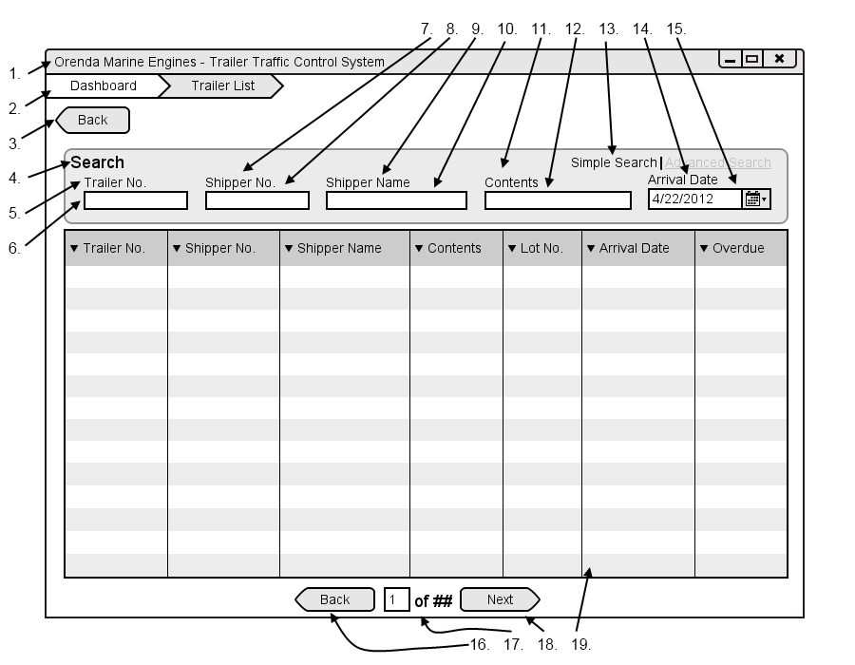

|  |  |  |  |
| --- | --- | --- | --- |
| # | Type | Text | Functions/Notes |
| 1 | Windows | Orenda Marine Engines – Trailer Traffic Control System | 800x600 |
| 2 | Breadcrumb |  | A list of all pages and subpages of the currently accessed page |
| 3 | Button | Back | Return to the Dispatcher Dashboard |
| 4 | Label | Search |  |
| 5 | Label | Trailer No. |  |
| 6 | Text Box |  | Trailer Number textbox, when it is filled in and taken from focus it filters the Datagrid |
| 7 | Label | Shipper No. | Corey |
| 8 | Text Box |  | Shipper No textbox, when it is filled in and removed from focus it filters the Datagrid |
| 9 | Label | Shipper Name |  |
| 10 | Text Box |  | Shipper Name textbox, when it is filled in and removed from focus it filters the Datagrid |
| 11 | Label | Contents |  |
| 12 | Text Box |  | Contents Textbox, when it is filled in and removed from focus it filters the Datagrid |
| 13 | Link | Simple Search | Advanced Search | Clicking this opens the Advanced Search options |
| 14 | Label | Arrival Date |  |
| 15 | Date Picker |  | Arrival Date Picker, when it is filled in and removed from focus it filters the Datagrid |
| 16 | Button | Back | Move back one list of trailers, only visible if there are enough results to require multiple pages. |
| 17 | Label | ## of ## | Display the number based on the current page and the total pages |
| 18 | Button | Next | Move forward one list of trailers, only visible if there are enough results to require multiple pages. |
| 19 | Datagrid |  | Fields: Trailer No., Shipper No., Shipper Name, Contents, Lot No., Arrival Date, Overdue  A list of all trailers that are current on the Orenda Properties |

Corey

### Print Report Dialog

#### Figure B-2

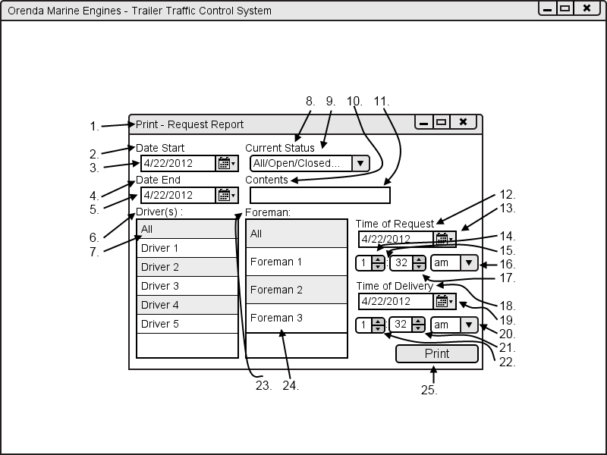

|  |  |  |  |
| --- | --- | --- | --- |
| # | Type | Text | Functions/Notes |
| 1 | Windows | Print - Report Name |  |
| 2 | Label | Start Date: |  |
| 3 | Date Picker |  | Start Date picker |
| 4 | Label | End Date: |  |
| 5 | Date Picker |  | End Date picker |
| 6 | Labels | Driver(s) : |  |
| 7 | DataList |  | List of all drivers in the system, more than one can be selected |
| 8 | Labels | Current Status |  |
| 9 | Selection box |  | List of all requests statuses |
| 10 | Labels | Contents |  |
| 11 | Textbox |  | Contents text box |
| 12 | Label | Time of request |  |
| 13 | Date Picker |  | Time of request date picker |
| 14 | Selection Box |  | Numbers one through 12 |
| 15 | Label | : |  |
| 16 | Selection box |  | Am / pm  Corey |
| 17 | Selection Box |  | Numbers 1 through 59 |
| 18 | Label | Time of delivery |  |
| 19 | Date Picker |  | Time of delivery date picker |
| 20 | Selection box |  | Am / pm |
| 21 | Selection Box |  | Numbers 1 through 59 |
| 22 | Selection Box |  | Numbers one through 12 |
| 23 | Label | Foreman: |  |
| 24 | DataList |  | A list of all foremen in the system. More than on can be selected |
| 25 | Button | Print | Print report based off information selected |

### Request Cancelation Dialog

#### Figure B-3

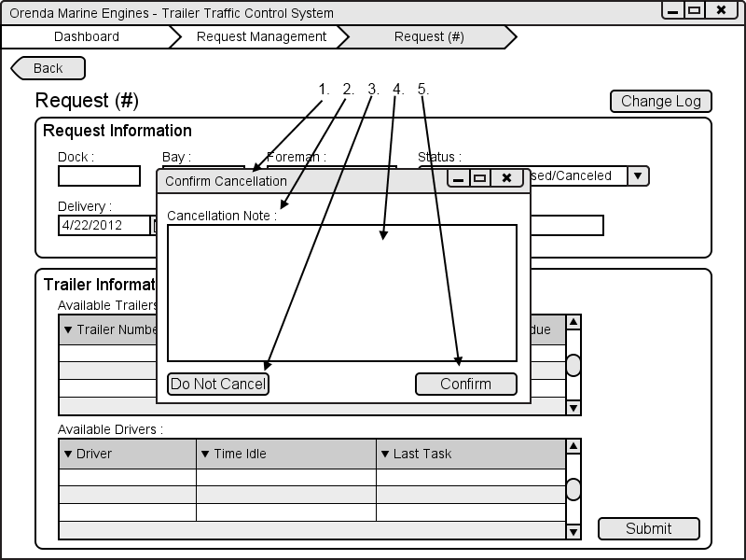

|  |  |  |  |
| --- | --- | --- | --- |
| # | Type | Text | Functions/Notes |
| 1 | Windows | Cancel Confirmation |  |
| 2 | Label | Cancellation Note : |  |
| 3 | Button | Do Not Cancel | Returns to the request screen with no changes |
| 4 | Text box |  | Cancellation Note Text Box |
| 5 | Button | Confirm | Returns to the request screen with the status changes to canceled  Corey |

### Request Change Log

#### Figure B-4

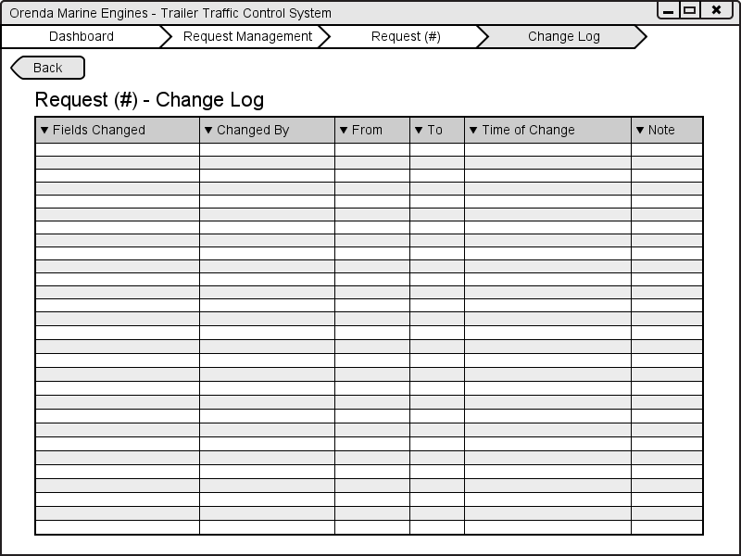

1

2

3

4

5

|  |  |  |  |
| --- | --- | --- | --- |
| # | Type | Text | Functions/Notes |
| 1 | Window | Orenda Marine Engines – Trailer Traffic Control System | 800X600 |
| 2 | Breadcrumb |  | A list of all pages and subpages of the currently accessed page |
| 3 | Button | Back | Returns user to previous screen |
| 4 | Data Grid |  | Fields: Fields Changed, Changed By, From, To, Time of Change, Notes  This table shows the logs of changes made to requests by the diaptchers |

Corey

### Assigned Tasks

#### Figure B-5

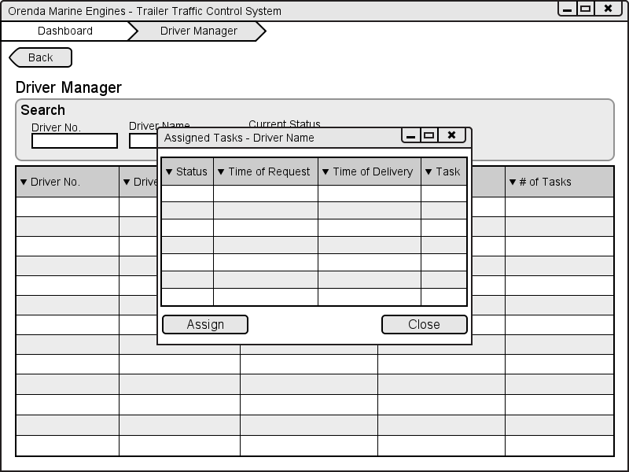

1

2

3

4

|  |  |  |  |
| --- | --- | --- | --- |
| # | Type | Text | Functions/Notes |
| 1 | Dialog | Assigned Tasks – Driver Name | Pop-up dialog, 400X300. |
| 2 | Data Grid |  | Fields: Status, Time of Request, Time of Delivery, Task  This table shows all the tasks that have been requested for a specific driver |
| 3 | Button | Assign | Completes of assigning of a task to a driver |
| 4 | Button | Close | Closes dialog |

Corey

### Driver Terminal Log in Screen

#### Figure B-6

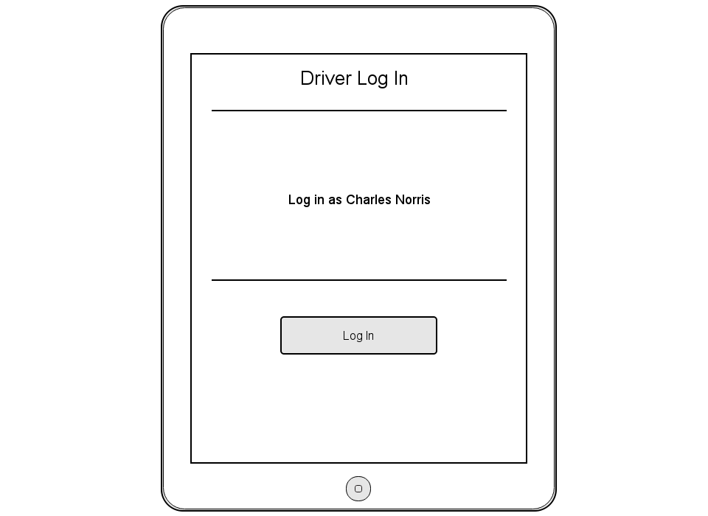

1

2

3

4

|  |  |  |  |
| --- | --- | --- | --- |
| # | Type | Text | Functions/Notes |
| 1 | Label | Driver Log In | Static |
| 2 | Label | Log in as | Static |
| 3 | Label | Driver name |  |
| 4 | Button | Log In | Take user to Task List view, time stamp as the beginning of his shift |

Ryan

Appendix C: Slide Show

Appendix D: Database

